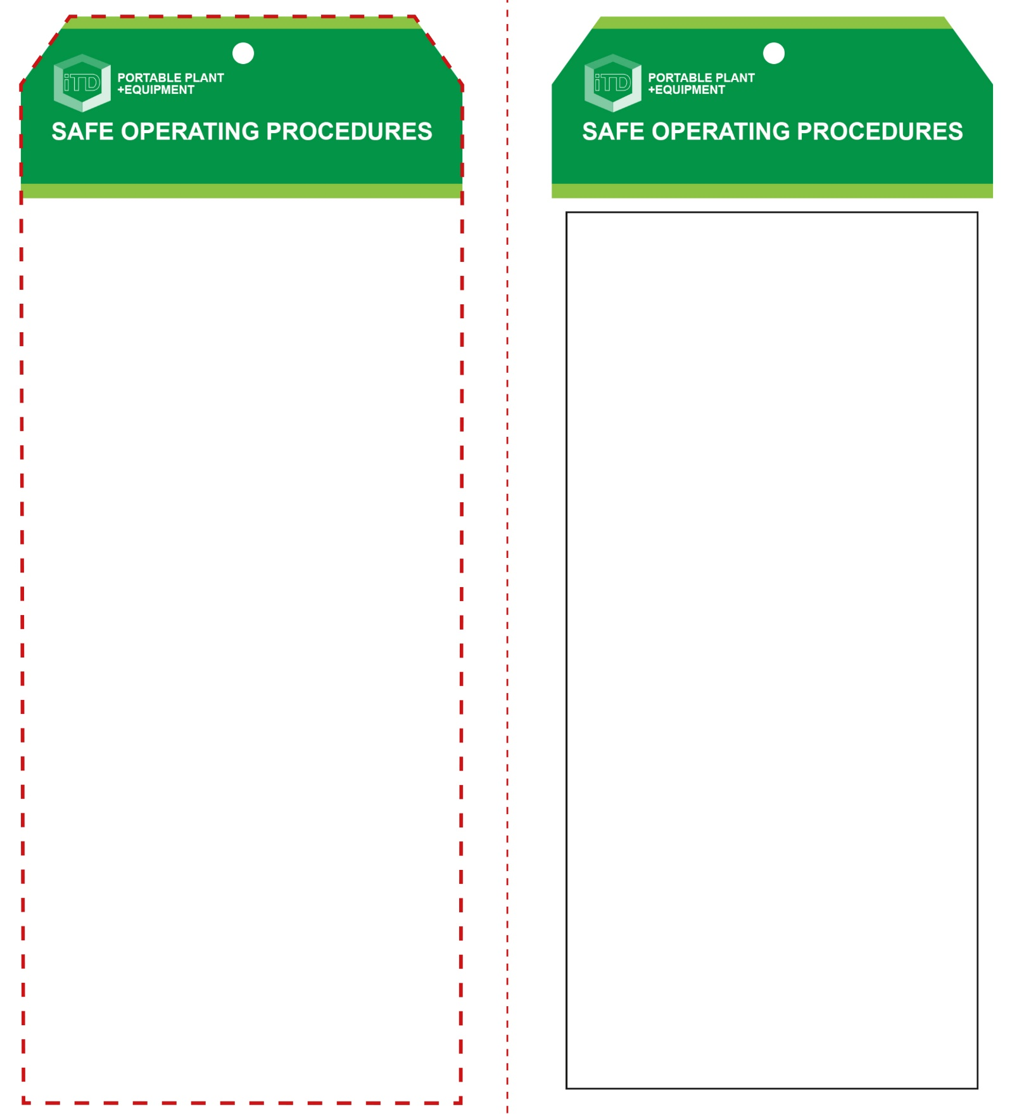

**OPERATIONAL SAFETY CHECK**

|  |
| --- |
| **Never operate a faulty electrical power tool. Report it to your teacher.** |
| 1. Never use electrical cord to lift, lower or carry the planer. 2. Do not support your material by hand – set up on bench or supports. Use two hands to operate. 3. Do not start planer with blade touching material. Allow the equipment to reach full speed before starting to cut. 4. Keep fingers and any objects clear of the chip ejector while the planer is running. 5. Keep hands and power leads away from underneath the work. Do not attempt to remove cut material while the blade is turning. 6. Never pull the planer backwards over the work piece, always cut in the forward direction. 7. Never place the planer down on a surface until the blade is completely stopped. 8. Before making any adjustments of the planer, bring the machine to a complete standstill and then disconnect the AC plug from the power source. 9. After changing blades, rotate the blade cylinder carefully by hand to make sure blades are secure and not hitting any part of the planer casing (must be unplugged). |
| **Keep fingers and power cords clear of the blade** |
| **HOUSEKEEPING**   1. Return this tool to the appropriate storage cupboard. 2. Leave the work area in safe, clean and tidy   **POTENTIAL HAZARDS AND RISKS**  ■ Moving, rotating and sharp blades  ■ Electricity ■ Noise  ■ Ejected waste ■ Eye injuries  ■ Dust and fumes |

**Students must read this important information before using the equipment**

|  |  |
| --- | --- |
| Has your teacher given you instruction on the safe use and operation of this equipment? | |
|  | |
| Has your teacher given permission  for you to use this equipment? | |
|  | Approved safety glasses and face shield *must* be worn at all times in all ITD workspaces. |
|  | Appropriate protective steel-toed boots *must* be worn in all ITD workspaces. |
|  | A mask (P2 dust and fumes) *should* be worn when excessive airborne dust is created. |
| Hearing Protection circle | Appropriate hearing protection *(Class 5 – SLC80 >26 dB)* must be worn. |
| mand154_safety_overalls_must_ | Sturdy, long ‘work wear’ must be worn when using this tool. |
| Prohibition circle | Remove all rings and jewellery. |
| **PRE-OPERATIONAL SAFETY CHECKS**   1. Ensure the power tool has a suitable safe work area. 2. Material should be free of loose knots or foreign objects. 3. Make sure the planer blades are not chipped or cracked. 4. Examine the power lead and plug for obvious damage 5. Material should be well supported and at a good working height. 6. Ensure you are familiar with the ON/OFF switch. | |

**Planer**

**Planer**

**Front Reverse**

**Assembly instructions:**

1. Carefully fold this page in half vertically down the centre line
2. This should align ‘front’ and ‘reverse’ sides, then glue the halves back to back
3. Cut out the ‘tag’ shape along the RED dotted outlines indicated on the ‘front’ side
4. Laminate and trim to size with a clear 2mm border
5. Securely fasten an 8mm (ID) brass eyelet and washer where indicated.