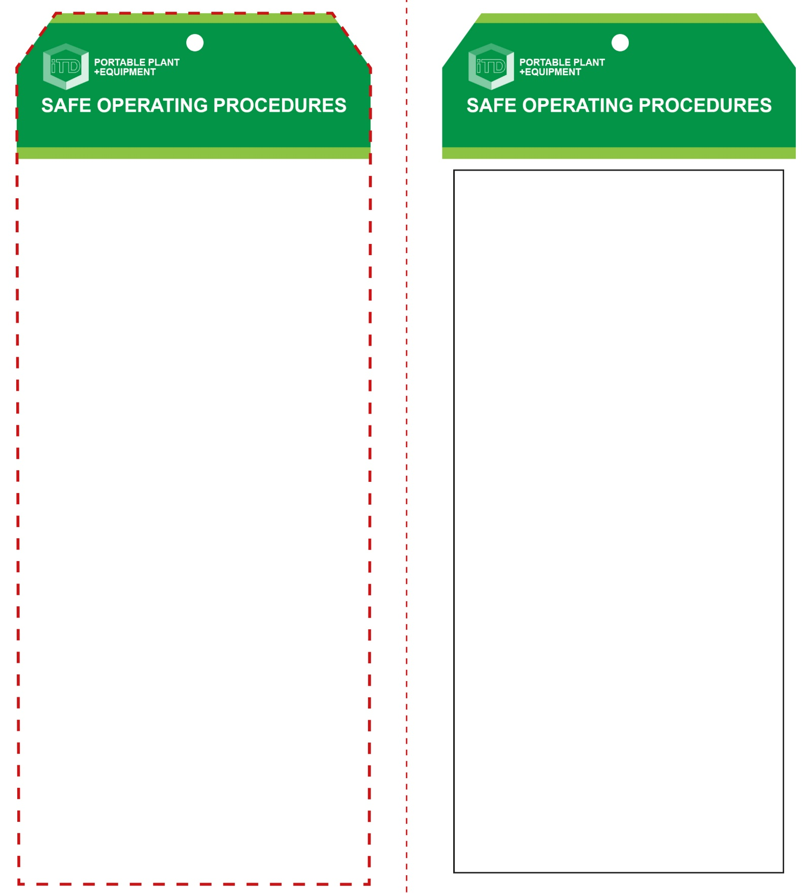

**OPERATIONAL SAFETY CHECK**

|  |
| --- |
| **Never operate a faulty electrical power tool. Report it to your teacher.** |
| 1. Check the work piece for faults and defects. 2. Fit the correct cutter bit to the machine. Ensure cutter bit conforms to machine specifications. 3. Make all adjustments for depth of cut BEFORE connecting to the power source. 4. Ensure your work piece is firmly secure and supported. 5. Keep fingers, hands and power cord clear of the bit. 6. Always consider the direction of rotation. This will determine the direction the router is to travel. 7. Allow the router to reach operating speed, then apply load gradually. Maintain a constant pace to avoid uneven finishes. 8. Keep the sole plate pressed firmly on the work piece. 9. Maintain complete control. Always operate with both hands. Maintain a proper and steady footing at all times. 10. Make a series of shallow cuts when creating a deep recess. This is much safer and easier on the tool bit. 11. Do not apply excessive force – this could cause the cutter bit to burn the work piece. 12. If any unforeseen problems arise while routing, stop immediately, switch off, and report it to your teacher. 13. Turn off immediately after use. Do not place the router down until the cutter has stopped rotating. |
| **Be extremely cautious of this high speed tool** |
| **HOUSEKEEPING**   1. Return this tool to the appropriate storage cupboard 2. Leave the work area in a safe, clean and tidy condition   **POTENTIAL HAZARDS AND RISKS**  ■ Rotating sharp parts ■ Kickback ■ Electricity ■ Eye injuries ■ Ejected material ■ Dust |

**Students must read this important information before using the equipment**

|  |  |
| --- | --- |
| Has your teacher given you instruction on the safe use and operation of this equipment? | |
|  | |
| Has your teacher given permission  for you to use this equipment? | |
|  | Approved safety glasses *must* be worn at all times in all ITD workspaces. |
|  | Appropriate protective footwear with substantial uppers *must* be worn in all ITD workspaces. |
|  | Hearing protection *must* be worn when excessive airborne dust or fumes are created. |
|  | A mask *should* be worn when excessive airborne dust or fumes are created. |
|  | Protective clothing, overalls or a suitable workshop apron is encouraged. |
|  | Rings and jewellery *must* NOT be worn when using this portable power tool. |
| **PRE-OPERATIONAL SAFETY CHECKS**   1. Ensure this power tool has a suitable safe work area. 2. Check the router and bit for obvious signs of damage. 3. Examine the power lead and plug for obvious damage. 4. Ensure the cord does not create a tripping hazard. | |

**Router**

**Router**

**Front Reverse**

**Assembly instructions:**

1. Carefully fold this page in half vertically down the centre line
2. This should align ‘front’ and ‘reverse’ sides, then glue the halves back to back
3. Cut out the ‘tag’ shape along the RED dotted outlines indicated on the ‘front’ side
4. Laminate and trim to size with a clear 2mm border
5. Securely fasten an 8mm (ID) brass eyelet and washer where indicated.