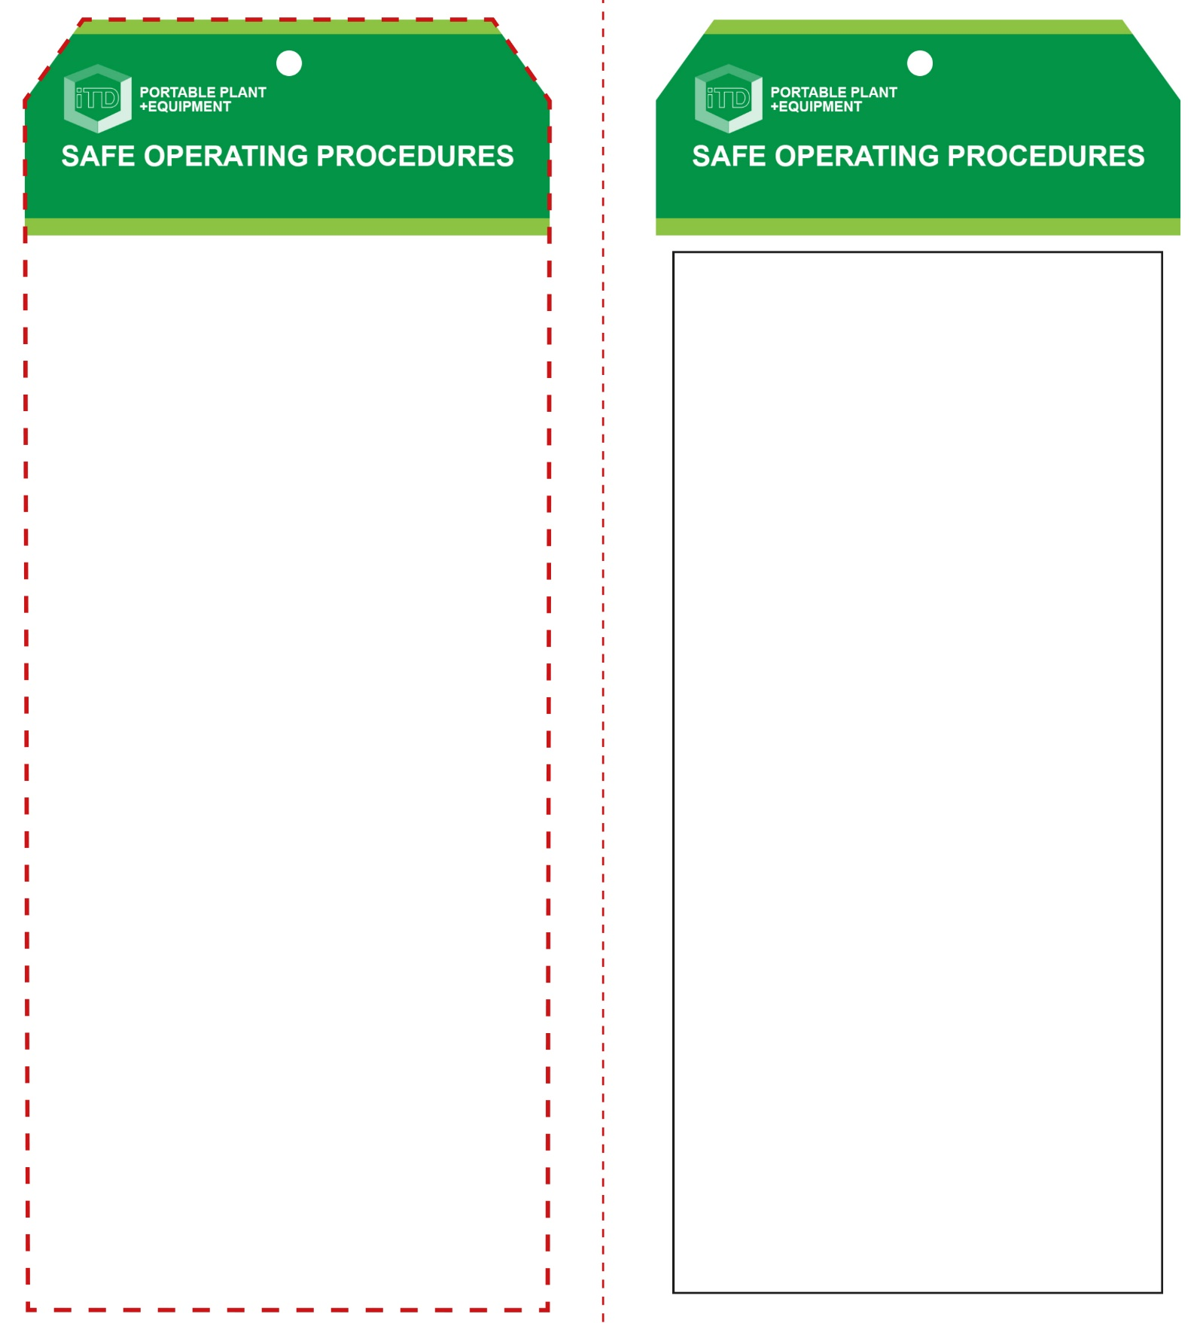

**OPERATIONAL SAFETY CHECK**

|  |
| --- |
| **Never operate a faulty electrical power tool. Report it to your teacher.** |
| 1. Check the work piece for faults and defects. 2. Ensure cutter bit conforms to machine specifications and is the correct size. 3. Make all adjustments for depth of cut BEFORE connecting to the power source. 4. Ensure your work piece is firmly secure and supported. Keep fingers and hands well clear of the rotating cutter bit. 5. Always consider the direction of the rotation. This will determine the direction the router is to travel. 6. Allow the router to reach operating speed, then apply load gradually. Maintain a constant pace to avoid uneven finishes. 7. Keep the sole plate pressed firmly on the work piece. 8. Maintain complete control. Always operate with both hands. Maintain a proper and steady footing at all times. 9. Make a series of shallow cuts when creating a deep recess. This is much safer and easier on the tool bit. 10. Do not apply excessive force – this could cause the cutter bit to burn the work piece. 11. If any unforeseen problems arise while routing, stop immediately, witch off and report it to your teacher. 12. Turn off immediately after use. Do not place any router down until the cutter bit has stopped rotating completely. |
| **Be extremely cautious of this high speed tool** |
| **HOUSEKEEPING**   1. Return this tool to the appropriate storage cupboard 2. Leave the work area in a safe, clean and tidy condition.   **POTENTIAL HAZARDS AND RISKS**  ■ Rotating sharp parts ■ Kickback  ■ Ejected material ■ Electricity  ■ Eye injuries ■ Noise  ■ Dust and fumes ■ Pinch and squash |

**Students must read this important information before using the equipment**

|  |  |
| --- | --- |
| Has your teacher given you instruction on the safe use and operation of this equipment? | |
|  | |
| Has your teacher given permission  for you to use this equipment? | |
|  | Approved safety glasses *must* be worn at all times in all ITD workspaces. |
|  | Appropriate protective steel-toed work boots *must* be worn in all ITD workspaces. |
|  | Appropriate hearing protection *(Class 5 – SLC80 >26 dB)* *must* be worn when using this machine. |
|  | A dust mask *should* be worn when excessive airborne dust or fumes is created. |
|  | Protective clothing, overalls or a workshop apron is encouraged. |
| Hair Protection circle | Long and loose hair must be contained and restrained. |
|  | Rings and jewellery *must not* be worn when using this portable power tool. |
| **PRE-OPERATIONAL SAFETY CHECKS**   1. Ensure this power tool has a suitable safe work area free of slip and trip hazards. 2. Inspect the condition of cutter bit and ensure it’s in good condition. 3. If changing the cutter bit, unplug and isolate the router. 4. Check the plunge adjustment and movement for accuracy. 5. Familiarise yourself with the ON/OFF switch. | |

**Plunge Router**

**Plunge Router**

**Front Reverse**

**Assembly instructions:**

1. Carefully fold this page in half vertically down the centre line
2. This should align ‘front’ and ‘reverse’ sides, then glue the halves back to back
3. Cut out the ‘tag’ shape along the RED dotted outlines indicated on the ‘front’ side
4. Laminate and trim to size with a clear 2mm border
5. Securely fasten an 8mm (ID) brass eyelet and washer where indicated.