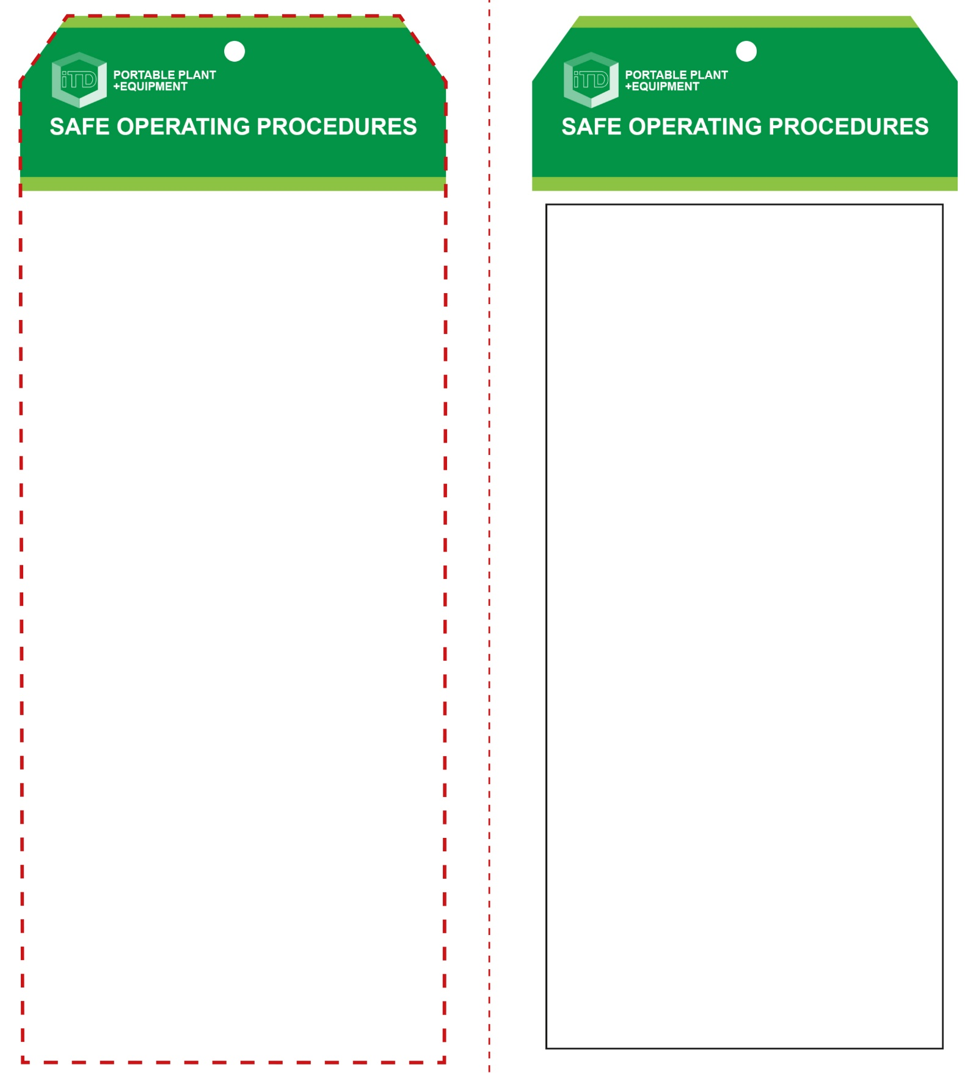

**OPERATIONAL SAFETY CHECK**

|  |
| --- |
| **Never operate a faulty electrical power tool. Report it to your teacher.** |
| 1. Ensure the material being worked is well supported. Use a vice or clamp to hold the material secure where necessary. 2. Always hold the belt sander securely with both hands. 3. Before starting the machine, hold it clear above the work surface. Allow the belt to reach full operating speed before applying the load gradually. 4. Do not use excessive force. 5. Avoid blocking or covering the motor ventilation slots. 6. Be vigilant of the tendency for the sander to ‘run away’ when not held and controlled firmly. 7. After finishing the sanding operation, release the switch and hold the machine up until the belt has stopped. 8. Never rest the sander on its side while running. 9. Always position electrical cords with care to avoid trip hazards and to prevent damage to the plug and lead. 10. Before making any belt adjustments, bring the sander to a complete standstill and then disconnect from the AC power source. |
| **Never sand metal or small items with this tool** |
| **HOUSEKEEPING**   1. Return this tool to the appropriate storage cupboard. 2. Leave the work area in a safe, clean and tidy condition.   **POTENTIAL HAZARDS AND RISKS**  ■ Moving, rotating and abrasive parts  ■ Electricity ■ Noise ■ Excessive dust  ■ Eye injuries ■ Burns to hands |

**Students must read this important information before using the equipment**

|  |  |
| --- | --- |
| Has your teacher given you instruction on the safe use and operation of this equipment? | |
|  | |
| Has your teacher given permission  for you to use this equipment? | |
|  | Approved safety glasses and a face shield *must* be worn at all times in all ITD workspaces. |
|  | Appropriate protective footwear with substantial uppers *must* be worn in all ITD workspaces. |
|  | A suitable P2 or P3 filter mask *should* be worn whenever potentially toxic fumes are created. |
|  | Hearing protection must be wornwhen noise levels are excessive. |
|  | A suitable workshop apron or overalls must be worn. |
|  | Rings and jewellery *must not* be worn when using this portable safety tool. |
| **PRE-OPERATIONAL SAFETY CHECKS**   1. Ensure this sanding tool has a suitable safe work area. 2. Disconnect the power cable before inspecting the tool. 3. Closely inspect the condition of the abrasive belt. 4. Ensure adequate dust ventilation and extraction. | |

**Belt Sander**

**Belt Sander**

**Front Reverse**

**Assembly instructions:**

1. Carefully fold this page in half vertically down the centre line
2. This should align ‘front’ and ‘reverse’ sides, then glue the halves back to back
3. Cut out the ‘tag’ shape along the RED dotted outlines indicated on the ‘front’ side
4. Laminate and trim to size with a clear 2mm border
5. Securely fasten an 8mm (ID) brass eyelet and washer where indicated.