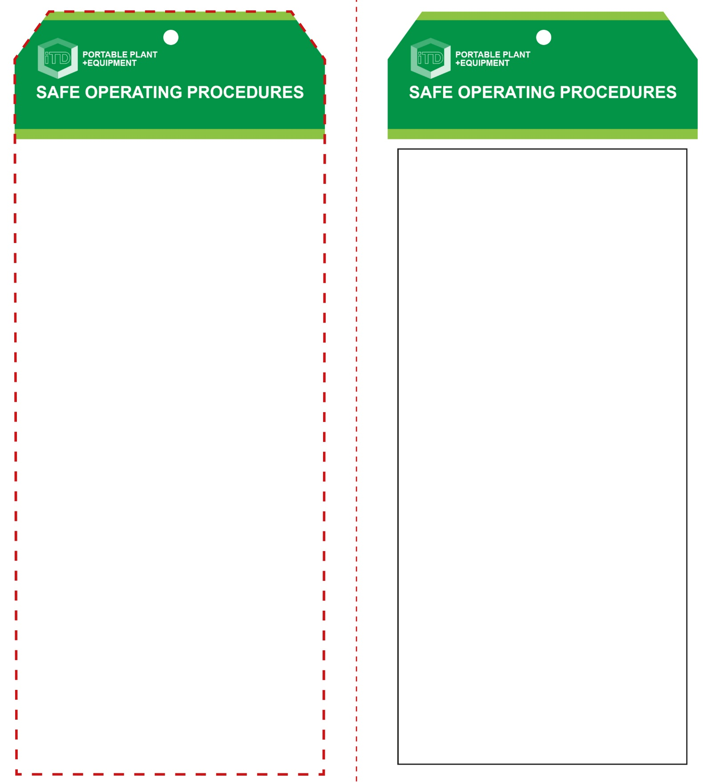

**Students must read this important information before using the equipment**

|  |  |
| --- | --- |
| Has your teacher given you instruction on the safe use and operation of this equipment? | |
|  | |
| Has your teacher given permission  for you to use this equipment? | |
|  | Approved safety glasses *must* be worn at all times in all ITD workspaces. |
|  | Appropriate protective footwear with substantial uppers *must* be worn in all ITD workspaces. |
|  | A mask *must* be worn when excessive airborne dust is created. |
|  | Hearing protection may be necessary when noise levels are considered excessive. |
|  | A suitable workshop apron or close fitting protective clothing must be worn. |
|  | Gloves *must not* be worn when using this portable power tool. |
| **PRE-OPERATIONAL SAFETY CHECKS**   1. Ensure these sanders have a suitable safe work area. 2. Examine the battery and sander for obvious damage. 3. Do not use dull or damaged sanding discs or belts. 4. Check sanding discs and belts are correctly fitted. | |

**OPERATIONAL SAFETY CHECK**

|  |
| --- |
| **Never operate a faulty electrical power tool. Report it to your teacher.** |
| 1. Fit battery only after all adjustments have been made. 2. Examine the material to be sanded for splits, loose knots and nails, etc. 3. Always select the correct abrasive and grade of disc. 4. Sanding discs with holes must align with those on the rubber pad to allow for efficient dust collection. 5. Always make sure a dust bag is fitted and emptied regularly for efficient operation of the sander. 6. Ensure the workpiece is secure and well supported. 7. All cordless portable sanders are best used when securely held with both hands. 8. Keep fingers and hands well clear of moving parts. 9. Allow the sander to reach operating speed, then apply load gradually. Do not apply excessive force. 10. Cordless sanders normally will not operate when the battery charge level is too low. 11. Avoid blocking and covering the motor ventilation slots with your hands. 12. Maintain a constant pace to avoid uneven sanding. 13. Be cautious of sanding too close to edges and corners. 14. Replace sanding disc once edges are torn or frayed. |
| **Always wear safety goggles and a dust mask.** |
| **HOUSEKEEPING**   1. After use, return the battery for recharging. 2. Leave the work bench and machine clean and tidy.   **POTENTIAL HAZARDS AND RISKS**  ■ Moving, rotating and abrasive parts ■ Electricity  ■ Dust ■ Noise ■ Eye injuries ■ Burns (friction) |

**Sander (cordless)**

**Sander (cordless)**

**Front Reverse**

**Assembly instructions:**

1. Carefully fold this page in half vertically down the centre line
2. This should align ‘front’ and ‘reverse’ sides, then glue the halves back to back
3. Cut out the ‘tag’ shape along the RED dotted outlines indicated on the ‘front’ side
4. Laminate and trim to size with a clear 2mm border
5. Securely fasten an 8mm (ID) brass eyelet and washer where indicated.