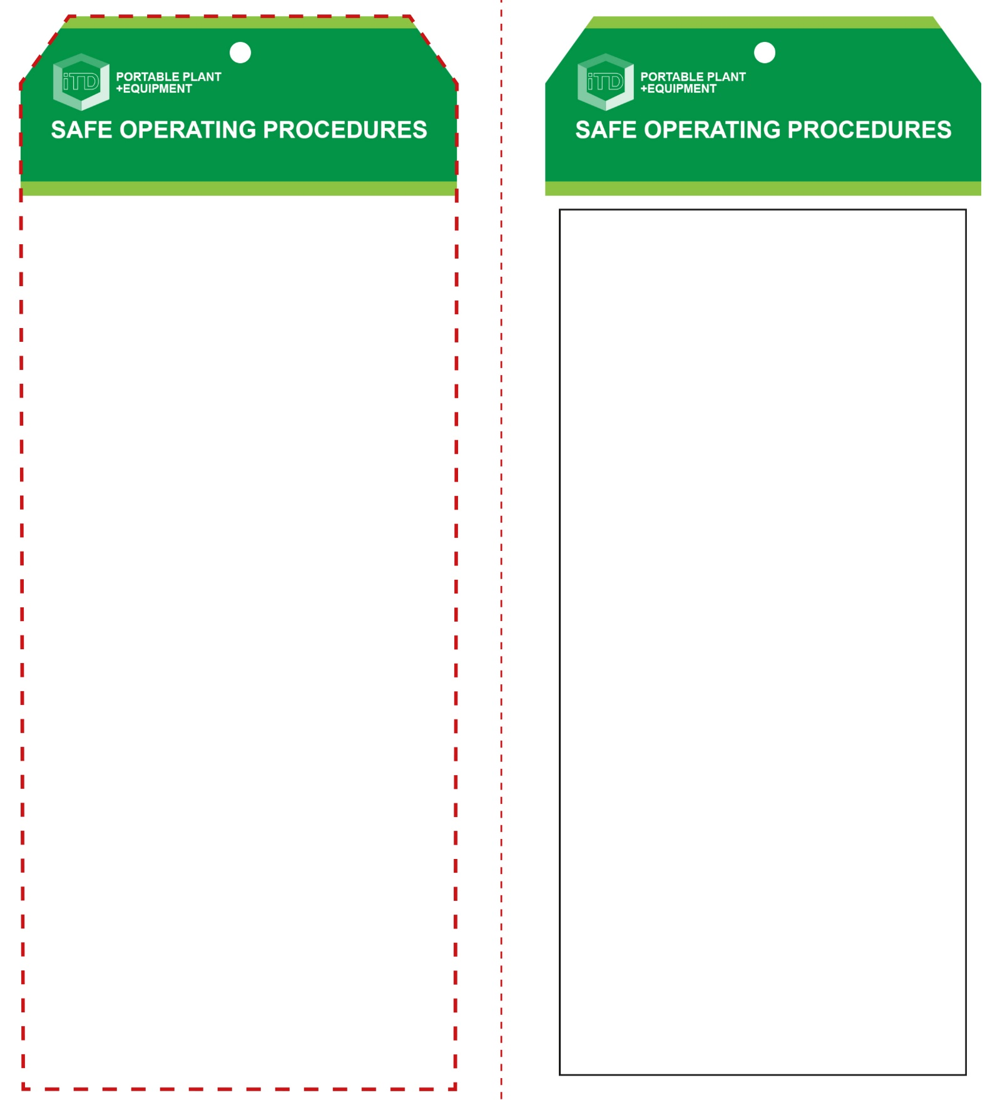

**OPERATIONAL SAFETY CHECK**

|  |
| --- |
| **Never operate a faulty electrical power tool. Report it to your teacher.** |
| 1. This sander is not suitable for wet sanding. 2. Examine the material to be sanded for splits, loose knots and nails, etc. 3. Always select the correct abrasive and grade of sheet. Do not use sanding paper larger than is needed. 4. Always make sure a dust bag (or ducting) is fitted and emptied regularly for efficient operation of the sander. 5. Ensure the work piece is secure and well supported. 6. This sander is designed to be used with both hands. Keep fingers and hands well clear of moving parts. 7. Allow the sander to reach operating speed, then apply load gradually. Do not apply excessive force. 8. Maintain a constant pace to avoid uneven surfaces. 9. Maintain a proper and steady footing at all times. 10. Always hold the sander flat onto the work surface. 11. Avoid blocking and covering the motor ventilation slots with your hands. Some abrasive sheets may also have dust ventilation holes that will need to be aligned. 12. Avoid prolonged use and high pressures. This could overheat the motor. 13. Replace sanding sheets once edges are torn or frayed. 14. Wait for the sander to stop before resting it on its side. |
| **Always wear safety goggles and a dust mask** |
| **HOUSEKEEPING**   1. Return this tool to the appropriate storage cupboard. 2. Leave the work area in a safe, clean and tidy condition.   **POTENTIAL HAZARDS AND RISKS**  ■ Moving, rotating and abrasive parts  ■ Electricity ■ Noise ■ Excessive dust  ■ Eye injuries ■ Burns (friction) |

**Sheet Sander**

**Students must read this important information before using the equipment**

|  |  |
| --- | --- |
| Has your teacher given you instruction on the safe use and operation of this equipment? | |
|  | |
| Has your teacher given permission  for you to use this equipment? | |
|  | Approved safety glasses *must* be worn at all times in all ITD workspaces. |
|  | Appropriate protective footwear with substantial uppers *must* be worn in all ITD workspaces. |
|  | A mask *must* be worn when excessive airborne dust is created. |
|  | Hearing protection must be worn when noise levels are identified as excessive. |
|  | A suitable workshop apron or close fitting protective clothing must be worn. |
|  | Gloves must *not* be worn when using this portable power tool. |
| **PRE-OPERATIONAL SAFETY CHECKS**   1. Ensure this sanding tool has a suitable safe work area 2. Examine the power lead and plug for obvious damage 3. Do not use dull or damaged abrasive sanding discs. 4. Check the sanding sheet is correctly fitted. | |

**Sheet Sander**

**Front Reverse**

**Assembly instructions:**

1. Carefully fold this page in half vertically down the centre line
2. This should align ‘front’ and ‘reverse’ sides, then glue the halves back to back
3. Cut out the ‘tag’ shape along the RED dotted outlines indicated on the ‘front’ side
4. Laminate and trim to size with a clear 2mm border
5. Securely fasten an 8mm (ID) brass eyelet and washer where indicated.