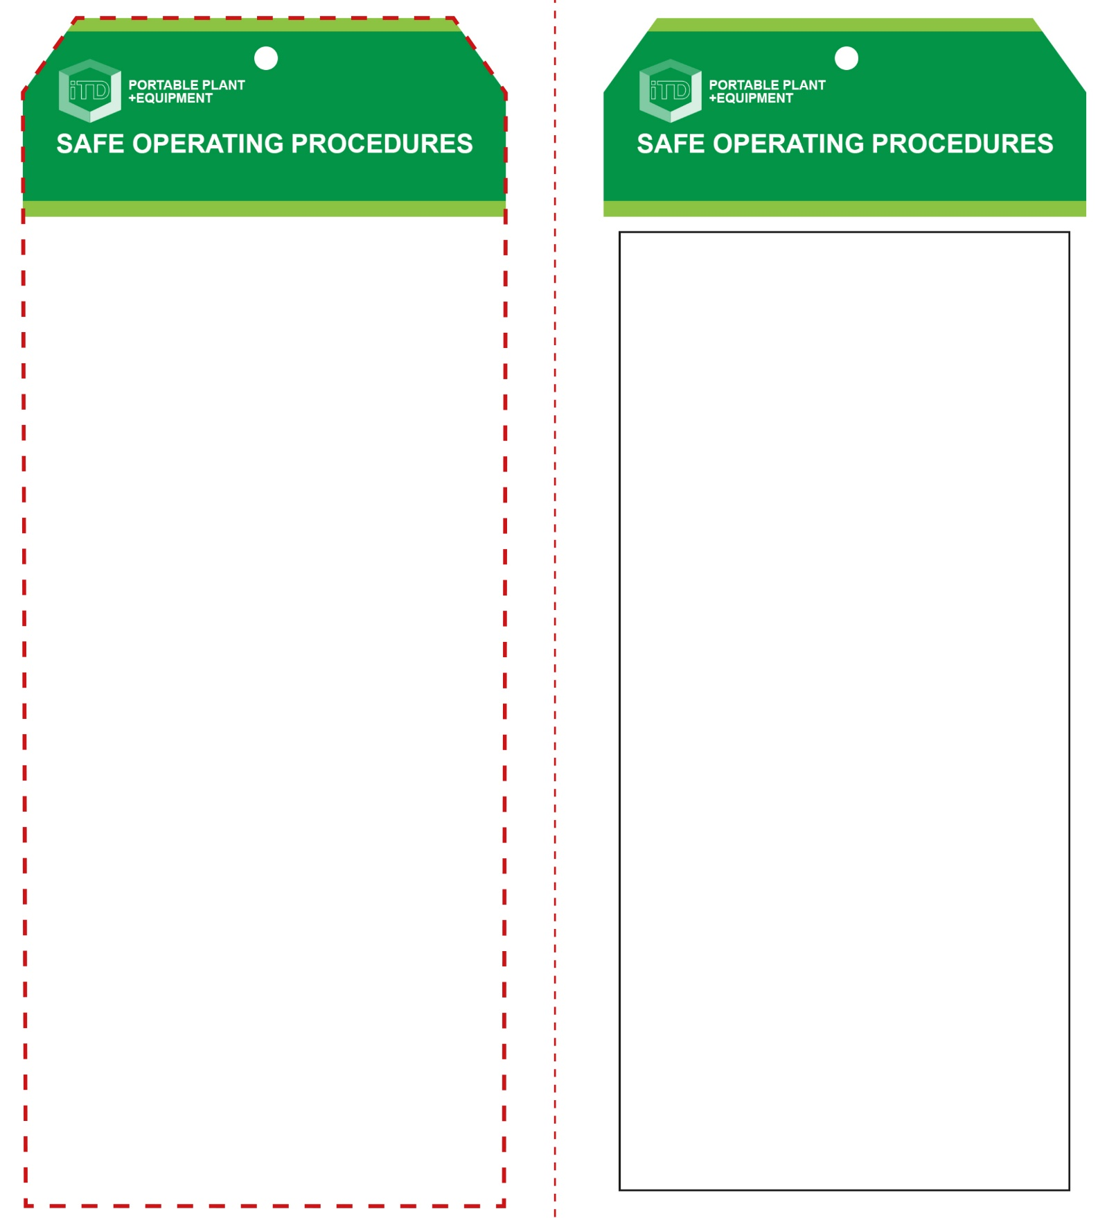

**OPERATIONAL SAFETY CHECK**

|  |
| --- |
| **Never operate a faulty electrical power tool. Report it to your teacher.** |
| 1. Ensure all adjustments to the machine are secure before making a cut. 2. Do not hold your work piece by hand. It may become very hot while being cut. 3. Use the vice to clamp the work and properly support any overhanging portion so the work piece is level with the base of the machine. 4. Do not use a length stop on the free off-cut end of a clamped work piece. 5. Allow the machine to reach full speed before contacting the work piece. 6. Do not have any part of your body in line with the path of the abrasive disc. 7. Ease the abrasive disc against the work piece when starting. Do not force tool. 8. Keep hands away from cutting. Do not attempt to remove cut material while the abrasive wheel is moving. 9. After finishing the cut, release the switch, hold the saw arm down and wait for the disc to stop before removing your work piece or off cut piece. 10. Before making any machinery adjustments bring the machine to a complete standstill and then disconnect the AC plug from the power source. |
| **NB this abrasive cut-off saw is not intended to cut wood or wood products** |
| **HOUSEKEEPING**   1. Ensure ventilation openings and switches are kept clean and free of foreign matter. 2. Leave the work area in a safe, clean and tidy condition.   **POTENTIAL HAZARDS AND RISKS**  ■ Moving, rotating and sharp parts ■ Noise  ■ Electricity ■ Dust and fumes ■ Eye injuries ■ Pinch and squash  ■ Burns and hot ejected waste material |

**FORBIDDEN**

■ NEVER grind on the side of the abrasive cut-off wheel.

**Students must read this important information before using the equipment**

|  |  |
| --- | --- |
| Has your teacher given you instruction on the safe use and operation of this equipment? | |
|  | |
| Has your teacher given permission  for you to use this equipment? | |
|  | Approved safety glasses and face shield *must* be worn at all times in all ITD workspaces. |
|  | Appropriate steel-toed work boots *must* be worn in all ITD workspaces. |
|  | Appropriate hearing protection *(Class 5 – SLC80 >26 dB)* *must* be worn at all times when using this power tool. |
|  | Long and loose hair *must* be contained or restrained and all rings and exposed jewellery must be removed. |
|  | A suitable workshop apron or overalls must be worn. |
| Dust mask sign | An approved dust mask must be worn. |
| **PRE-OPERATIONAL SAFETY CHECKS**   1. Ensure the power tool has a suitable safe work area 2. If changing cut-off wheel, check for appropriateness and arbor hole size. 3. Inspect the cut-off wheel for chips and cracks. 4. Check that the guards are all in place and in good working order. 5. If fitted with a depth stop, ensure that it is in proper adjustment/alignment. 6. Familiarise yourself with the ON/OFF switch. 7. Ensure your work area is clear of slip/trip hazards and flammable materials. | |

**Abrasive Cut-Off Saw**

**Abrasive Cut-Off Saw**

**Front Reverse**

**Assembly instructions:**

1. Carefully fold this page in half vertically down the centre line
2. This should align ‘front’ and ‘reverse’ sides, then glue the halves back to back
3. Cut out the ‘tag’ shape along the RED dotted outlines indicated on the ‘front’ side
4. Laminate and trim to size with a clear 2mm border
5. Securely fasten an 8mm (ID) brass eyelet and washer where indicated.