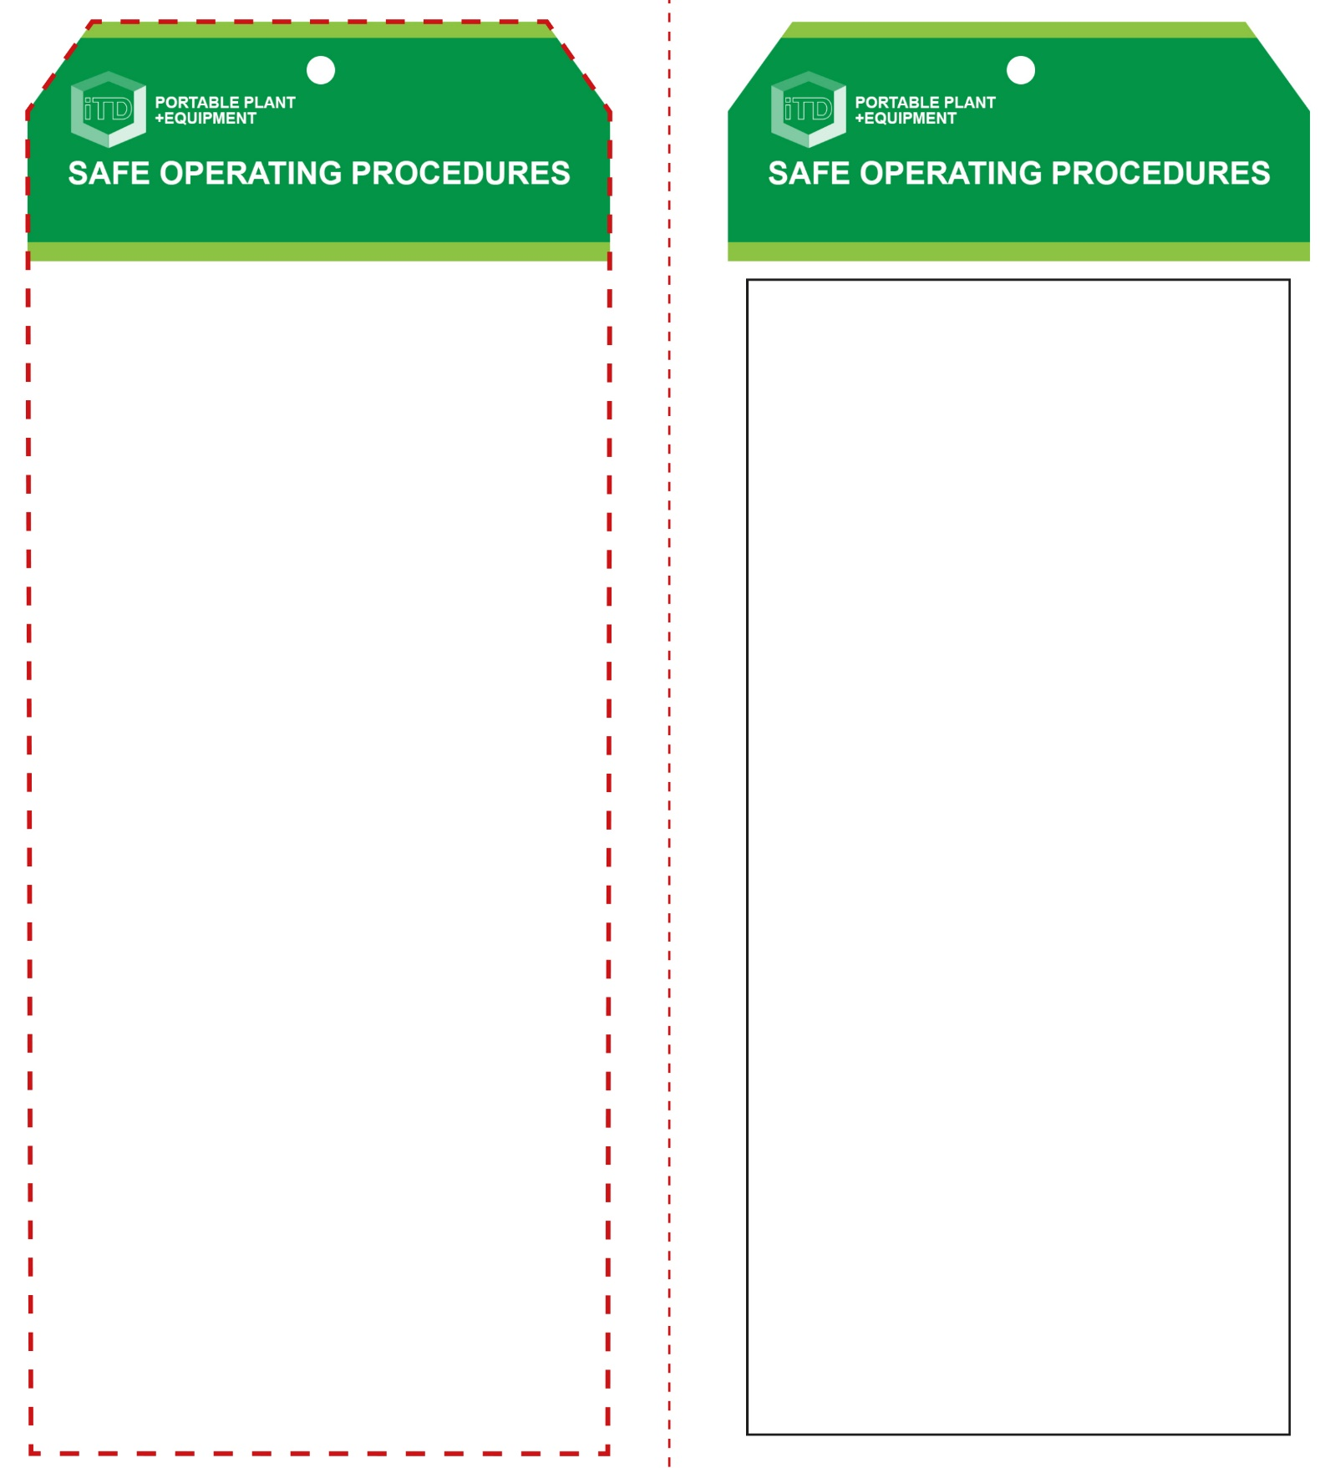

**Front Reverse**

**Assembly Instructions:**

1. Carefully fold this page in half vertically down the centre line
2. This should align “Front” & “Reverse” sides, then glue the halves back to back
3. Cut out the “Tag” shape along the RED dotted outlines indicated on the “Front” side
4. Laminate & trim to size with a clear 2 mm border
5. Securely fasten an 8mm (ID) brass eyelet and washer where indicated.

*Website link to this SOP document:* <http://education.qld.gov.au/health/safety/hazards/equip-resources.html>

**OPERATIONAL SAFETY CHECK**

|  |
| --- |
| **Never operate a faulty electrical power tool. Report it to your teacher.** |
| 1. The maximum cut for the saw must not be exceeded. 2. Material should be sitting flat on the base, securely clamped and supported up against the rear fence. 3. Do not start the saw with blade touching material. Allow the saw to reach full speed before starting to cut. 4. If required, set the mitre angle for the task, ensuring the adjustment lever is located in the notch of the base and locked by tightening the knob. 5. Avoid reaching over the path of the saw line. Do not cross arms when cutting. 6. Keep non-trigger hand, especially the thumb, well clear of the line of cut. 7. After finishing a cut, release the switch, hold the saw arm down and wait for the blade to stop before removing the workpiece or off-cuts. 8. Inspect blade guard/s and mechanism regularly. Ensure waste does not prevent correct operation. 9. Before making any adjustments to the saw, bring the machine to a complete standstill, and then disconnect the AC plug from the power source. |
| **Keep material supported against the fence** |
| **HOUSEKEEPING**   1. Return the power tool to its correct storage cupboard. 2. Leave the work area in a safe, clean and tidy condition.   **POTENTIAL HAZARDS AND RISKS**  ■ Moving, rotating and sharp parts  ■ Electricity ■ Noise ■ Eye injuries  ■ Ejected waste  **FORBIDDEN**  ■ Cutting dowel and non-ferrous metals  ■ Rip cutting along the grain of the timber. |

**Students must read this important information before using the equipment**

|  |  |
| --- | --- |
| Has your teacher given you instruction on the safe use and operation of this equipment? | |
|  | |
| Has your teacher given permission  for you to use this equipment? | |
|  | Approved safety glasses *must* be worn at all times in all ITD workspaces. |
|  | Appropriate protective footwear with substantial uppers *must* be worn in all ITD workspaces. |
|  | Appropriate hearing protection may be needed when noise levels are excessive (*Class 3 – SLC80 18-21dB*). |
|  | Long and loose hair *must* be contained or restrained for some operations. |
|  | A suitable workshop apron or close fitting protective clothing must be worn. |
| **PRE-OPERATIONAL SAFETY CHECKS**   1. Ensure the power tool has a suitable safe work area 2. Material should be well supported at a good working height. 3. Ensure material is free of loose knots and foreign objects. 4. Check that saw is stable and secured to bench or trolley. 5. Examine the power lead and plug for obvious damage. 6. Check saw guard/s and blade are in good condition. | |

**Compound Mitre Saw**

**Compound Mitre Saw**