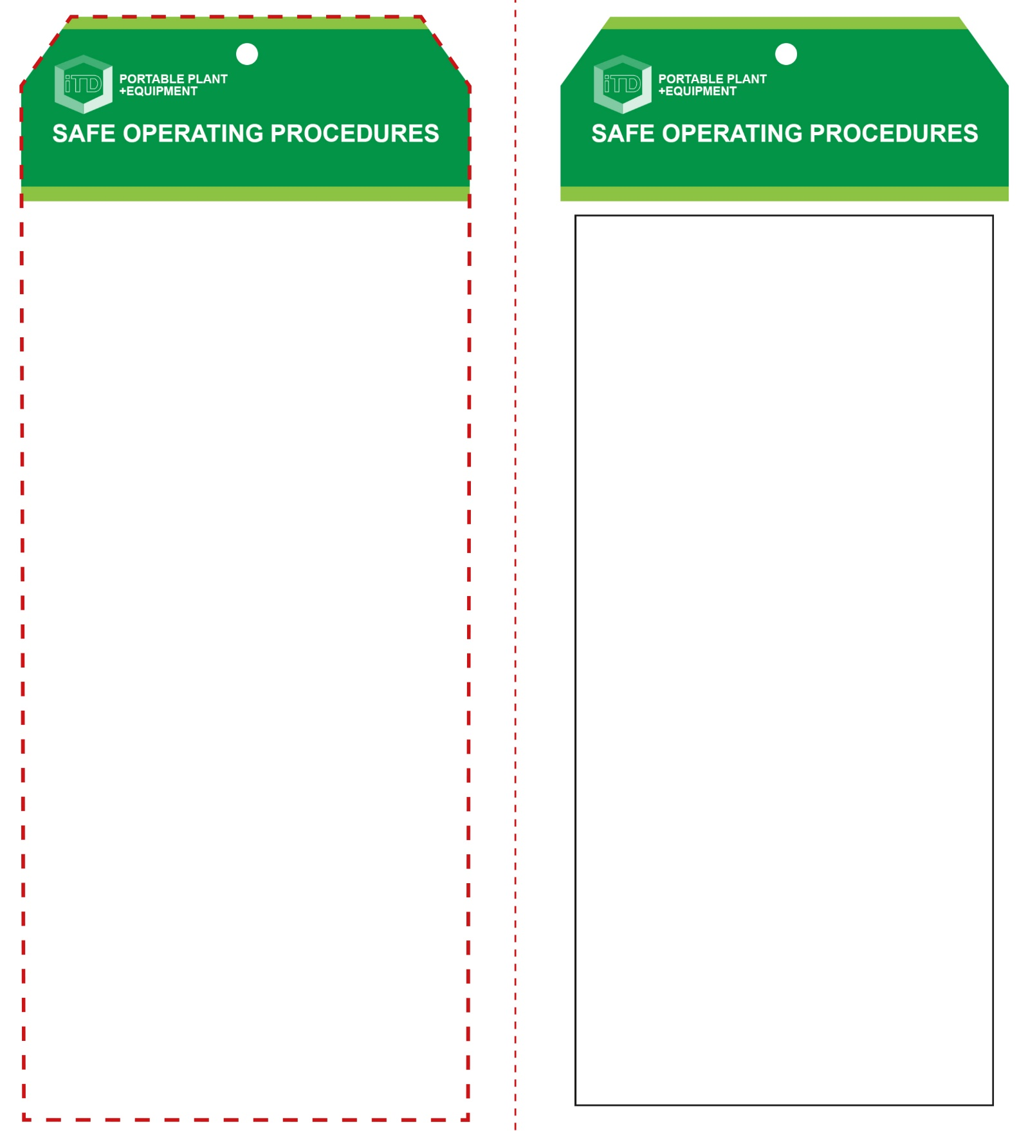

**Students must read this important information before using the equipment**

|  |  |
| --- | --- |
| Has your teacher given you instruction on the safe use and operation of this equipment? | |
|  | |
| Has your teacher given permission  for you to use this equipment? | |
|  | Approved safety glasses *must* be worn at all times in all ITD workspaces. |
|  | Appropriate protective footwear with substantial uppers *must* be worn in all ITD workspaces. |
|  | Appropriate hearing protection *should* be worn when noise levels are excessive. |
|  | Long and loose hair *must* be contained or restrained for all operations. |
|  | A suitable workshop apron or close fitting protective clothing must be worn. |
|  | Gloves *must not* be worn when using this portable power tool. |
| **PRE-OPERATIONAL SAFETY CHECKS**   1. Ensure the power tool has a suitable safe work area 2. Make sure blade is intact and suits the material to be cut. 3. Examine the power lead and plug for obvious damage. 4. Plan a sawing procedure to minimise backing out. | |

**OPERATIONAL SAFETY CHECK**

|  |
| --- |
| **Never operate a faulty electrical power tool. Report it to your teacher.** |
| 1. Examine the material to be cut for splits, loose knots and nails, etc. 2. Ensure the work piece is secure and well supported. 3. Do not plug in until all adjustments have been made. 4. Ensure the power cord is well clear of the blade. 5. Check the underside of the cut to ensure that the blade will not cause any damage or be obstructed. 6. Allow the machine to reach full speed before starting a cut – always saw at a moderate rate. 7. Keep hands away from front of cutting operation. 8. Do not apply excessive force to the material being cut. 9. Take care when cutting curves to ensure that the blade does not twist or bind – if necessary, drill small holes. 10. If the blade binds, release the switch immediately – free the blade and inspect for damage. 11. Do not allow waste to accumulate on or around the saw blade or the work piece. Ensure that off-cuts will not cause binding, or fall on your feet. 12. On completion, wait for the blade to stop moving before lifting the jigsaw from the work piece, and then rest the saw on its side, protecting the blade. 13. If the blade breaks, stop sawing immediately. Switch the machine off and report it to your teacher. |
| **Ensure the power cord is clear of the blade** |
| **HOUSEKEEPING**   1. Return the power tool to its correct storage cupboard. 2. Leave the work area in a safe, clean and tidy condition.   **POTENTIAL HAZARDS AND RISKS**  ■ Moving, rotating and sharp parts  ■ Electricity ■ Dust ■ Eye injuries  ■ Ejected waste ■ Burns |

**Jigsaw**

**Jigsaw**

**Front Reverse**

**Assembly instructions:**

1. Carefully fold this page in half vertically down the centre line
2. This should align ‘front’ and ‘reverse’ sides, then glue the halves back to back
3. Cut out the ‘tag’ shape along the RED dotted outlines indicated on the ‘front’ side
4. Laminate and trim to size with a clear 2mm border
5. Securely fasten an 8mm (ID) brass eyelet and washer where indicated.