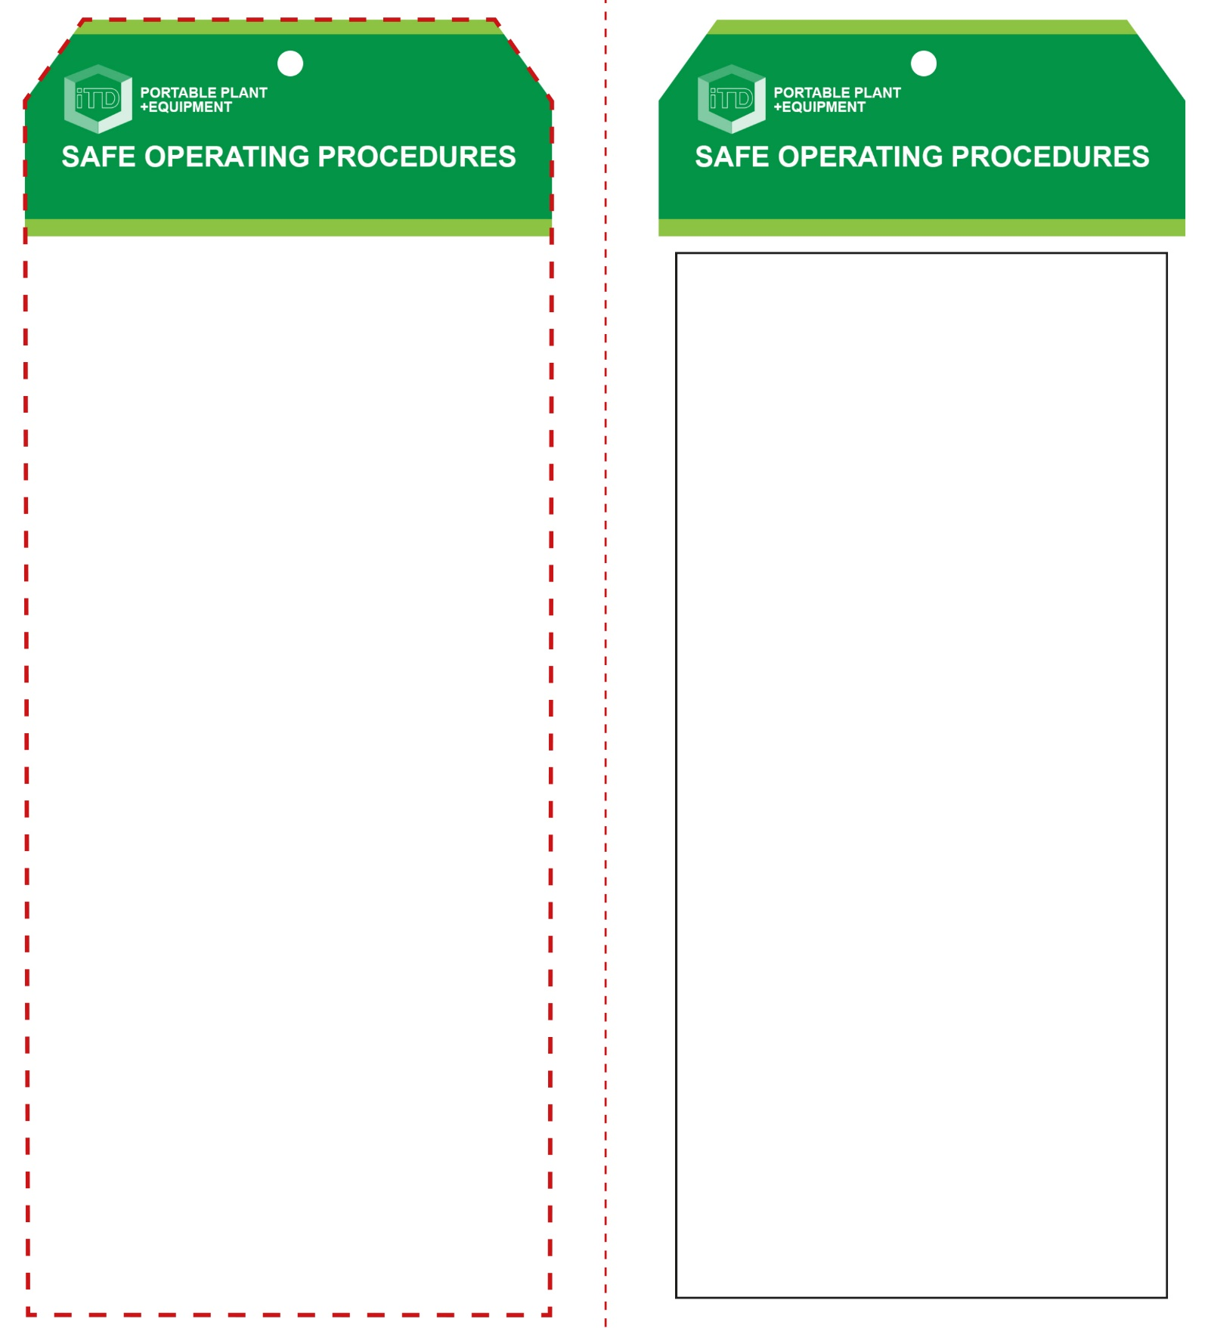

**OPERATIONAL SAFETY CHECK**

|  |
| --- |
| **Never operate a faulty electrical power tool. Report it to your teacher.** |
| 1. Examine the material to be cut for splits, loose knots. 2. Check the blade runs ‘true’ and does not wobble. 3. Ensure the workpiece is secure and well-supported. 4. Do not plug in until all adjustments have been made. 5. Ensure the power cord is well clear of the blade. 6. Check the underside of the cut to ensure that the blade will not cause any damage or be obstructed. 7. Allow the saw to reach full speed before starting. 8. Always saw at a moderate rate. Do not apply excessive force to the material being cut. 9. Keep hands away from the cutting operation. 10. Take care when cutting curves to ensure that the blade does not twist or bind. If the blade breaks, stop sawing immediately. Switch the machine off and report it to your teacher. 11. If the blade binds, release the switch immediately – free the blade and inspect for damage. 12. Ensure that off-cuts will not cause binding, or fall on your feet. 13. On completion, wait for the blade to stop moving before resting the saw on its side, protecting the blade. |
| **Ensure the blade runs ‘true’ and does not wobble.** |
| **HOUSEKEEPING**   1. After use, return the battery for recharging. 2. Leave the work bench and machine clean and tidy.   **POTENTIAL HAZARDS AND RISKS**  ■ Moving, rotating and sharp parts ■ Electricity  ■ Dust ■ Ejected waste ■ Eye injuries ■ Burns |

**Students must read this important information before using the equipment**

|  |  |
| --- | --- |
| Has your teacher given you instruction on the safe use and operation of this equipment? | |
|  | |
| Has your teacher given permission  for you to use this equipment? | |
|  | Approved safety glasses *must* be worn at all times in all ITD workspaces. |
|  | Appropriate protective footwear with substantial uppers *must* be worn in all ITD workspaces. |
|  | Contain or restrain long and loose hair and remove exposed rings or jewellery. |
|  | A suitable workshop apron or close fitting protective clothing must be worn. |
|  | Hearing protection should be worn when noise levels are excessive. |
| **PRE-OPERATIONAL SAFETY CHECKS**   1. Ensure this power tool has a suitable safe work area. 2. Ensure the blade is intact and suits the material to be cut. 3. Ensure blade guarding is in place (if applicable). 4. Examine the power lead and plug for obvious damage. | |

**Reciprocating Saw**

**Reciprocating Saw**

**Front Reverse**

**Assembly instructions:**

1. Carefully fold this page in half vertically down the centre line
2. This should align ‘front’ and ‘reverse’ sides, then glue the halves back to back
3. Cut out the ‘tag’ shape along the RED dotted outlines indicated on the ‘front’ side
4. Laminate and trim to size with a clear 2mm border
5. Securely fasten an 8mm (ID) brass eyelet and washer where indicated.