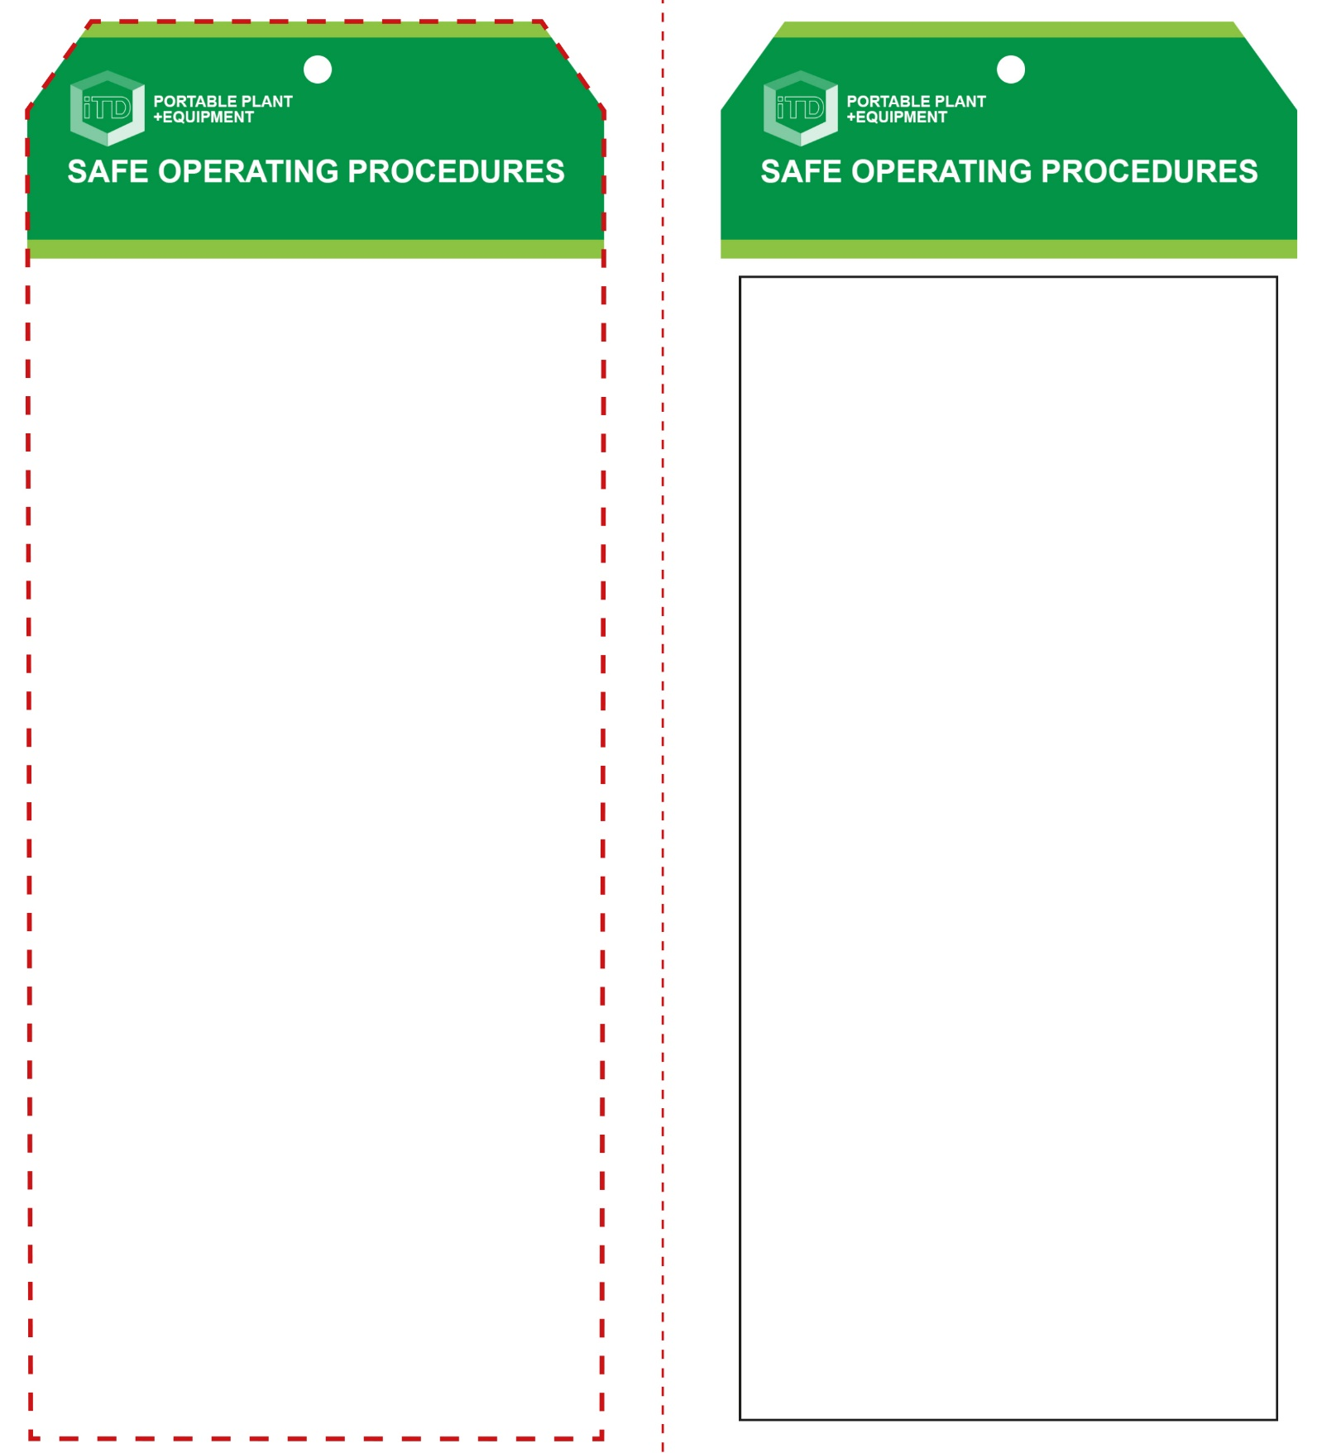

**Students must read this important information before using the equipment**

|  |  |
| --- | --- |
| Has your teacher given you instruction on the safe use and operation of this equipment? | |
|  | |
| Has your teacher given permission  for you to use this equipment? | |
|  | Approved safety glasses *must* be worn at all times in all ITD workspaces. |
|  | Appropriate protective footwear with substantial uppers *must* be worn in all ITD workspaces. |
|  | A dust mask *should* be worn when excessive airborne dust or fumes are created. |
|  | Long and loose hair *must* be contained or restrained for some operations. |
|  | A suitable workshop apron or close fitting protective clothing must be worn. |
|  | Rings and jewellery *must not* be worn when using this portable power tool. |
| **PRE-OPERATIONAL SAFETY CHECKS**   1. Ensure the power tool has a suitable safe work area 2. Examine the lead and machine for obvious damage. 3. Check that the blade guard is securely fixed in place. 4. Check that the blade teeth point downward. | |

**OPERATIONAL SAFETY CHECK**

|  |
| --- |
| **Never operate a faulty electrical power tool. Report it to your teacher.** |
| 1. Do not plug in until all adjustments have been made and the blade has been tightened. 2. Check that the saw is stable and on an even surface. 3. Always fit the blade with the teeth pointing downward. 4. For very small work pieces, do not hold by hand. Use a jig or push stick to avoid mishaps. 5. For other larger work pieces, hold the work piece flat on the table with both hands. 6. Keep fingers clear and never in line with the blade. 7. Maintain complete control and feed work slowly. 8. Do not apply excessive force – this could cause the blade to break. 9. Avoid prolonged use. This could overheat the blade and the motor. 10. A broken blade, ejected chips of wood and fine dust can all be thrown into the eyes. 11. Many species of exotic timbers create a dust that can be toxic – in these circumstances, wear a dust mask. 12. Use the flexible blower tube, if fitted, to safely clear your cutting line of dust. 13. Turn off and wait until the blade completely stops before removing scrap material or making adjustments. |
| **Use a V-block when cutting rounded stock** |
| **HOUSEKEEPING**   1. Ensure all switches, guards and fittings are cleaned. 2. Leave the work area in a safe, clean and tidy condition.   **POTENTIAL HAZARDS AND RISKS**  ■ Oscillating sharp blades ■ Electricity  ■ Pinch and squash ■ Eye injuries  ■ Dust and fumes |

**Scroll Saw**

**Scroll Saw**

**Front Reverse**

**Assembly instructions:**

1. Carefully fold this page in half vertically down the centre line
2. This should align ‘front’ and ‘reverse’ sides, then glue the halves back to back
3. Cut out the ‘tag’ shape along the RED dotted outlines indicated on the ‘front’ side
4. Laminate and trim to size with a clear 2mm border
5. Securely fasten an 8mm (ID) brass eyelet and washer where indicated.