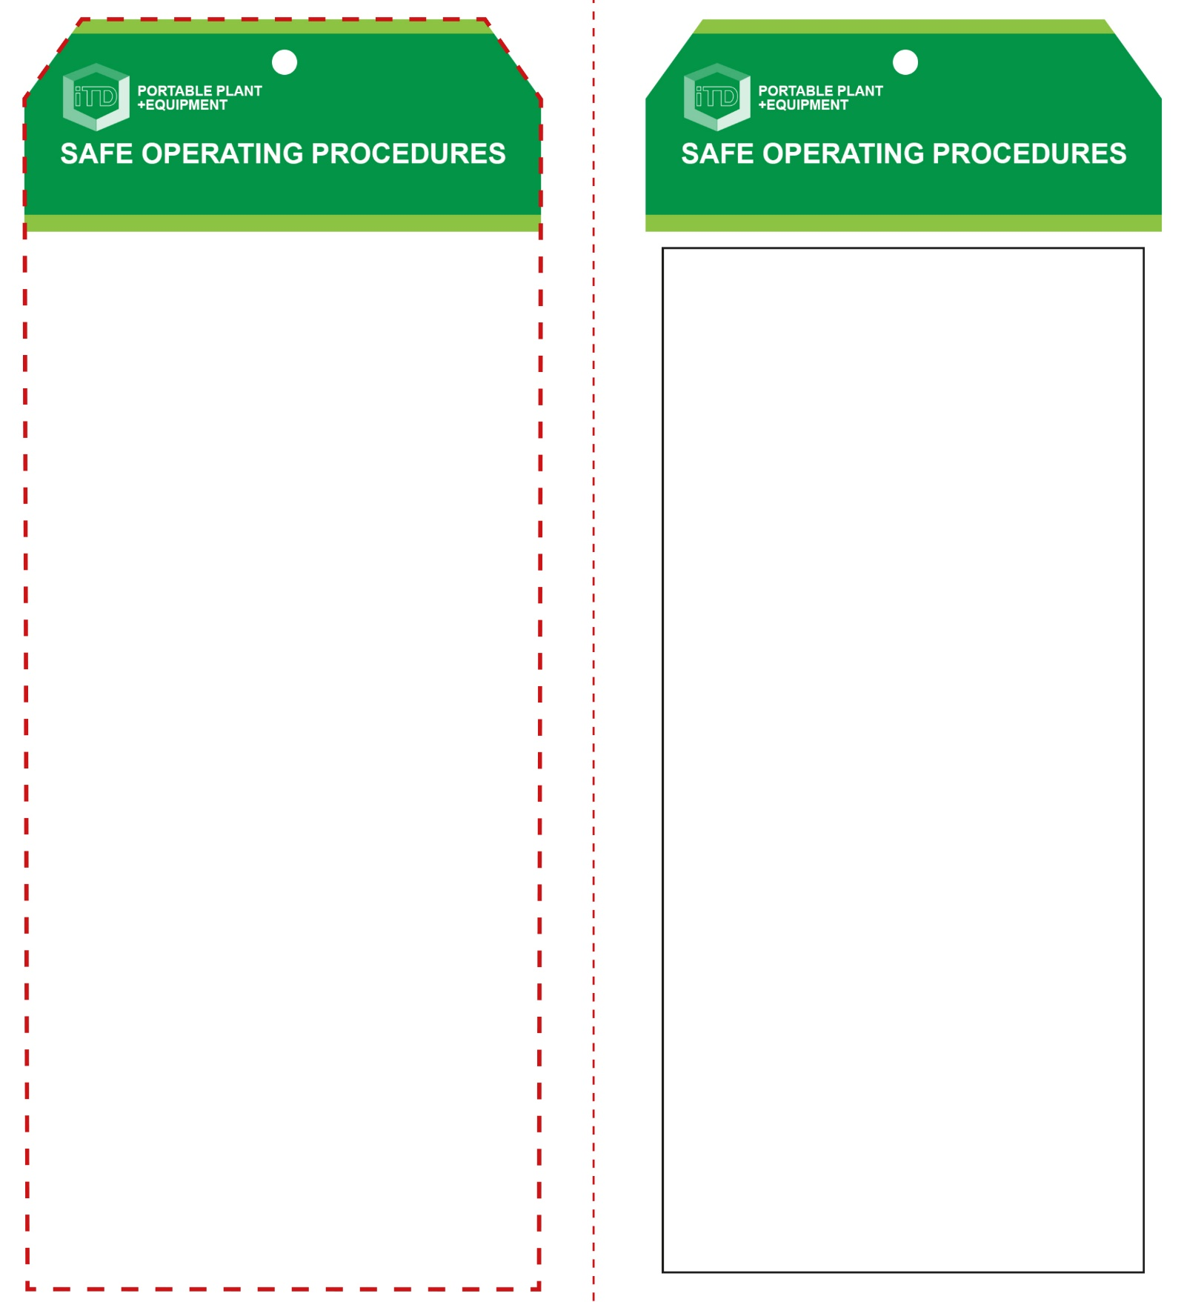

**Students must read this important information before using the equipment**

|  |  |
| --- | --- |
| Has your teacher given you instruction on the safe use and operation of this equipment? | |
|  | |
| Has your teacher given permission  for you to use this equipment? | |
|  | Approved safety glasses *must* be worn at all times in all ITD workspaces. |
|  | Appropriate protective footwear with substantial uppers *must* be worn in all ITD workspaces. |
|  | Prevent fumes from breathing zone of operator or use a suitable P2 or P3 filter mask. |
|  | A suitable workshop apron and cotton gloves are advisable. |
| **PRE-OPERATIONAL SAFETY CHECKS**   1. Examine the power lead and machine for damage. 2. Ensure that the cord does not create a slip/trip hazard. 3. Ensure the workspace is well ventilated to prevent fumes in the breathing zone e.g. use in open area with cross ventilation or with fume extraction system. 4. Check condition of soldering tip. Replace if damaged. 5. Ensure tip is ‘tinned’ and free from waste build-up. Once the tip has warmed-up, wipe on a damp sponge to clean it. 6. Leave the soldering iron in the stand when warming up. 7. Never leave a soldering iron unattended when turned on or still hot. Leave unplugged when not required. | |

**OPERATIONAL SAFETY CHECK**

|  |
| --- |
| **Never operate a faulty electrical power tool. Report it to your teacher.** |
| 1. Do not plug in and turn on until the tip element has been checked, or replaced and tightened. 2. Never touch the soldering tip. Keep your fingers clear. 3. Always wear safety glasses. Smoke and hot embers can often result when soft soldering. 4. Avoid positioning your head directly over the soldering process. Soldering often creates fumes that can be toxic. 5. Avoid prolonged use. This could overheat the tip element causing it to fail or oxidise. 6. Always allow the soldering iron to reach the desired temperature. This can take several minutes. 7. Ensure electrical cords are well clear of the soldering process. Do not touch electrical cords with the tip. 8. Wash your hands after using solder – many soft solders contain toxic lead products. 9. Never leave the machine unattended when still switched ON or when switched OFF but still hot. 10. Turn off and wait until the tip element has completely cooled before storing the machine away correctly. |
| **NEVER flick the iron to remove excess solder** |
| **HOUSEKEEPING**   1. Switch off, unplug and allow to cool down before storing. 2. Leave the work area in a safe, clean and tidy condition.   **POTENTIAL HAZARDS AND RISKS**  ■ Hot element, surfaces ■ Electricity  ■ Burns ■ Eye injuries  ■ Toxic fumes ■ Trip and slip  ■ Fire |

**Soldering Iron**

**Soldering Iron**

**Front Reverse**

**Assembly instructions:**

1. Carefully fold this page in half vertically down the centre line
2. This should align ‘front’ and ‘reverse’ sides, then glue the halves back to back
3. Cut out the ‘tag’ shape along the RED dotted outlines indicated on the ‘front’ side
4. Laminate and trim to size with a clear 2mm border
5. Securely fasten an 8mm (ID) brass eyelet and washer where indicated.