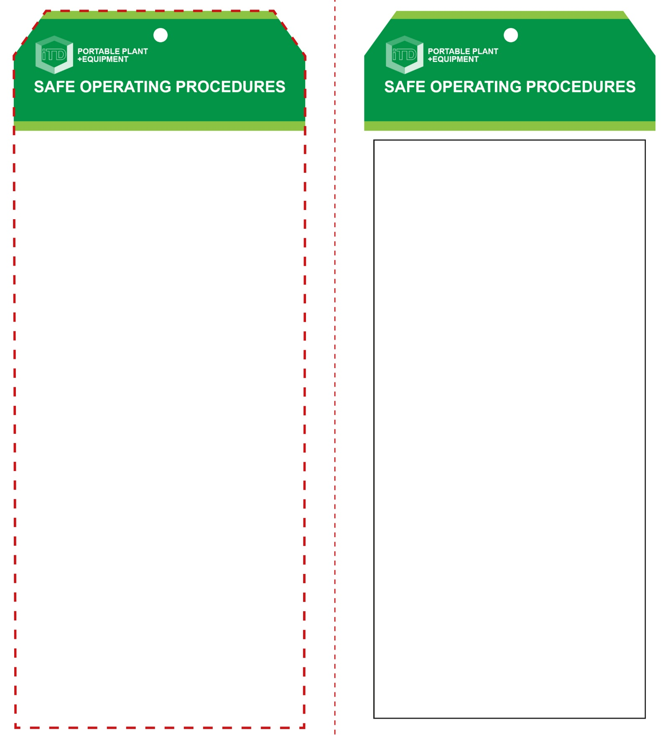

**Students must read this important information before using the equipment**

|  |  |
| --- | --- |
| Has your teacher given you instruction on the safe use and operation of this equipment? | |
|  | |
| Has your teacher given permission  for you to use this equipment? | |
|  | Approved safety glasses and face shield *must* be worn at all times in all ITD workspaces. |
|  | Appropriate protective steel-toed work boots *must* be worn in all ITD workspaces. |
|  | Hearing protection *(Class 5 – SLC80 >26 dB)* must be worn when noise levels are identified as excessive. |
|  | Long and loose hair must be contained or restrained. |
| mand154_safety_overalls_must_ | Sturdy work wear or overalls are recommended. |
|  | Rings and jewellery should not be worn when using this portable power tool. |
| **PRE-OPERATIONAL SAFETY CHECKS**   1. Check that the actuation muzzle has been serviced and is in good condition for the safe operation of the tool. 2. Establish an appropriate exclusion zone with barricading and appropriate signing. 3. Be aware of departmental safety alerts with this equipment (check with your teacher). 4. Familiarise yourself with the type of nail gun you are about to operate and how it is powered i.e. compressed air, electricity, explosive gas, etc. 5. If you are using a pneumatic nail gun, inspect the condition of the air compressor. 6. Inspect the equipment for any obvious mechanical defects. | |

**OPERATIONAL SAFETY CHECK**

|  |
| --- |
| **Never operate a faulty electrical power tool. Report it to your teacher.** |
| 1. Stapling will be more successful if you have a firm, stationary and non-cushioned surface underneath the work piece. 2. Use clamps to secure and support the work piece to a steady platform or workbench. 3. Be very aware of others who may be working nearby. 4. Keep your finger off the trigger when not firing staples or when carrying around. The centre of gravity at the trigger makes it easy to accidentally fire the staple gun. 5. NEVER use a staple gun if the ‘safety’ or trigger does not operate properly. Report this to your teacher. 6. Be careful to always keep your hands and feet away from the nose of the staple gun when firing staples. 7. Fire staples into appropriate surfaces ONLY. Do not fire staples on top of another – they may ricochet. 8. Never rest the staple gun against any body part, or try to climb a ladder with the staple gun cradled against your body. Never point a staple gun at anyone. 9. Empty out unused staples before clearing a staple jam. 10. Never leave the staple gun unattended when it is still plugged into the AC power source. |
| **NEVER use a bump-fire staple gun in a school workshop environment** |
| **HOUSEKEEPING**   1. Return this tool to the appropriate storage cupboard. 2. Leave the work area in a safe, clean and tidy condition.   **POTENTIAL HAZARDS AND RISKS**  ■ Sharp projectiles ■ Electricity  ■ Pinch and squash ■ Eye injuries  ■ Sparking, fire and explosion |

**FORBIDDEN**

■ Students must NEVER operate a stapling gun of any model or operational mode when working on ladders, high platforms, or in confined spaces.

**Staple Gun**

**Staple Gun**

**Front Reverse**

**Assembly instructions:**

1. Carefully fold this page in half vertically down the centre line
2. This should align ‘front’ and ‘reverse’ sides, then glue the halves back to back
3. Cut out the ‘tag’ shape along the RED dotted outlines indicated on the ‘front’ side
4. Laminate and trim to size with a clear 2mm border
5. Securely fasten an 8mm (ID) brass eyelet and washer where indicated.