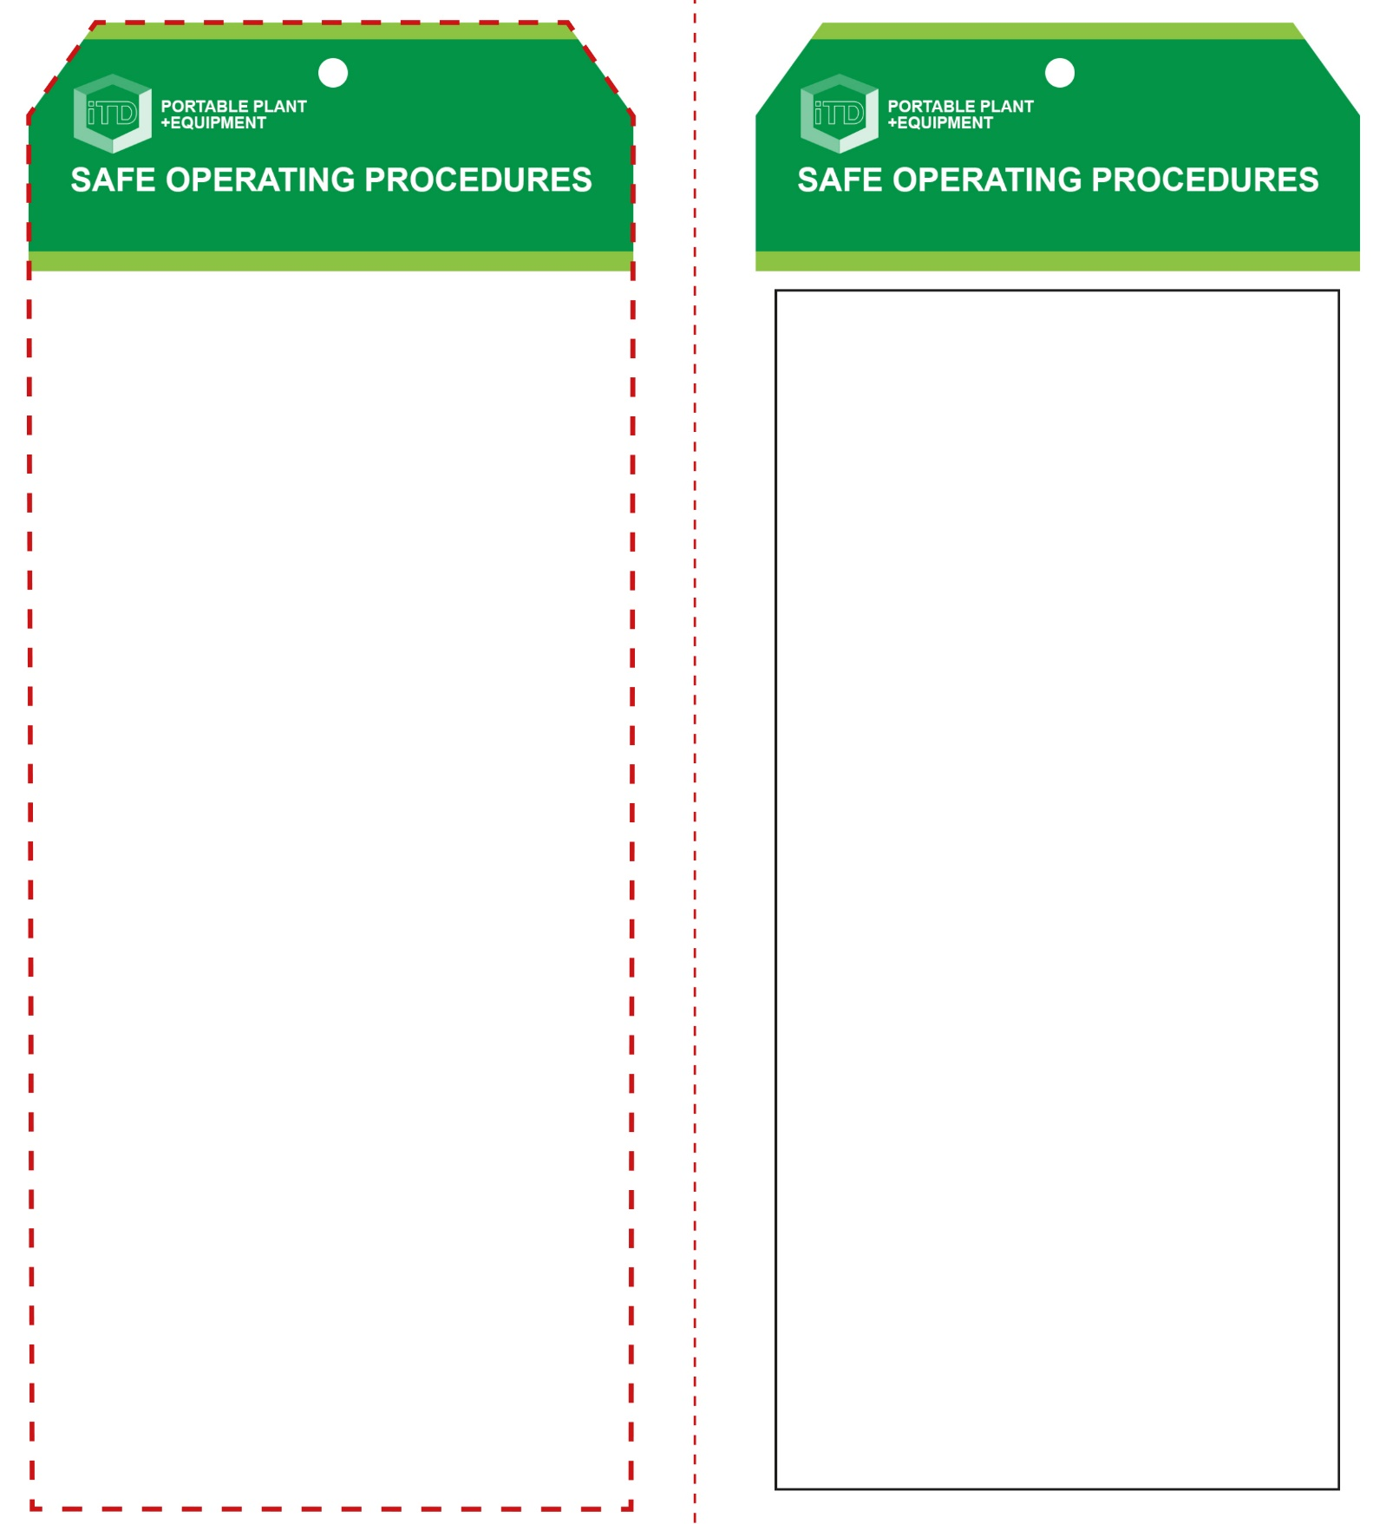

**Students must read this important information before using the equipment**

|  |  |
| --- | --- |
| Has your teacher given you instruction on the safe use and operation of this equipment? | |
|  | |
| Has your teacher given permission  for you to use this equipment? | |
|  | Approved safety glasses *must* be worn at all times in all ITD workspaces. |
|  | Appropriate protective footwear with substantial uppers *must* be worn in all ITD workspaces. |
|  | Protective cotton gloves *must* be worn when using this equipment. |
|  | A suitable workshop apron is encouraged. |
| **PRE-OPERATIONAL SAFETY CHECKS**   1. Examine the power lead and heater for obvious damage. 2. Check there is no foreign matter in the element channel. 3. Ensure that the adjustable rests are in place, that they are correctly spaced to suit the thickness of material to be bent, and that they provide the desired heating zone for the bending profile. 4. Only use the strip heater for approved plastics e.g. acrylic. 5. Ensure that the cord does not create a slip/trip hazard. 6. Ensure the workspace is well ventilated. | |

**OPERATIONAL SAFETY CHECK**

|  |
| --- |
| **Never operate a faulty electrical power tool. Report it to your teacher.** |
| 1. Turn on to pre-heat the heater element for ten minutes prior to use. 2. Always wear safety glasses and cotton gloves that are resistant to high temperatures to protect against burns. 3. Regularly check the heating element for build-up of dust or waste such as sawdust. Invert heater carefully and allow foreign waste to fall away (when unplugged). 4. Before heating and bending any thermoplastic material, remove all protective paper from both sides. 5. Accurately mark the desired position for the bend with a felt marker or china-graph pencil so marks can be removed later. 6. Support the material to be heated. Use the outrigger support where fitted or other appropriate supports. 7. A thermoplastic work piece with a material thickness >5mm may need to be turned over after one minute to ensure even heating and to improve the desired profile. 8. Turn off and wait until the element has completely cooled before storing the strip heater away correctly. 9. Children often show curiosity towards the operations of the strip heater. Never leave the strip heater unattended when still switched ON or when still HOT. 10. Leave the strip heater unplugged when not in use. |
| **Paper/cloth must NOT touch the HOT element** |
| **HOUSEKEEPING**   1. Switch off, unplug and allow to cool down before storing. 2. Leave the work area in a safe, clean and tidy condition.   **POTENTIAL HAZARDS AND RISKS**  ■ Hot element and surfaces ■ Electricity  ■ Burns ■ Eye injuries  ■ Toxic fumes ■ Trip and slip  ■ Fire |

**Strip Heater**

**Strip Heater**

**Front Reverse**

**Assembly instructions:**

1. Carefully fold this page in half vertically down the centre line
2. This should align ‘front’ and ‘reverse’ sides, then glue the halves back to back
3. Cut out the ‘tag’ shape along the RED dotted outlines indicated on the ‘front’ side
4. Laminate and trim to size with a clear 2mm border
5. Securely fasten an 8mm (ID) brass eyelet and washer where indicated.