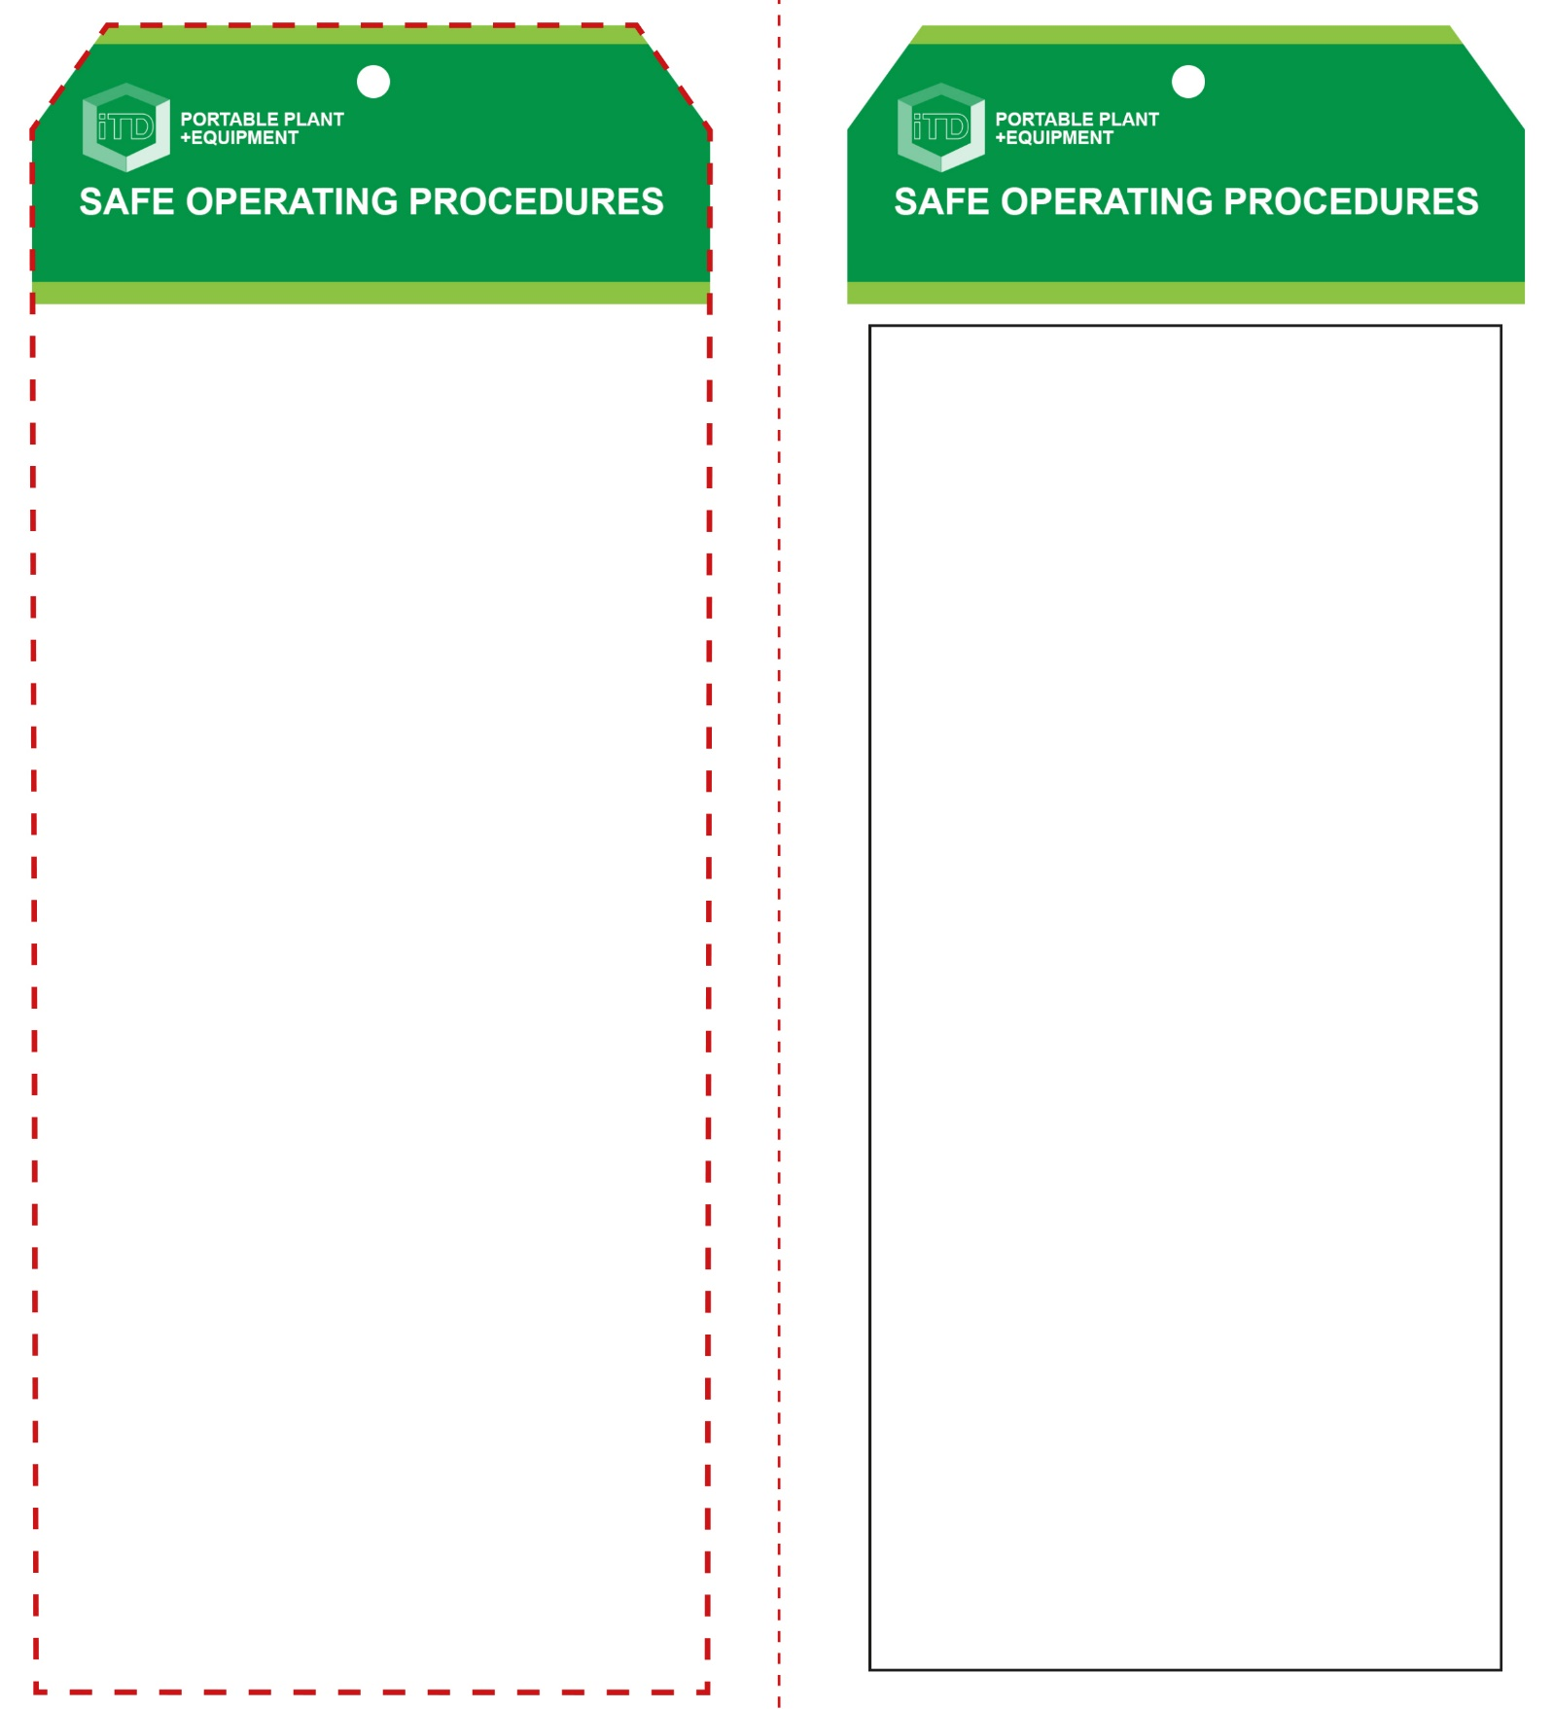

**Students must read this important information before using the equipment**

|  |  |
| --- | --- |
| Has your teacher given you instruction on the safe use and operation of this equipment? | |
|  | |
| Has your teacher given permission  for you to use this equipment? | |
|  | Approved safety glasses *must* be worn at all times in all ITD workspaces. |
|  | Appropriate protective footwear with substantial uppers must be worn. |
|  | Hearing protection *(Class 5 – SLC80 >26 dB)* must be worn at all times. |
| Description: Hand Protection circle | Wear heavy duty work gloves to absorb vibration. |
| mand154_safety_overalls_must_ | Sturdy, long work wear or overalls are recommended. |
|  | Remove all rings and exposed jewellery. |
| **PRE-OPERATIONAL SAFETY CHECKS**   1. Ensure your work area is well ventilated and not interfering with other students/activities. 2. Visually check the condition of the trolley jack for damage. 3. Check that the jack is labelled with a sticker indicating that it meets Australian standards – AS/NZS 2615. 4. Familiarise yourself with the safe operation of this pneumatic trolley jack i.e. ensure you can safely raise and lower the jack. 5. Ensure the floor surface you are rolling the jack on is hard, level and unobstructed. 6. Familiarise yourself with the safe working limit of the trolley jack. | |

**OPERATIONAL SAFETY CHECK**

|  |
| --- |
| **Never operate a faulty electrical power tool. Report it to your teacher.** |
| 1. Ensure raised vehicles are supported with vehicle support stands. 2. No person should get bodily under a vehicle supported by a hydraulic trolley jack. 3. Read the vehicle manufacturer’s *owner’s manual* before lifting the vehicle. 4. The wheels of the vehicle remaining on the ground should be chocked before the lifting operation proceeds. 5. No person should be in the vehicle during the lifting process. 6. The load should be centrally located on the head cap for the lift process. 7. The trolley jack should be used to raise and lower only. 8. Ensure that lubrication or other maintenance of the trolley jack is carried out according to the manufacturer’s instructions. |
| **DO NOT exceed the safe ‘working load’ of this trolley jack.** |
| **HOUSEKEEPING**   1. Ensure trolley wheels and jack handle are well maintained. 2. Leave the work area in a safe, clean and tidy condition.   **POTENTIAL HAZARDS AND RISKS**  ■ Hydraulic fluid under pressure  ■ Slips, trips and falls  ■ Heavy loads  ■ Manual handling – equipment and materials. |

**Trolley Jack**

**Trolley Jack**

**Front Reverse**

**Assembly instructions:**

1. Carefully fold this page in half vertically down the centre line
2. This should align ‘front’ and ‘reverse’ sides, then glue the halves back to back
3. Cut out the ‘tag’ shape along the RED dotted outlines indicated on the ‘front’ side
4. Laminate and trim to size with a clear 2mm border
5. Securely fasten an 8mm (ID) brass eyelet and washer where indicated.