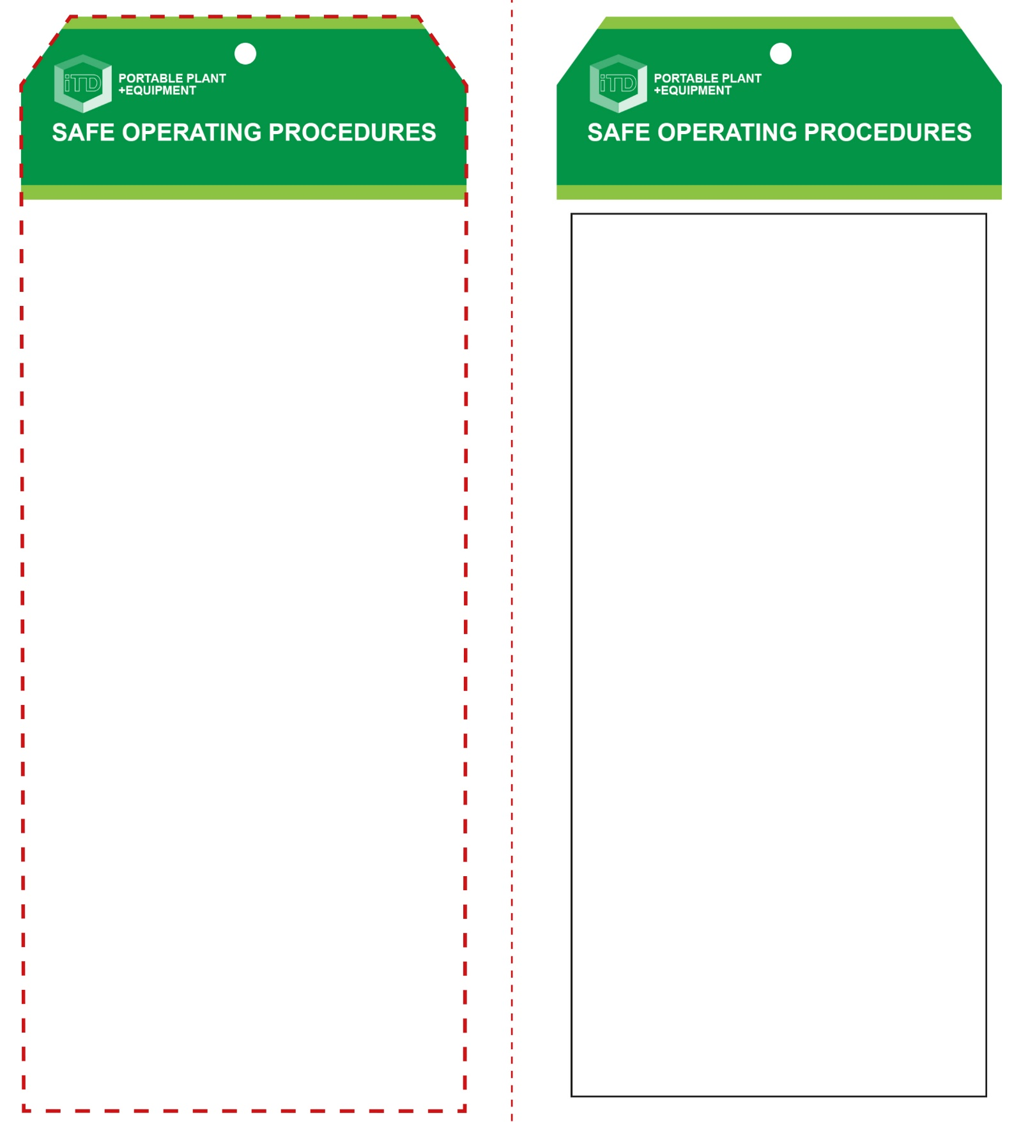

**Vacuum Former**

**Students must read this important information before using the equipment**

|  |  |
| --- | --- |
| Has your teacher given you instruction on the safe use and operation of this equipment? | |
|  | |
| Has your teacher given permission  for you to use this equipment? | |
|  | Approved safety glasses *must* be worn at all times in all ITD workspaces. |
|  | Appropriate protective footwear with substantial uppers *must* be worn in all ITD workspaces. |
|  | A suitable protective workshop apron is encouraged. |
| **PRE-OPERATIONAL SAFETY CHECKS**   1. Ensure this machine has a suitable safe work area. 2. Ensure all safety guards are serviceable and in place. 3. Check the general condition of the forming table. 4. Ensure that all clamping arrangements are adequate, secure and correctly adjusted. 5. Before switching on the power, ensure all controls are in their correct positions. 6. Have your teacher check all adjustments i.e. heat settings and air pressures, before attempting to vacuum form an article. 7. Ensure no other students are in the surrounding area. | |

**OPERATIONAL SAFETY CHECK**

|  |
| --- |
| **Never operate a faulty electrical power tool. Report it to your teacher.** |
| 1. Take particular care when vacuum forming very hot thermoplastic materials. High air pressures are also used in this forming process. 2. Familiarise yourself with all machine operations and controls. If in doubt, ask for assistance. 3. Pre-heat the vacuum former to be sure the machine has reached the required temperature. Always handle heated plastic material with suitable cotton gloves. 4. Keep hands clear of the clamping area, the platen and the heating element while the machine is operating. 5. Take care to ensure that the heating element is moved away from the plastics material before the vacuum forming process begins. 6. Ensure that the air pressure vacuum is released to zero before releasing the clamping arrangements. 7. Do not use the compressed air to cool down an article or to clean down the work area. |
| **Caution – high air pressures and heated plastics** |
| **HOUSEKEEPING**   1. Ensure all switches, guards and surfaces are cleaned. 2. Leave the work area in a safe, clean and tidy condition.   **POTENTIAL HAZARDS AND RISKS**  ■ Hot machine parts ■ Electricity  ■ Burns ■ Eye injuries  ■ Compressed air |

**Vacuum Former**

**Front Reverse**

**Assembly instructions:**

1. Carefully fold this page in half vertically down the centre line
2. This should align ‘front’ and ‘reverse’ sides, then glue the halves back to back
3. Cut out the ‘tag’ shape along the RED dotted outlines indicated on the ‘front’ side
4. Laminate and trim to size with a clear 2mm border
5. Securely fasten an 8mm (ID) brass eyelet and washer where indicated.