Computer workstation setup
self-assessment
This document is designed to help you set up your computer workstation in the best way possible according to best practice guidelines. Sitting comfortably may lower stress and reduce the potential for injuries caused by repetitive computer work and awkward postures.
Note that the advice provided is of a generic nature and is not prescriptive. The most important thing is that you are comfortable at work. If you are experiencing discomfort, don’t persevere and don’t be afraid to make changes to your setup. If you ‘hot desk’ (share workstations), always adjust your workstation to suit at the start of the work day.
Regardless of how well your computer and desk is set up, you should move often! The Heart Foundation suggests:
- Taking regular breaks from your computer. Get up and take a break every 30 minutes.
- Rotating standing tasks and sitting tasks across your shift.

Some examples of how you can stay active at work and cut down your sitting time include:
- Standing often – even for a few seconds at a time.
- Have lunch and morning and afternoon tea away from your desk.
- Stand to greet visitors.
- Stand to retrieve folders and files off shelves in your workstation.
- Stand when you’re on the phone (a headset or speaker phone can make it easier).
- Instead of phoning or emailing a colleague, get up and go talk to them.
- Use the stairs instead of the lift.
- Have standing or walking meetings. If you have to sit in long meetings, take standing breaks.
- Stand at the back of the room during talks or presentations.
- Drink more water. Walk to the water cooler to refill your glass or water bottle.
- Move your bin away from your desk so you have to get up to use it.
- Vary your tasks through the day so that you change your posture and use different muscles e.g. do some filing after a period of typing.
- Stretch regularly (refer to the department’s ‘Daily stretches for staff’ poster).
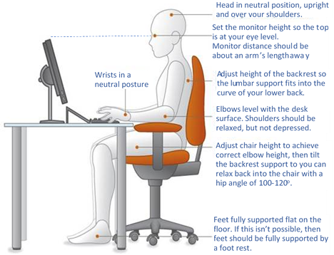

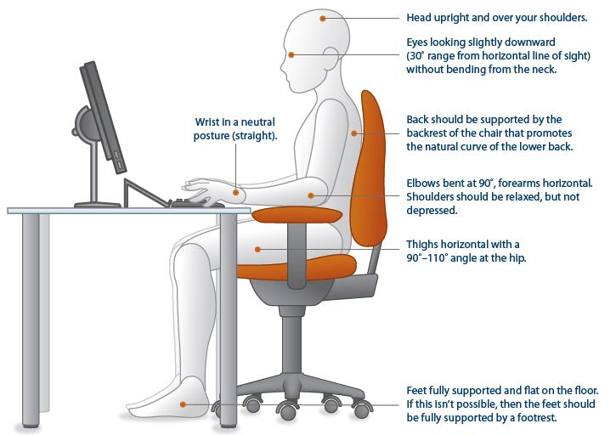
It is not necessary to purchase a sit stand workstation to improve your posture and decrease risks of sedentary work. Getting up from your desk regularly can be just as effective to create a change in posture and burn calories. You can try to get in to the habit of sitting less by setting reminders on your phone or computer.

Postural comfort
Study the diagram opposite showing good posture in sitting. Setting up your workstation to imitate this will go a long way towards minimising your risk of discomfort and injury at your desk.

Self-assessment checklist
- Complete the following self-assessment preferably with a team member or your supervisor/manager. They can see your posture better than you can. Remember, the aim is to set yourself up so that you achieve a good natural sitting posture but you must regularly move for your health!
- Read each section carefully and tick yes, no or not applicable to each question. For additional advice, refer to the office and computer workstation resources in the Hazard and risks: Manual tasks and ergonomics menu.
- Be sure to return the completed form to your supervisor/manager and discuss any actions or requirements with them.

1 | Your work surface/ desk  It is important to position your computer appropriately to optimise the space available whilst ensuring good postures are maintained. To begin with, your desk should be smooth and flat with your keyboard and mouse on the same level. |  |  |  |  |  | Yes | No | N/A |  | Suggested Actions / Notes
Is your desk height adjustable? If yes, then sit back in your chair with your feet flat on the floor, your knees slightly lower than your hips and your elbows by the side of your body bent like an L-shape. Adjust the desk height so that your forearms rest on it parallel to the floor (see diagram on page 1). |  |  |  |  |  |  |  |  |  |  | - Adjust desk height accordingly  - If non-adjustable, adjust your chair according to the guidelines in section 2 “Your chair”
Are you sitting facing the desk straight on with sufficient forearm support?  Aim to sit with your stomach parallel to the edge of the desk to avoid twisting your back and neck. Try to get close enough so that you have enough desk space to rest your wrists/forearms on between spells of typing (roughly 10 -15cm from the edge of the desk and your keyboard). If your desk is scalloped shaped (curved cut-out), sit so that your forearms have equal support on either side. |  |  |  |  |  |  |  |  |  |  | - Adjust orientation of self /desk items accordingly
Is there sufficient room under your desk for you to comfortably stretch your legs?  Ensure there are no obstructions under your desk making you straddle or causing you to sit with both legs to one side therefore twisting your body. Avoid crossing your legs. |  |  |  |  |  |  |  |  |  |  | - Remove obstacles from under your desk  - Move your setup to somewhere without obstruction where possible
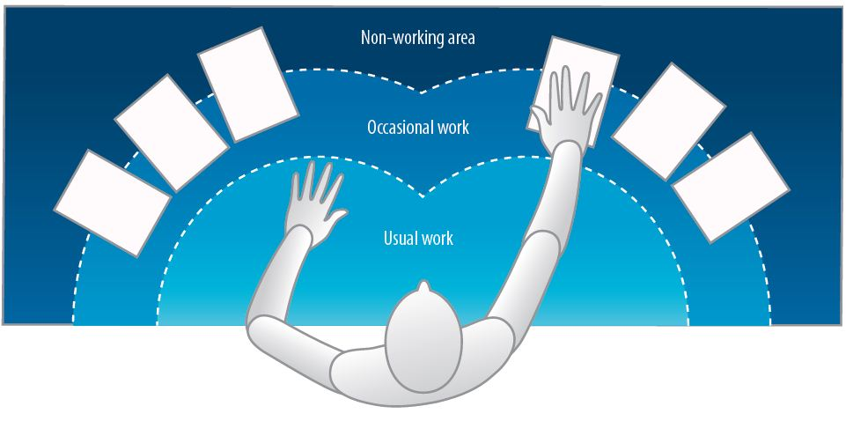  Are frequently used items in the “usual work” zone and occasionally used items in the “occasional work” zone (see diagram below)? Determine what items are used ‘occasionally’ or ‘usually’ on your desk e.g. your phone, sticky notes, stapler, water etc.  to avoid overreaching. |  |  |  |  |  |  |  |  |  |  | - Re-arrange workstation
2 | Your Chair  A comfortable chair that is in full working order is pivotal to a good setup. If there are levers and knobs on your chair (usually underneath), don’t be afraid to use them! To be effective, the chair needs to be adjusted to suit you and allow you to maintain the natural “S-curve” of the back. If you find faults such as the backrest keeps slipping down, you must report it to your supervisor/manager. |  |  |  |  |  | Yes | No | N/A |  | Suggested Actions / Notes
Can the height of your chair be adjusted?  Adjust the height of your chair so that when your shoulders are relaxed (elbows by your sides), your forearms rest horizontally on the desk with your elbows bent like an L-shape and your knees are slightly lower than your hips (refer to diagram on page 1). |  |  |  |  |  |  |  |  |  |  | - No adjustment option to suit? Obtain an alternative chair with adjustable height – check out other chairs in your work area to identify suitable options. Remember to trial first before purchase from a supplier
Are your feet fully supported by the floor when you are seated?  After you’ve adjusted the chair height as recommended above, check whether your feet are still flat on the floor. |  |  |  |  |  |  |  |  |  |  | - Feet not flat after chair adjustment? Obtain and use a footrest
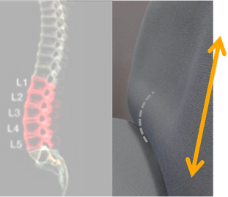  Is the height of your chair’s backrest adjustable?  Run your hand down the backrest until you feel the lumbar support (protruding part). You should be able to adjust the height of the backrest so that this lumbar support fits snuggly into the natural curve of your lower back allowing you to maintain the “S-curve”. Secure in place when satisfied. |  |  |  |  |  |  |  |  |  |  | - No adjustment option to suit you/back rest no longer adjustable? Obtain an alternative chair with adjustable backrest height - see notes above about trials  - If no/inadequate lumbar support consider a lumbar roll
Is your back at a comfortable angle with adequate support?  Sit with your bottom as far back in the chair and adjust the backrest angle if needed to achieve the desired 100° – 120° angle at the hip. Ensure your back rests comfortably against the back of the chair for adequate support. |  |  |  |  |  |  |  |  |  |  | - Inadequate support? Consider a chair with a larger/alternative backrest
Is there a 2-3 finger width gap between the back of your knees and the seat edge?  Too little support under the thighs (i.e. the gap is greater than 2-3 fingers width) will cause discomfort and too much pressure (i.e. the chair is pressing on the back of your knee) may affect circulation. |  |  |  |  |  |  |  |  |  |  | - Seat pan too deep - consider a back support to reduce depth or chair with shallow seat pan. Too shallow- Obtain an alternative chair with deeper seat pan
Do your armrests allow you to get close to your workstation?  If the chair has armrests and you like using them make sure they are adjusted to elbow height with your shoulders relaxed. They must not prevent you from sitting close to the edge of the desk or restrict natural movements. |  |  |  |  |  |  |  |  |  |  | - Adjust armrests  - Remove armrests if impeding movement or if preferred
3 |  | Your monitor/s Sizes of monitors can vary greatly and there is a growing trend for staff to use dual monitors (or more). The positioning of your monitor/s is important for the health of your head, neck, shoulders and eyes. |  |  |  |  | Yes | No | N/A |  | Suggested Actions/Notes
Single monitor
Is your monitor positioned centrally in front of you?  If your monitor is slightly off to the left or right, it could cause neck and shoulder pain from inadvertent twisting. |  |  |  |  |  |  |  |  |  |  | - Reposition monitor
Is your monitor positioned approximately an arm’s length away? Too close or too far away may cause eye strain. This may be dependent on monitor size. |  |  |  |  |  |  |  |  |  |  | - Reposition monitor
Is your monitor height at eye level or below? upwards? Avoid a forward head posture as this puts extra strain on your muscles and may cause neck pain, headaches etc. The optimal height for you may vary if you wear glasses. |  |  |  |  |  |  |  |  |  |  | - Add or remove monitor stand  - Adjust monitor height  - Adjust monitor tilt mechanism
Is your monitor and work surface free from glare? Glare may cause eyestrain and headaches. Minimise tilting your screen to reduce potential glare or reflection. |  |  |  |  |  |  |  |  |  |  | - Adjust overhead lighting  - Cover windows  - Obtain antiglare screen/screen-cover
Dual monitors Consider if you really need more than one – there may be a greater risk for using repetitive muscle exertions for your head, neck and eyes to visually scan info.
Are your monitors of equal size and their properties (brightness, contrast, font size etc.) matched? The more closely matched the monitors, the better it is for your eyes. |  |  |  |  |  |  |  |  |  |  | - Obtain the same sized monitors  - Adjust the font size and brightness levels to match
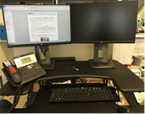  If your work involves looking equally at both monitors, are they positioned right next to each other (touching), directly in front of you and angled slightly in an arc so they are equal distances away? Use your eyes to look between screens not your neck. |  |  |  |  |  |  |  |  |  |  | - Reposition monitors
If your work involves looking at one monitor for most of the time (primary monitor), is it as close to directly in front as possible? Less important information should be at the periphery to avoid twisting the body or neck so place your second monitor to the side next to your primary monitor. |  |  |  |  |  |  |  |  |  |  | - Reposition monitors
4 | Your keyboard and mouse  Ensure you take short breaks of approximately 30-60 seconds as needed when using a keyboard and change activities to relieve fatigue and rest tired muscles. Limit use of the mouse if it causes pain or discomfort by using keyboard shortcuts. |  |  |  |  |  | Yes | No | N/A |  | Suggested Actions / Notes
Are your keyboard and mouse level on your work surface and at elbow height?  Some desks have a keyboard tray (shelf) so it’s important to ensure the mouse is on the same level as your keyboard to prevent unnecessary repetitive shoulder flexion movements. |  |  |  |  |  |  |  |  |  |  | - Rearrange workstation  - Obtain larger keyboard tray if necessary
If you rarely use the numeric keypad, is the centre of the alpha keypad in line with your midline (typically where the letter G sits)?  Sitting with the alpha keypad slightly off-centre is not uncommon and can easily be corrected. |  |  |  |  |  |  |  |  |  |  | - Move keyboard to correct position  - Consider using a keyboard without a numeric keypad
Is your keyboard flat?  Aim to keep your wrists in a neutral position and avoid bending them by keeping your keyboard flat (not propped up on its legs).  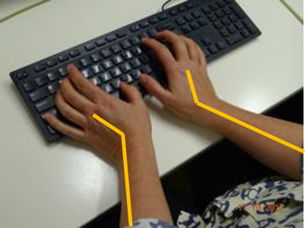  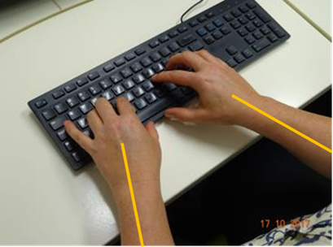  RIGHT!  WRONG! |  |  |  |  |  |  |  |  |  |  | - Adjust keyboard
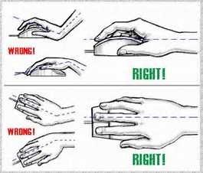  Is your mouse comfortable to use?  When using your mouse, keep your wrists straight and your upper arms relaxed. Your mouse should be positioned next to and parallel to the keyboard as much as possible. If using your mouse for long periods, consider bringing the mouse directly in front of you and pushing your keyboard back. You can always rest your dominant hand by switching to your non-dominant hand for brief periods. |  |  |  |  |  |  |  |  |  |  | - Move mouse  - Remove armrests if impeding movement or if preferred
5 | Accessories and laptops  Accessories can improve your workstation setup but it’s important to choose the most suitable option and trial items where possible. |  |  |  |  |  | Yes | No | N/A |  | Suggested Actions / Notes
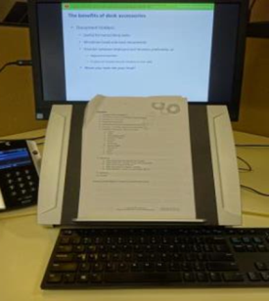  Do you often transcribe work from documents/repeatedly refer to papers whilst typing or perform reading and writing tasks?  Consider a document holder that preferably sits between the keyboard and monitor to eliminate head movement. Alternatively position one adjacent to your monitor and try using your eyes instead of moving your head to view. When performing reading or writing tasks, preferably move to a clear part of the desk in your chair to avoid twisting and use an angle board/desk slope or similar. |  |  |  |  |  |  |  |  |  |  | - Obtain a document holder  - Make space on your desk for writing tasks  - Obtain an angle board/desk slope
Are you using a headset or speakerphone if you are writing or keying while talking on the phone?  Avoid an awkward neck posture cradling the phone between your ear and shoulder by using alternative methods such as a speakerphone or headset. |  |  |  |  |  |  |  |  |  |  | - Obtain a headset if using the phone and keyboard
Laptops
Do you use a laptop at work?  If you use a laptop for extended periods of time, do not use it on your lap! An external keyboard and mouse, and a docking station with full sized monitor or a laptop stand should be used to prevent awkward postures of the neck.  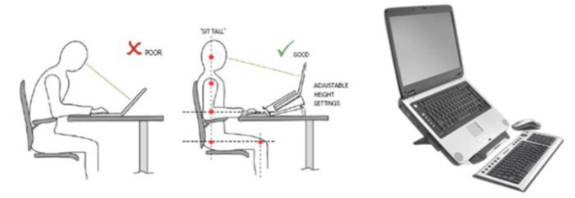 |  |  |  |  |  |  |  |  |  |  | - Obtain appropriate laptop accessories  - Refer to the department’s ‘Safe use of laptops’
6 | Computer stress  As great as computers are, they can also be frustrating especially when they go slow, applications don’t open or crash and you lose your work. Relieving computer stress can be just as important as sitting comfortably. |  |  |  |  |  | Yes | No | N/A |  | Suggested Actions / Notes
Does your computer slowdown, crash or experience lengthy boot-up times and interrupted connectivity more frequently than usual or seemingly more readily than those around you?  If your computer appears to be performing less effectively than usual and it is not an isolated incident, then it is important to get it checked out to prevent rising stress levels. If waiting for technical support to resolve the issue is frustrating, try working on something else in the interim. |  |  |  |  |  |  |  |  |  |  | - Ask for help - Use Service Centre Online (SCO) to log a request online, find self-help articles or check for current ICT outages. For urgent issues, call 1800 680 445  - Raise the issue with your supervisor/manager  - Continue to monitor system performance in consultation with your supervisor/manager  - Backup your files regularly  - Be prepared – read manuals and books on computers to understand how your systems work  - Take regular breaks from your computer. Get up and take a break every 30 minutes  - Stand often – even for a few seconds at a time  - Have lunch and morning and afternoon tea away from your desk  - Vary your tasks through the day so that you change your posture and use different muscles e.g. do some filing after a period of typing  - Stretch regularly (refer to the department’s ‘Daily stretches for staff’ poster)
PERSON COMPLETING THE ASSESSMENT
Name: |  |  |  |  | Position: |  |  | Date: |  |  |  | Signature:
SUPERVISOR/LINE MANAGER
Name: |  |  |  |  | Position: |  |  | Date: |  |  |  | Signature:
Comments: |  |  |  | E.g. New ergonomic chair approved – please follow up directly with Administration
NOTES

