BYOxLink - How to guide

Use guest Wi-Fi service to connect a visitor’s Windows device
This document explains how to connect a visitor’s Windows device to the school guest Wi-Fi network (EQGUEST). The connection is limited to the filtered internet service and will be available to use for two hours.
The school will provide you with a guest account logon.
Step 1. Connect to EQGUEST Wi-Fi network
- Select the Wi-Fi icon at the bottom right of the screen.
- Scroll the Wi-Fi networks to select EQGUEST. Select Connect.

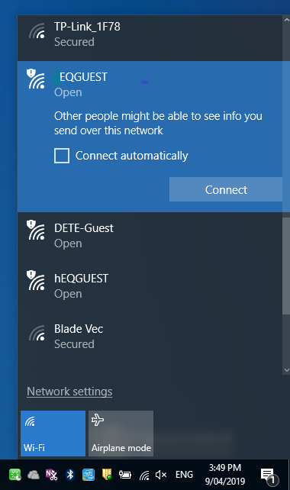
Step 1b
Step 1a

Step 2. Sign in to EQGUEST Wi-Fi network

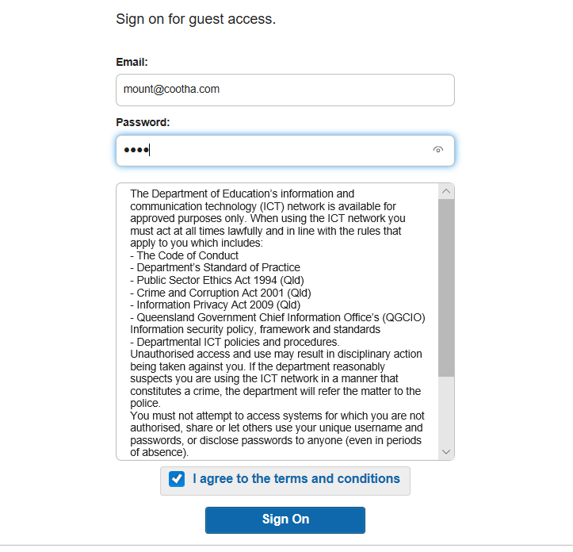
- A sign on page will be displayed.
- Enter the guest account logon credentials.
- Read and accept the Acceptable Use Policy by ticking the box.
- Select Sign On.
- You will be prompted to change the password. This must be a four digit numerical pin.
- A success screen will be displayed.

