BYOxLink - How to Guide

Use guest Wi-Fi service to connect visitor’s iOS devices

This document explains how to connect a visitor’s iOS device (iPad, iPhone) to the school guest Wi-Fi network (EQGUEST). The connection is limited to the filtered internet service and will be available to use for two hours.
The school will provide you with a guest account logon.

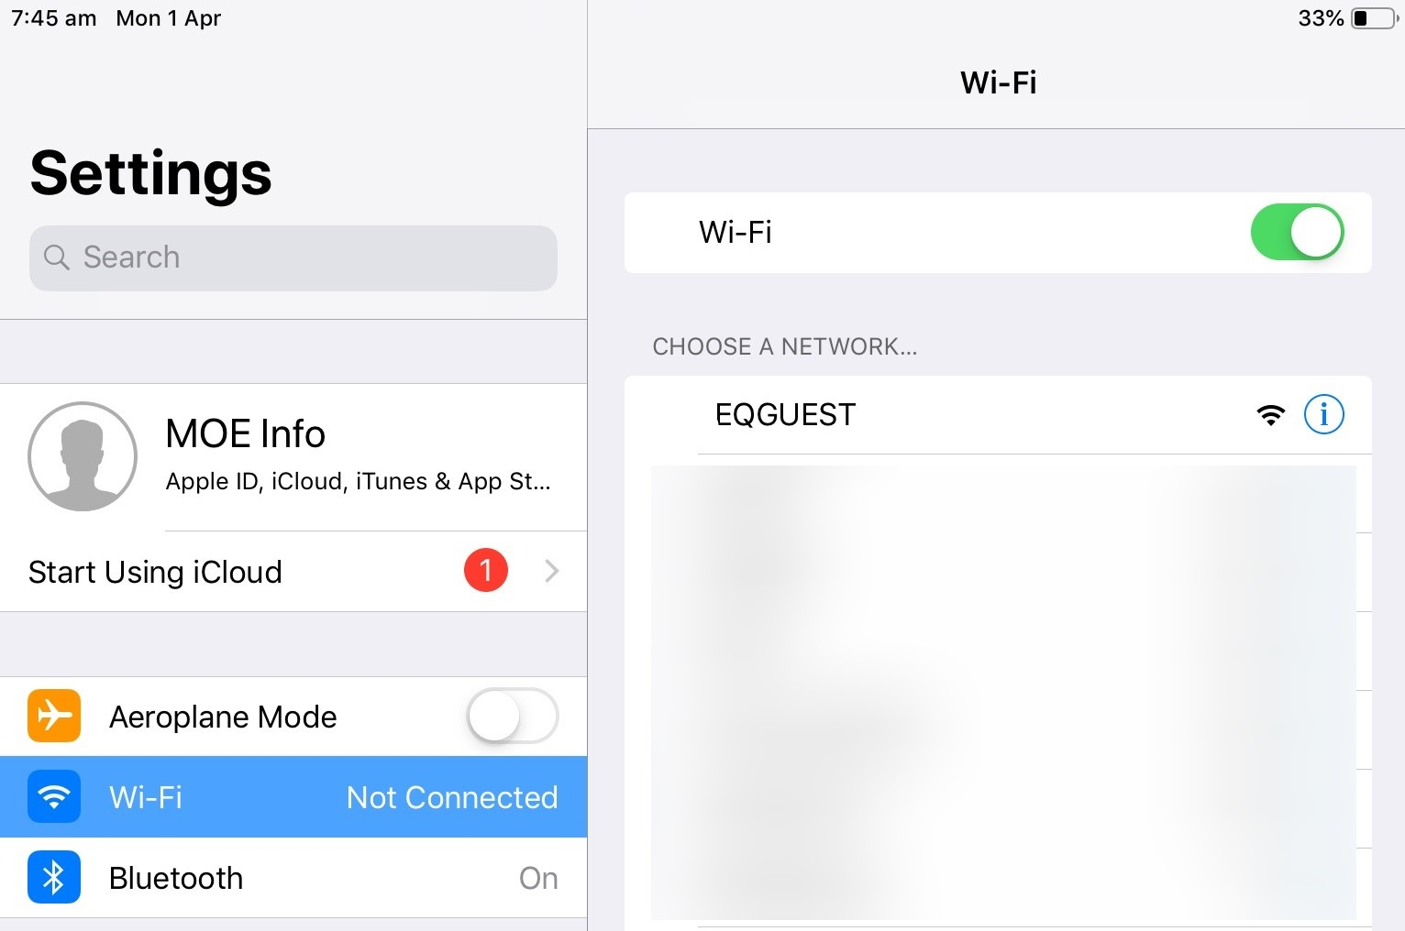
Step 1. Select the guest Wi-Fi network
- Open Settings and select Wi-Fi.
- Select EQGUEST.
- A sign on page will be displayed.

Step 2. Sign on to the Guest Wi-Fi Network
- Enter the guest account logon credentials.
- Read and accept the Acceptable Use Policy by ticking the box.
- Select Sign on.
- You will be prompted to change the password. This must be a four digit numerical pin.
- A confirmation page will be displayed, which on an IOS device will have a DONE button at the top right.
- Select DONE, the page will disappear and the device is now connected.

