BYOxLink - How to Guide

Use guest Wi-Fi service to connect a visitor’s MacOS device
This document explains how to connect a visitor’s MacOS device to the school guest Wi-Fi network (EQGUEST). The connection is limited to the filtered internet service and will be available to use for two hours.
The school will provide you with a guest account logon.

Step 1. Select the guest Wi-Fi network
- Select the Wi-Fi icon in the menu bar at the top of the screen
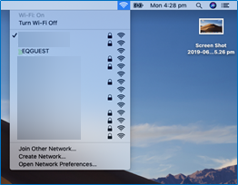
- Select the EQGUEST Wi-Fi network.

- A sign on page will be displayed.
- Enter the guest account logon credentials.
- Read and accept the Acceptable Use Policy by ticking the box.
- Select Sign on.
- You will be prompted to change the password. This must be a four digit numerical pin.
- A success page will be displayed.

