Reporting for Registration for Home Education
Education (General Provisions) Act 2006 - Section 217 (2)

Report pack

Table of contents
Set 1 - Reporting information and work samples

Title | Details
Preparing your child’s report | Details on what to provide for your child’s report.
Guidelines for choosing work samples | Information about selecting work samples to demonstrate educational progress.
The teaching and learning cycle | The phases of teaching and learning.
Reporting examples (Annotations and work samples) | Examples and ideas about what to look for when collecting and reviewing your child’s work samples.
Information about your legal obligations | References to the legislation relating to registration for home education.

Set 2 - Year in review and work sample annotations

Title | Details
Annotations | A template providing guidance on the contextual information relating to the selected work samples.

Set 3 - Summary of the educational program (template and example)

Title | Details
Summary of the educational program (template and example) | A template and completed example providing guidance relating to the summary of educational program.

The Reporting for registration for home education form is available on the Home Education Unit website. Completion of this hardcopy is not required if submitting the report online.

Home Education Unit
Page 1 Department of Education

Report Pack

Set 1 - Reporting information and work samples

Preparing your child’s report
For the annual report, you will be providing information on your child’s educational progress. This progress can be demonstrated through annotated work samples that have been completed throughout the year.

It is a standard condition of registration that a parent of the child must give to the chief executive a written report on the educational progress of the child while undertaking home education.

The attached reporting information (Set 1) provides a suggested structure for the annotations and samples of work to demonstrate your compliance with the standard conditions of registration for home education, including educational progress.

Please note:
Due to Departmental privacy and cyber security policies, the HEU cannot retrieve material from cloud-based applications. This prevents the viewing of samples contained within file-sharing services such as: Dropbox, Google Drive, OneDrive and Apple iCloud. Similarly, links to online content located within private blogs, YouTube channels or websites cannot be accessed.

Items to include in your report

- Reporting for registration for home education form – must be signed and included if emailing or posting the report.
- Change of personal details for home education form – if personal details regarding you or your child require updating, this form must be completed and submitted with the report. The form is available on the Home Education Unit website or can be accessed via a link, if submitting the report online.
- Annotations – an overview of the past year and statements providing context for the samples (Set 2). Annotations provide an opportunity to highlight the high-quality education your child is receiving. The annotations template provides guidance as to the information to include regarding the samples of work. In addition to general statements regarding your child’s learning, annotations enable you to explicitly identify the progress made between the samples of work provided. Identification of progress in the samples will assist the chief executive (or delegate) to be reasonably satisfied regarding your child’s educational progress.
- Samples of work - see below for further details.
- A summary of the educational program for the upcoming period - a suggested template (Set 3) has been provided to assist you.
- Additional material – while additional material (e.g. photos of activities) may display the broad education occurring in your home, the best evidence of your child’s educational progress is usually provided by the samples of your child’s work and annotations explicitly in relation to those samples.

Guidelines for choosing work samples

- Comparative – the work samples should focus on the same learning concept. The first sample could show the initial learning and the second would demonstrate more complex tasks to demonstrate the educational progress achieved.
- Comprehensive – sufficient work to demonstrate educational progress.
- Dated – ensure the work samples include the date the samples were completed.
- Annotated – ensure the annotations regarding the work samples provide relevant information about the teaching and learning process (Set 2).
- Reviewed – show evidence of parent/teacher instructions, support and feedback.

English samples

Include two dated, comparative and reviewed samples of your child’s own composition. For example, essays, recounts, letters, plays, reports, narratives. (Refer to examples of children’s work samples below). If the samples of work are not from the learning area of English, include samples that demonstrate your child’s progress in literacy in another learning area. For example, an historical narrative.
Extended writing samples that include drafts and final copies show the application of a range of literacy skills, may assist in demonstrating educational progress. These types of writing samples show the stages of thinking, including planning, draft completion and/or note taking.

Mathematics samples
Include two dated, comparative and reviewed samples that display the development of a particular mathematical concept. (Refer to examples of children’s work samples below). If the samples of work are not from the learning area of mathematics, include samples that demonstrate your child’s progress in numeracy in another learning area. For example, this may be numeracy as part of a scientific investigation.
Real-life maths examples, demonstrating application of skills learnt and including the child’s workings which led to the solution, may assist in demonstrating educational progress.

Samples of the learning area of choice
Include two dated, comparative and reviewed samples of your child’s work in one other learning area (for example, Science, Humanities and Social Sciences, The Arts, Languages, Technologies, HPE).

The teaching and learning cycle

- PLAN THE YEAR’S PROGRAM
  - establish goals, plan program activities and monitoring tasks
  - decide whether revision, consolidation or extension activities are a priority
5. REASSESS
•
- TEACH
  - engage your child in an activity
  - collect and date WORK SAMPLE 1
•
after further targeted teaching, provide a more complex task focused on a similar learning concept to WORK SAMPLE 1
parent and child reflect and discuss progress between samples
- collect and date WORK SAMPLE 2
3. OBSERVE-IDENTIFY-ANALYSE
•
4. INSTRUCT
•

•
identify strengths and areas for
development reference to Australian
Curriculum Guidelines (ACARA)
may assist
•
•
•
find additional resources to support the program
find new strategies to work on areas for development
provide opportunities to consolidate plan activities to extend acknowledge progress and provide
feedback about areas of development
•

Reporting examples

Australian Curriculum ACARA - Work Sample Portfolios

The Australian Curriculum website provides examples of work portfolios in relation to national achievement standards. To access click on the link - Australian Curriculum website.

Choose the learning area you would like to view.
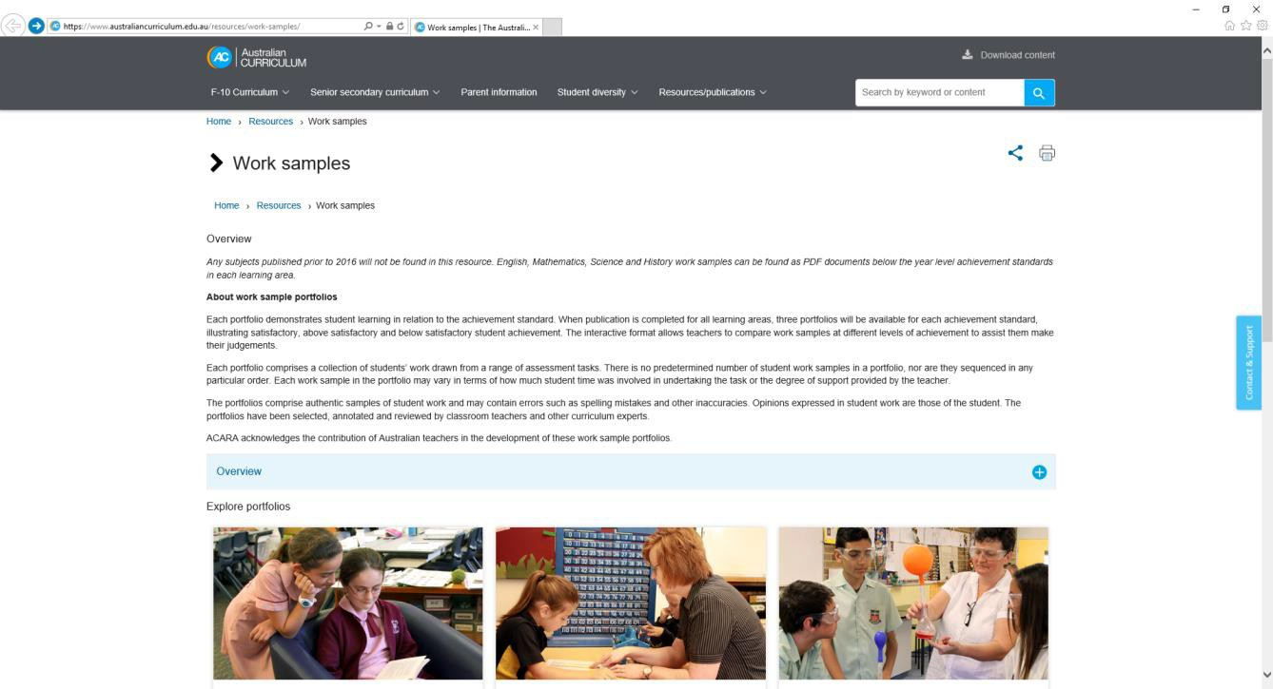

Completed annotations

Examples on the following pages offer ideas about suitable and comparative work samples and annotations for the report on your child’s educational progress.

Annotations (example)
This information will be viewed in combination with your samples to determine compliance with the standard conditions of registration. It is recommended that responses be suitably detailed.

Provide comment on the year in review.
  - What are your general impressions on the year of home education?
Overall, I feel this year has been a success. As it was our first year of home education, we began the year exploring the best way for Katie to learn. We soon saw that Katie required more structure than we had previously thought. In response, we implemented a daily timetable where we would complete formal workbook and textbook activities in English and Maths. More natural, hands-on learning occurred in the afternoon, with HPE, cooking, and construction being regular activities. This structure appeared to work well in maintaining Katie’s engagement and is one we will continue to use.
Katie’s results have improved with the one-on-one support offered through home education. While she still struggles in some areas, I believe she has made excellent progress over the past year. It is my intention to continue home education until such time that Katie reaches her age equivalency and can confidently return to mainstream schooling.

  - Did you achieve the goals outlined in your program?
Our initial goal was to improve Katie’s literacy and numeracy and this has been achieved to some extent. Spelling has improved as a result of our regular spelling tests and games, with Katie showing good ability to sound out words and at least give it a go. Katie has even developed an enjoyment of reading, with her now choosing to pick up a book on occasion. Her ability in Maths also appears to have improved. She continues to struggle with understanding of basic number concepts and often refuses to engage in lessons when she finds the work difficult. Still, she has shown some improvement in Maths, particularly with regard to her understanding of geometry, perhaps linked to her interest in construction.

  - Did you make any changes to your program? Why/why not?
I included more structure in our daily routine. Given Katie’s struggles in Maths, I decided to cover some concepts in less detail than others which provided more time to fully explore key areas before moving on. When I realised how much she enjoyed geometry, I focused on this learning and was able to include a range of Math concepts (e.g. distance, weight, shape, angles etc.) to build her understanding.
I had initially intended to include an introduction to German based on my family background. However, Katie did not seem to enjoy this subject area, perhaps because there is little relevance in daily life. I may return to this subject in the future.

  - What were the highlights or lowlights?
A clear highlight was simply getting to spend more time with Katie. It has been such a wonderful opportunity to get to know Katie and her learning styles better over the past year. As mentioned, I believe she has developed well with the one-on-one support offered through home education – a level of support that could not be offered in mainstream school.
More generally, highlights have included seeing Katie’s success in cooking and construction – she is talented with her hands and either of these options could be a future career. Excursions and theatre performances were also highlights, as was observing Katie’s growing friendship circle through our home education groups.
A lowlight occurred during Katie’s participation in a local basketball team. Katie struggled with the big personalities of other girls and she felt overwhelmed. I cancelled her membership and am looking for other sporting opportunities for the coming year.
  - In what area did your child achieve the most success?
Spelling has shown a significant improvement; however, the growth and enthusiasm in Maths (geometry) is hard to beat. I never thought I would find an area of Maths that Katie enjoyed so much!
On a personal level, Katie’s growing confidence in some areas has been great to observe. There are some days when she gets so happy and excited about her learning! I have often heard her sharing details of what she has learnt with family and friends, even on topics I didn’t realise she enjoyed. It’s great to see and really affirms my decision to home educate.
  - Any other relevant information?
I am very glad I made the decision to home educate as I can see long-term benefits for Katie and the wider family. I know it will be a long road ahead of us, though I am sure we will continue to make progress and I am enthusiastic about where this journey will lead us.

Provide comment on the accompanying work samples.
- What approaches did you use to support your child in completing these samples?
  - English
Katie enjoys learning with her hands more so than writing. To support this, I provided Katie with cards containing illustrations and short sentences and asked her to physically move the illustrations into an order that made sense when read as a story. Katie enjoyed doing this. From there, she was asked to expand on the story in her initial draft. I encouraged Katie to write as much detail for each picture as she could. We read lots of storybooks to look at sentence structure and story elements and discussed how the illustrations connect to the pictures through the use of descriptive language. We then focused on adding adjectives to our writing to ensure a detailed and engaging story was created in the final draft.
In the second sample, I encouraged Katie to draw her own illustration as inspiration for her writing. Her drawing isn’t the greatest and her illustration didn’t show many story elements; however, when she had completed the picture, Katie spoke all about the story that was happening behind the scenes and I could see she had given some clear thought to her task. I encouraged her to write the story down. I encouraged more independence in this task, simply reminding Katie of the elements that make a story more engaging (e.g. details and description). Katie tried very hard to include these details in her finished piece.
  - Mathematics
Again, I supported Katie’s preference for hands-on learning by allowing her to draw and construct objects based on our exploration of geometry. The first sample was completed after we had already explored 2D shapes and were beginning to identify their occurrence in 3D pieces. I allowed Katie to play with the bag of 2D shapes to see how they fit together. When she finished her table, we explored the house to look for examples of these shapes in our surroundings (luckily I had a Toblerone in the fridge to give an example of a rectangular prism!).
The second sample was great fun for Katie. She had total freedom to build any shape she wanted, as long as she could find an example of it in our home. Katie thought about her shape choice for a while, before deciding she would build our house itself! It’s a simple shape (one cube and a triangular pyramid), but Katie really enjoyed putting the pieces together. Her finished presentation was also improved (mainly due to having lines to write on rather than the blank table from Sample 1).
  - Other learning area
As Katie is a hands-on learner, we completed many Science experiments. In the first experiment, we learnt about physical and chemical changes by doing simple things such as melting chocolate, freezing water and dissolving bi-carb soda. In the second experiment, we explored magnetism. She was supported by discussions and prompting about what she observed.

. What progress did you observe between the samples?
- English
Katie’s spelling has clearly improved between English samples, with far fewer spelling mistakes in the second piece. Paragraph structure has also improved, with the second sample demonstrating her understanding of introduction and body in a short story. I believe this is a result of the increased volume of her reading and due to the spelling games we played between the pieces.

- Mathematics
Maths samples show her understanding of significantly more complex geometry activities. This progress was made possible due to Katie’s enjoyment of geometry and hands-on construction – following her learning preferences ensured she put more effort into each activity.

- Other learning area
For both Science experiments in the samples, the goal was for Katie to write a basic scientific report. The first sample is the first attempt and we took photos of the equipment, steps and the results. Katie completed simple annotations against the photos. The second sample displays a more structured report without the use of photos and lengthier sentences by Katie.

. At what level are these samples targeted? (For example, above, at or below age equivalence)
Katie is working at age level for English, Science and most concepts in Maths. However, she requires more practice in number concepts to be at age equivalency.
4. Any other relevant information?

Work samples (example)

English Sample 1

Name of Child: ………………………… Date of Sample: …………
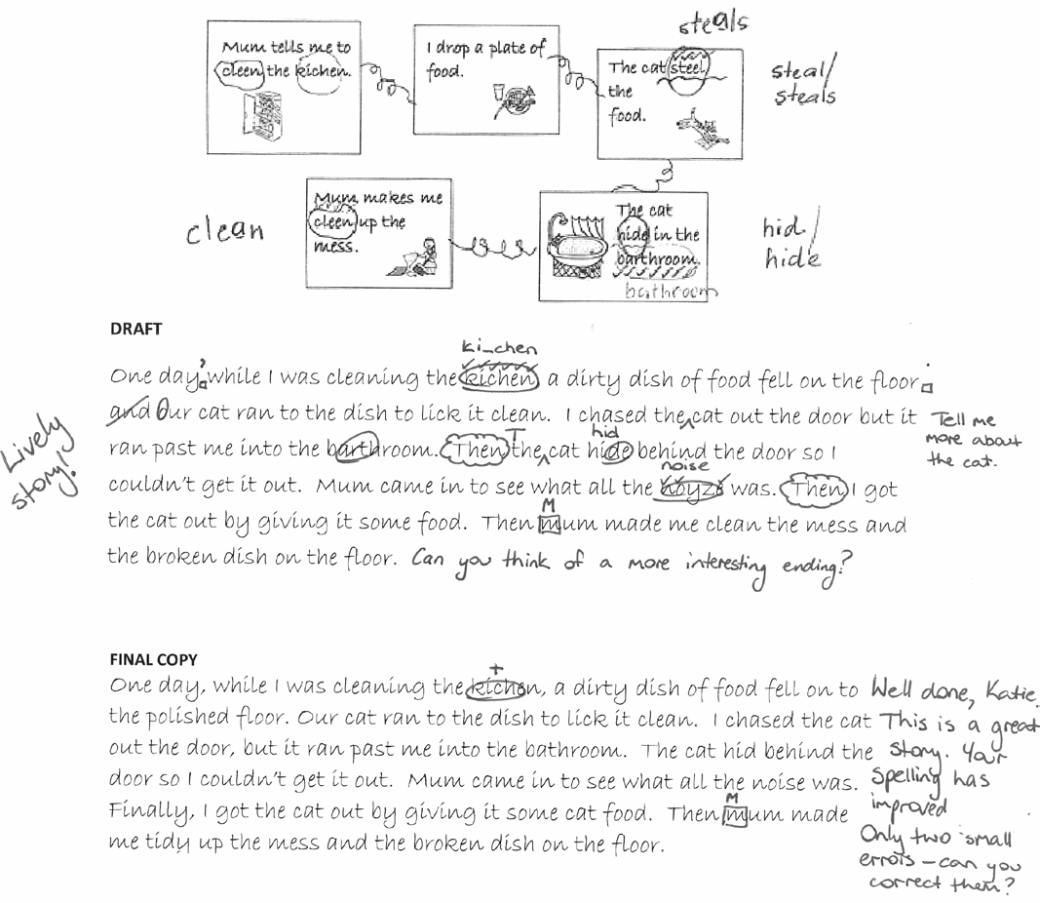
HEU comment on why this is a suitable work sample
- The sample is legible and clearly labelled with sample number, name and date.
- The sample provides feedback about areas of development.
- There is evidence of the child’s self-editing.
- Planning for writing (story maps) and drafts are included.
- Annotations detail the teaching strategies engaged to support the child in the learning activity.
HEU comment on why this may not be a suitable work sample
- The quantity of information (i.e. text length) could be more extensive.
- The learning goal and specific instructions for the task were not included.

English Sample 2
Name of Child: ………………………… Date of Sample: …………
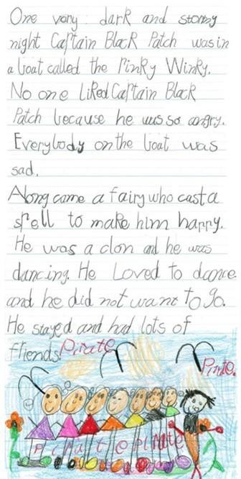
HEU comment on why this is a suitable work sample
- The sample clearly compares to Sample 1 as it is also an extended writing piece.
- The sample is a clear, complete and illustrated story.
- The sample shows progress in regard to use of descriptive language, spelling and structure.
- The parent annotations indicate less help was required - child worked independently.
- The task instructions were included (not on the sample but as part of the parent annotations).
- The final product shows multiple creative opportunities existed for the child.
HEU comment on why this may not be a suitable work sample
- The text length was not significantly greater than Sample 1.
- No draft work was included.
- The sample provides no feedback; however, these omissions were explained in the parent annotations.

Mathematics Sample 1

Name of Child: ………………………… Date of Sample: ………………
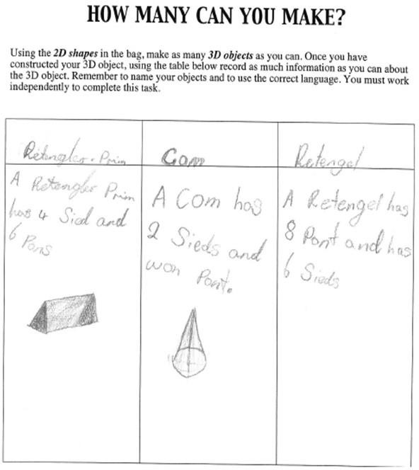
HEU comment on why this is a suitable work sample
- Clear instructions for the task are included.
- Annotations detail the teaching strategies engaged to support the child in the learning activity.
- The sample is legible and clearly labelled with sample number, name and date.
- The sample shows the child’s introductory knowledge of shapes and specific mathematical language.
- The sample shows practical application – construction and design elements.
- The sample includes some critical thinking – 2D to 3D shape conversion.
HEU comment on why this may not be a suitable work sample
- The sample does not provide feedback about areas of development. (See English Sample 1 for an example of feedback).
- Limited information is provided due to brief and incomplete task.

Mathematics Sample 2

Name of Child: ………………………… Date of Sample: …………………
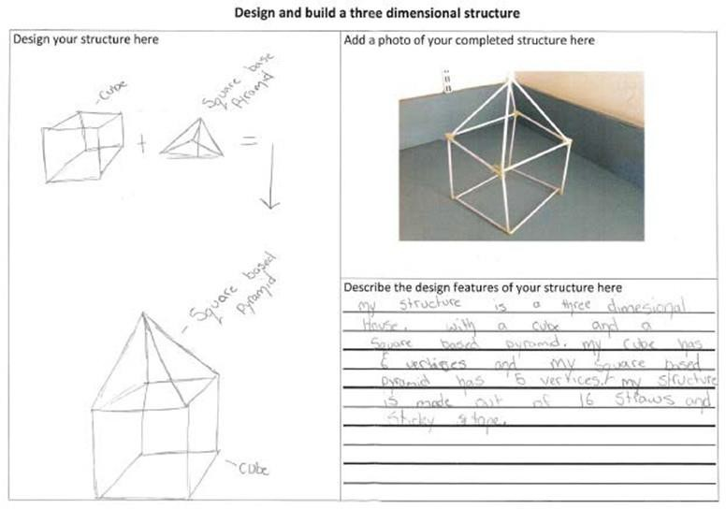
HEU comment on why this is a suitable work sample:
- This sample clearly compares to Sample 1 – same mathematical concept (geometry) is involved.
- Some instructions for the task are included.
- The sample is legible and clearly labelled.
- The sample shows the child’s developing knowledge of shapes and more accurate use of mathematical language.
- Sample 2 is a more comprehensive design as the sketch shows all faces of 3D shapes.
- The sample shows practical application through construction of shape.
- The sample provides information about more complex understandings.
- Increased critical and creative skills are demonstrated.
- Draft designs are incorporated and match the construction.
- Presentation is improved and includes photographic evidence.
HEU comment on why this may not be a suitable work sample:
- The sample does not provide feedback about areas of development or acknowledge progress.
- Task requirements could have been further developed to display child’s ability to measure and draw more accurately.

The samples above are based on ACARA materials.

Information about your legal obligations

Registration for home education in Queensland is governed by provisions in the Education (General Provisions) Act 2006 (the Act).

Definition of home education – s.205

Home education, for a child, means the education of the child provided by 1 or both of the child’s parents, or a registered teacher, primarily at the child’s usual place of residence.
The provisions below are in regard to the standard conditions of registration and grounds for cancellation of registration.
If you would like to read further provisions in the Act which specifically relate to registration for home education, please refer to sections 205 to 229 of the Education (General Provisions) Act 2006.

Standard conditions of registration – s.217

- The registration of a child for home education is subject to the following conditions of registration-

  - the child’s parents must ensure the child receives a high-quality education;
  - a parent of the child must give to the chief executive a written report on the educational progress of the child while undertaking home education;
  - a parent of the child must notify the chief executive of any change in the address of the child’s usual place of residence within 28 days after the change happens.
- A report mentioned in subsection (1)(b) must –
  - be given to the chief executive at least 2 months, but not more than 3 months, before each anniversary of the registration; and
  - be in the approved form; and
  - be accompanied by any other documents, identified in the approved form, the chief executive reasonably requires.

Grounds for cancellation – s.221

Each of the following is a ground for cancelling the registration of a child for home education –

- a parent of the child has contravened a condition of the registration;
- the chief executive is not reasonably satisfied about the educational progress being made by the child;
- the child was registered because of a materially false or misleading representation or declaration.

