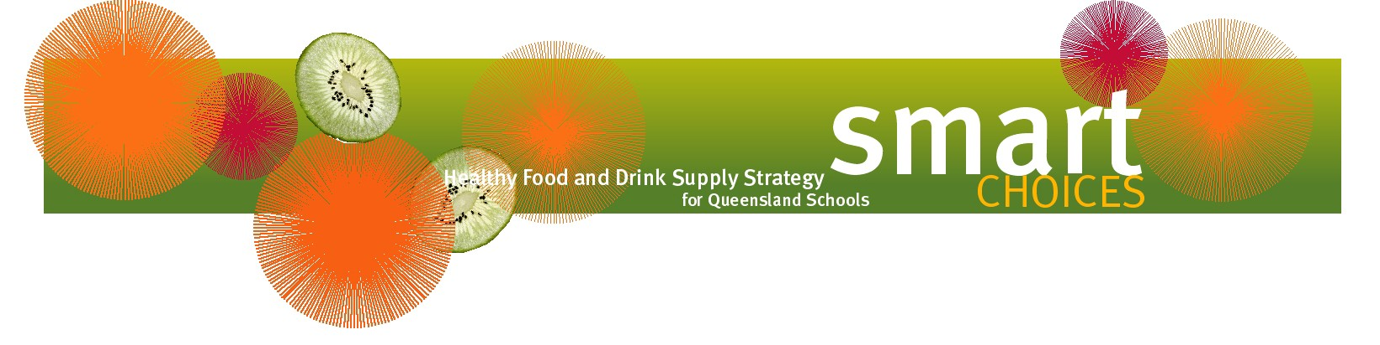
How does Smart Choices support healthy eating for children?

Children and young people’s daily food and drink intake needs to provide the nutrients and energy required for growth, physical and cognitive development, resistance to infection and protection against the development of chronic diseases.

Smart Choices – the Healthy Food and Drink Supply Strategy for Queensland Schools (https://education.qld.gov.au/student/Documents/smart-choices-strategy.pdf) is all about offering healthy food and drink choices to students in Queensland schools, but it’s important to remember that more than half of a child’s daily food and drink intake occurs away from school.

Parents, carers and schools can work together to ensure children and young people always have access to healthy food and drink.

Healthy eating for children and young people
The Australian Guide to Healthy Eating and the Australian Dietary Guidelines outline the recommended amounts of food and drinks required to meet the daily energy and nutrient needs of children and young people. To obtain copies of these guidelines visit https://nhmrc.gov.au/about-us/publications/australian-dietary-guidelines.

Every day, children and young people should have access to a wide variety of healthy food rom the five food groups including:
- plenty of vegetables and legumes (e.g. lentils and chickpeas)
- plenty of fruit
- plenty of cereals (including breads, rice, pasta and noodles), preferably wholegrain
- lean meat, fish, poultry and/or alternatives
- milk, yoghurt, cheese and/or alternatives.

Extra foods
Extra foods are those that are high in added fat, sugar, and/or salt e.g. cakes, lollies, chocolate, chips, soft drinks and deep fried foods. These do not fit within the five food groups as they are not essential to provide the nutrients the body needs. The additional energy requirements of children and young people can be met by providing more food and drinks from the five food groups rather than from extra foods.

Healthy snacking
Many children and young people like to snack frequently throughout the day. It is important that these snacks are healthy foods that provide essential nutrients as well as energy e.g. tub of yoghurt, sandwich, fruit or vegetable sticks. Filling up on extra foods at snack times may mean children and young people are not receiving the essential nutrients for growth and development.

Drinks
Children and young people should be encouraged to drink water and plain milk when thirsty. Sweetened drinks such as soft drinks, sports drinks, energy drinks and fruit drinks should be limited as they contain added sugar which can contribute to tooth decay and add excess energy to a child or young person’s diet.

Food and drink supplied by the school
Smart Choices helps parents and carers by ensuring food and drink supplied by the school in the school environment is consistent with the Australian Dietary Guidelines.

