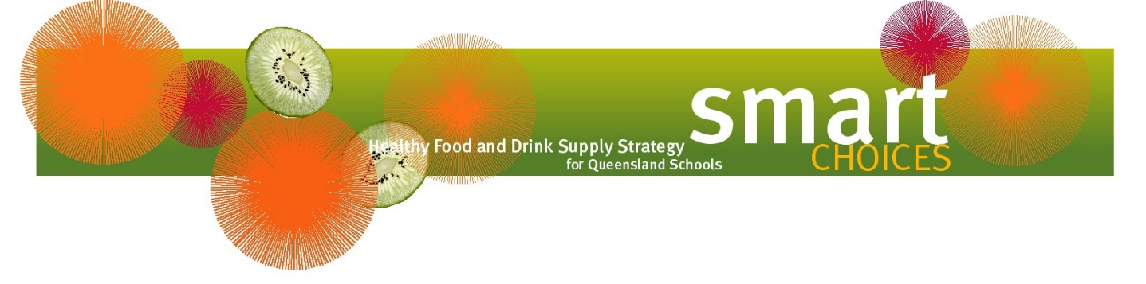

Top Tuckshop Sellers

For the Primary School

Hot foods
- toasted jaffles (popular fillings include: cheese, ham, baked beans)
- pasta type dishes (spaghetti mince and vegetables, lasagne, ravioli)
- fried rice
- hamburgers with lean mince patties and lots of salad
- chicken burger and salad
- freshly made soup (in winter)
- muffin-based pizza
- cheesy pasta (ham, cheese and vegetables mixed through pasta)
- stuffed potatoes

Sandwiches/Wraps
- Popular fillings include:
Drinks
- water
- reduced fat flavoured milk
- reduced fat plain milk
- smoothies (made on reduced fat milk)
- 100% fruit juice
- frozen 100% fruit juice cups
  - cheese and tomato
  - egg
  - egg and lettuce
  - chicken and salad
  - salad

Salads
- salad boxes with egg/cheese/ham/chicken

Hot snacks
- corn on the cob
- chicken legs marinated in honey
- freshly prepared garlic or herb bread
- raisin toast

Cold snacks
- frozen fruit (pineapple rings, grapes, bananas)
- apple slinkies (using an apple slinky machine)
- dried fruit packs
- fruit yoghurt
- boiled eggs
- custard
- celery boats (celery filled with peanut butter / cottage cheese)
- air popped popcorn
- cracker biscuits with cheese or vegemite

For the Secondary School

Hot foods
- pasta bolognaise
- pesto pasta bake
- lasagne
- hamburgers with lean mince patties and lots of salad
- chicken burger and salad
- cheesy pasta (ham, cheese and vegetables mixed through pasta)
- freshly made lean meat balls
- fried rice
- freshly made soup (winter)
- freshly made pizza
- nachos (using pita breads)
- stuffed potatoes
Drinks
- water
- reduced fat flavoured milk
- 100% juice
- frozen 100% fruit juice cups

Sandwiches/Wraps/Foccacia
- Popular fillings include:
  - roasted chicken and sweet chilli
  - chicken and salad
  - salad

Salad/Sushi
- salad boxes with egg/cheese/ham/chicken
- pasta salad
- sushi rolls with chicken / tuna / salad fillings

Snacks
- fruit salad
- yoghurts
- air popped popcorn
- watermelon

Further information on Smart Choices can be found on the Department of Education’s website https://education.qld.gov.au/students/student-health-safety-wellbeing/student-health/smart-choices.

