Chemicals in curriculum activities
When planning to use chemicals during curriculum activities with students, schools are required to comply with the department’s Chemical management and Managing risks in school curriculum activities procedures.
Consumer chemicals are products packaged for use in a household or office and pose low risk to students when used according to the product label.
All other chemicals in the workplace are to be determined as either non-hazardous or hazardous.
Curriculum activities requiring CARA records in OneSchool must include safety information about all workplace chemicals used with/by students in the activity. This information is to be included by entering the information directly onto the CARA record in OneSchool or by attaching a summary document.
Hazardous chemicals are chemicals that are hazardous in themselves (by type or by quantity), generate hazardous substances/materials (e.g. reactants, chemical waste products) during the activity, and/or have hazardous clean-up/waste disposal processes.
To ensure the hazards and control measures of chemicals being used by/with students in curriculum activities are being recorded schools are to utilise the risk assessment information from the Chemwatch manifest to determine hazards and control measures for each chemical.

Further support
Risk assessment and management training and advice | Contact your school’s Health and Safety Advisor (HSA) or Health and Safety Representative (HSR); or  Contact your Regional Senior Health and Safety Consultants (Health and safety tab).
Managing chemicals in schools | Consult the Chemical management procedure and support website or email HSW@qed.qld.gov.au
Completing Curriculum Activity Risk Assessment (CARA) records | Contact the CARA team at CARA@qed.qld.au
Safety advice of historical incidents | Consult the Safety and Hazard Alerts

Chemicals in curriculum activities
- Consumer chemicals pose low risk to students when used according to label instructions and in line with normal household/office use. All consumer chemicals must be managed according to the product label and are not required to be added to Chemwatch.
In this case, the CARA risk level may be low, medium, high or extreme and is determined by the other risks/hazards of the curriculum activity.
However, consumer chemicals must be added to Chemwatch when they are:
- not used according to label instructions; or
- beyond normal household/office use.
Beyond normal household/office use means the chemical is used more frequently, in greater quantities or for different purposes other than intended. Similarly, the chemical has transferred/decanted into other containers.

When consumer chemicals are added to Chemwatch, they are to be considered as Workplace Chemicals.
- Workplace Chemicals
Consult the hazard category from the Chemwatch manifest
NON-HAZARDOUS | LOW | MODERATE | HIGH | EXTREME
 |  |  |  | 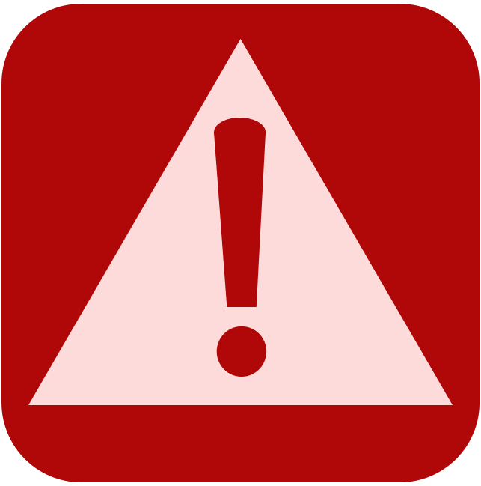
These chemicals pose a low risk to students. | These chemicals pose a medium risk to students. |  | These chemicals pose an unacceptable risk to students at this stage.  Further management of the risk is required prior to conducting the curriculum activity.
Conduct (and have approved) an ILO (Health exposure) risk assessment with the aim to reduce the risk band to the lowest risk level
ILO risk level
MIN. | LOW | MOD. | HIGH | EXTREME
 |  |  | Consider substituting the chemical with an alternative (less hazardous) chemical or plan an alternative activity.  If an alternative cannot be found, complete a SOP and adhere to it during activity. | These chemicals still pose an unacceptable risk to students.
 |  |  |  | An alternative, lower risk chemical must be found.
The CARA risk level may be medium, high or extreme.
Consider all other risks/hazards of the curriculum activity to determine the CARA risk level.
Manage the chemical risk in the activity according to the Chemwatch ILO health risk assessment, SOP (if used), product label and any workplace instructions

The CARA risk level may be low, medium, high or extreme. | The CARA risk level may be medium, high or extreme.
Consider all other risks/hazards of the curriculum activity to determine the CARA risk level
Manage the chemical in the curriculum activity according to the pre-purchase chemical risk assessment, product label and the SDS.

Summary of chemicals
Curriculum activities requiring CARA records in OneSchool must include information about the chemicals used in the activity. When complete, this document may be uploaded as an attachment to the CARA record in OneSchool for the activity.
Two examples are provided to demonstrate requirements.
Add rows as required. |  |  |  |  | Chemicals requiring an ILO risk assessment may state “As per ILO health risk assessment” or similar in these columns.
Chemical name | Conc. | Approx. quantity | Initial Chemwatch hazard rating | Final ILO risk assessment level | List the hazard statements from the SDS (section 2).  Do not include hazard codes. | Primary route of exposure  Include all that apply  - Skin, eyes contact.  - Inhalation.  - Injection. | Controls planned from SDS
2-butanol | stock | 50 mL | Moderate hazard | Not available | Flammable liquid and vapour.  Causes serious eye irritation.  May cause respiratory irritation.  May cause drowsiness or dizziness | Inhalation | Natural ventilation  Keep away from ignition source  Gloves and safety glasses
Sodium dichromate | 0.1 M | 5 mL | High hazard | ILO risk level = 2 | As per ILO health risk assessment | As per ILO | As per ILO health risk assessment

Acknowledgement of practice:
☐ Control measures from the appropriate chemical risk assessment, product label and the SDS are complied with.
☐ The CARA risk level and safety procedures for the curriculum activity have been informed by the appropriate chemical risk assessment, product label and SDS.
This information is to be reviewed and amended (if necessary) when subsequently conducting the same curriculum activity.

All curriculum activities must be recorded in the three levels of planning, typically unit plans, however high and extreme risk curriculum activities conducted on-site also require a CARA record to be completed in OneSchool. Consult your school-based CARA process for documentation requirements for medium risk activities conducted on-site. All off-site curriculum activities require CARA records to be completed as part of the Excursion Planner in OneSchool.
Hazardous chemicals commonly used in curriculum activities include some fertilisers, scheduled poisons, veterinary products, cleaning/sterilising agents, paints, dyes, adhesives, fuels, lubricants, propellants, gases, fumes, acids etc.
All curriculum activities must be recorded in the three levels of planning, typically unit plans, however high and extreme risk curriculum activities conducted on-site also require CARA records to be completed in OneSchool. Consult your school-based CARA process for documentation requirements for medium risk activities conducted on-site. All off-site curriculum activities require CARA records to be completed as part of the Excursion Planner in OneSchool.

