Workplace (including School) Health, Safety and Wellbeing Committee

Purpose
To provide a forum for improving health, safety and wellbeing (HSW) performance within department workplaces (including schools), promote worker engagement in health, safety and wellbeing and support the requirement for consultation under work health and safety legislation.

Guiding principles
Performance-based outcomes
Monitor and review the implementation of HSW risk management strategies at all workplaces (including schools) to ensure the department meets legislative and policy requirements.
Evidence-based
Use evidence-based decision-making and HSW risk analysis to drive and shape operational priorities, strategies and objectives relevant to HSW.
Fit-for-purpose
Be responsive to emerging drivers, hazards, trends and issues that may impact HSW.
Trust and transparency
Make impartial and ethical decisions that uphold human rights, promote confidence, demonstrate accountability and prioritise HSW.
Risk-based
Make decisions that balance opportunity and risk to achieve operational priorities and objectives in relation to HSW.

Responsibilities
The workplace (including school) HSW Committee will:
- Track and progress HSW actions at the location (e.g. the Annual Safety Assessment (ASA) and Action Plan).
- Oversee the application of HSW risk management to ensure that hazards and risks are identified, assessed, controlled and monitored.
- Oversee the effectiveness of HSW (and associated risk) reporting.
- Oversee the effective management of HSW risks and incidents through review of incidents and trends.
- Review HSW performance, identify the factors contributing to performance and direct reinforcing or corrective actions/plans.
- Escalate HSW information and issues to the Regional HSW Committee for information and/or decisions as required.

Membership
The composition of the Committee will reflect the scale, scope and risk profile of workplace (including school) operations and includes incumbents in the following positions:
[Add/delete cells as required]
Role | Position
Chair | Principal / Manager
Member | Health and Safety Advisor/s
Member | Health and Safety Representative/s
Member | Rehabilitation and Return to Work Coordinator/s
Member | Business Services Manager
Member | Head(s) or Department(s)
Member | Employee representatives from departments / business units / work groups
Member | Other – Representatives from employee cohorts
Secretariat | To be determined by Chair

Committee operations
- The workplace (including school) HSW Committee is a decision-making body.
- The workplace (including school) HSW Committee’s decisions are underpinned by the Work Health and Safety Act 2011 (Qld).
- The Workplace HSW Committee will meet at a minimum once each term (weeks 1 – 5) or as determined by the Chair.
- Committee relationships and pathways for escalation and decisions are illustrated through the department’s HSW Committee Governance Framework in the below diagram.
- See Appendix 1 for further information about the Committee’s operating model.
- See Appendix 2 for further information about the Annual Forward Work Plan.

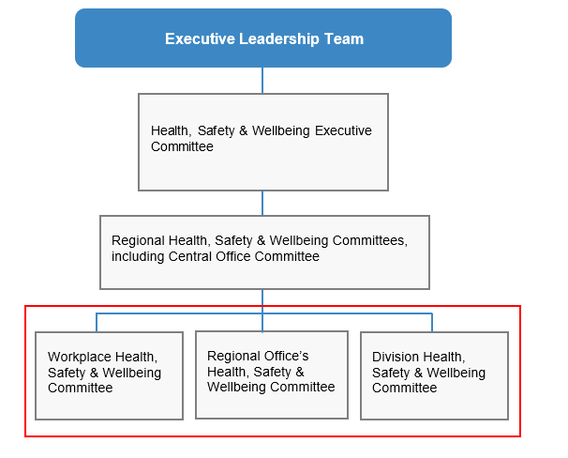

Reporting and referral relationships
The Committee, through the Chair, prepares the following reports for the Regional HSW Committee:
- minutes of meetings;
- items for escalation; and
- progress against regional HSW priorities.
Regular reports to the Committee include:
- items raised by individuals, MyHR WHS Workplace/school incidents (generated at the location).

Appendix 1 – Operating model
Quorum | The Chair (or Acting Chair) plus 50% of members.
Agenda, papers & minutes | Agenda  - Committee members may sponsor items for the agenda.  - Agenda items should be forwarded to the Secretariat at least one week before the scheduled meeting.  - The Chair will approve agendas no less than three working days before the meeting date.  Record keeping  - Minutes of meetings will be taken by the Secretariat using the department’s HSW Committee minutes template.  - Once endorsed, the minutes will be distributed to members and will be available for administrative release under the Right to Information legislation.  - The minutes and the status of associated actions must be reviewed at the next meeting.  Reporting  - As required, the Committee will escalate issues to the Regional HSW Committee for endorsement or a decision.  - Escalation of issues to the Regional HSW Committee is through the Chair (or other invited members as appropriate); completion of Appendix B of the minutes template is required.  - Will address compliance issues and performance of the HSW Management System.  - Communication of meeting outcomes will be through the distribution of minutes to members. Members are responsible for the communication of issues within their areas as appropriate.  Resolution of issues ‘out-of-session’  - The Chair may schedule out-of-session meetings of the Committee or part thereof as deemed necessary.  - The Chair may issue papers to members for consultation and decision outside scheduled meeting. This may include papers or issues unable to be included in scheduled meetings due to time constraints.
Roles | Chair  - Ensure that the Committee is registered in MyHR (WHS).  - Ensures the Committee operates effectively and according to agreed protocols.  - Facilitates the flow of information during meetings.  - Provides HSW performance reports for consideration as required.  - Approves the draft minutes no more than three weeks after each meeting for circulation to members.  - Ensures that issues and risks are considered by the Committee and escalated to the Regional HSW Committee as appropriate.  - Delegates the above responsibilities to the next most senior executive present as required.  Secretariat  - Compiles and distributes the agenda and any supporting papers at least three working days prior to each meeting.  - Circulates minutes (approved by chair) to members for endorsement within five business days of draft approval.  - Once endorsed, ensures all employees can access the minutes.  - Monitors and tracks actions and decisions recorded in the Outcome Register.  - Maintains Terms of Reference.  - Reviews Committee registration in MyHR WHS quarterly to ensure currency of membership.  Members  - Acquire and maintain knowledge of:  - WHS duties and obligations that affect the workplace/school; and  - safety hazards and risks inherent in the workplace/school.  - Represent the interests of, and make decisions on behalf of, employees, students and others (e.g. volunteers).  - Prepare and present sponsored items for the agenda.  - Provide feedback or endorse minutes of each meeting within one week of their circulation by the Secretariat.
Review | The Committee will undertake a review of these Terms of Reference, membership and operations annually through a self-assessment process, with a focus on continuous improvement.

Appendix 2 – Annual Forward Work Plan
This work plan is directed by the workplace (including schools) HSW Committee’s purpose. It guides the Committee’s focus and outcome for each meeting, assists with scheduling and supports performance assessment in annual reviews.
Meeting date | Key area of focus | Outcome Committee is seeking… | Sponsoring member/s
January - June
 | Ensure Committee details are correct on MyHR WHS | Improved performance measures
 | Ensure Committee minutes are uploaded to MyHR WHS | Improved performance measures
 | Implement ASA Action Plan from previous year | Finalisation of last year’s Action Plan
 | Determine HSW priorities for this year | Focus areas for the year
 | Planning for ASA | Preparedness for action
July to December
 | Undertake ASA
 | Implement ASA Action Plan | Endorsement of activities
 | Safe Work Month activities (October) | Identify key messages
 | Implement HSW related policy and procedures | Preparedness and endorsement
 | Determine HSW priorities for next year | Focus areas for the following year
 | Review Terms of Reference | Review and update of ToR

Version:
Approved: Date:

Part 5 of the Work Health and Safety Act 2011 outlines requirements which must be considered by the workplace when determining consultation, representation and participation in the WHS Committee. Workers directly affected by a matter relating to work health or safety must be consulted.

