BRUSH CUTTER/LINE TRIMMER – PETROL OPERATED

DO NOT use this machine unless a teacher has instructed
you in its safe use and operation and has given permission.

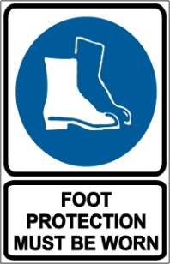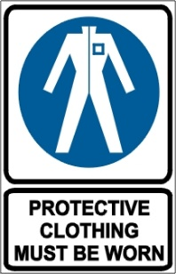

PRE-OPERATIONAL SAFETY CHECKS
- Check unit for loose/missing nuts, bolts and screws. Tighten and/or replace as needed.
- Inspect fuel lines, tank, and area around carburetor for fuel leaks. Do not operate unit if leaks are found.
- Ensure that all guards are fitted, secure and functional.
- Ensure the blade unit has a debris shield, has either a bar handle or a U-handle, and is suspended from a shoulder harness.
- Select the correct cutting tool for the task to be undertaken – refer to manufacturer’s specification.
- Load the nylon line cutting head only with nylon trimmer line of the proper diameter.
- Do not operate if the line cutter is missing.
- Before operating unit, thoroughly inspect blades for damage and cracks.
- When operating the unit with a blade, ensure the blade is attached to the unit as designed, such as with a locknut and cotter pin, and with the teeth pointing in the direction the blade head rotates.
- Faulty equipment must not be used. Report suspect machinery immediately.

OPERATIONAL SAFETY CHECKS
- Watch especially for ejected material and ensure that no person or animal is endangered when operating.
- Adjust the handle/s to a position for comfort and good balance.
- When starting, ensure the machine is in a clear area so the line or blade cannot contact the ground or any other obstruction.
- The muffler side of the engine should be away from your body to avoid burns.
- Maintain footing and balance at all times. Do not work on slippery, uneven or unstable surfaces.
- Maintain a straight wrist position. Avoid using your wrist in a bent, extended or twisted position for extended periods.
- Always keep both hands on the control handles. Do not operate one-handed.
- Do not raise the line or blade head above knee height.
- Keep machine clear of fences, wires, posts, rocks, etc. to prevent kick out and cutter head damage.
- Shut down immediately if the unit starts to shake or vibrate.
- After shutting down engine, keep fingers and feet away from cutting line or blade until all rotation stops.
- Disconnect spark plug wire before you work on the unit or leave it unattended.
- Take extreme caution when refuelling to avoid igniting fuel on hot exhaust or engine.

HOUSEKEEPING
- Remove any foreign material from engine, cutting tool and guards.
- Keep the work area and implement shed in a clean and tidy condition.

POTENTIAL HAZARDS
The blade can push, pull or kick out Noise
Entanglement Ejected materials

This SOP should be used in conjunction with Curriculum Activity Risk Management Modules
Acknowledgement: Much of the information for this document has been sourced from content kindly provided by Department for Education SA website.
Date of last review | ______/______/______ | Signature ______________________

