DRILL SEEDER – TRACTOR OPERATED

DO NOT use this machine unless a teacher has instructed you in its safe use and operation, and has given permission.

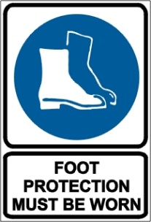

PRE-OPERATIONAL SAFETY CHECKS
- Operate only with roll over protection structure (ROPS) and seatbelt equipped tractors.
- Ensure that all guards are fitted, secure and functional.
- Ensure that the three point linkage, securing pinions and safety chains are in sound condition.
- Ensure that the rotary slasher is attached according to manufacturer’s specification.
- Ensure that hopper lid is locked or interlocked and that the interlocking device (if fitted) is functioning.
- Check the tyre pressure on the drill seeder and tractor.
- Ensure that the PTO and driveline guard is functioning.
- Ensure that hydraulic rams, hoses and couplings are in sound condition.
- Faulty equipment must not be used. Report suspect machinery immediately.

OPERATIONAL SAFETY CHECKS
- Keep clear of moving machine parts.
- Ensure that the seed metering mechanism is functioning and in sound condition.
- Ensure that towing mechanism, securing pinions and safety chains are in sound condition.
- Ensure that the coulters are in good sound condition.
- Ensure that the power source to the hopper is disengaged before opening the lid.
- Ensure that the hopper lid is locked after topping up with seed.
- Ensure that no person or animal is endangered when operating the equipment.

HOUSEKEEPING
- Remove any foreign material from coulters, spacers and hydraulic rams, etc.
- Keep the work area and implement shed in a clean and tidy condition.

POTENTIAL HAZARDS
Moving components
Noise
Loose clothing entanglement

This SOP should be used in conjunction with Curriculum Activity Risk Management Modules
Acknowledgement: Much of the information for this document has been sourced from content kindly provided by Department for Education SA website.

Date of last review | ______/______/______ | Signature ______________________

