FORKLIFT TRUCK

THIS VEHICLE IS NOT FOR STUDENT USE

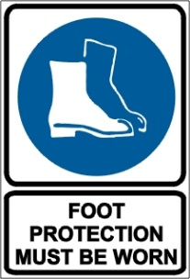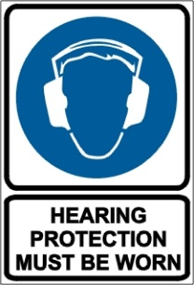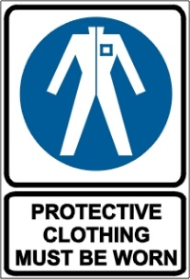

PRE-OPERATIONAL SAFETY CHECKS
- Check brakes, lights and horn before use.
- Ensure seat belt/safety restraint is in good condition.
- Know the capacity of the forklift or lift truck before using it. Do not use a forklift without a load rating plate.
- Always remember the safe working load of a forklift reduces as the mast is tilted forward.
- Ensure that the lifting forks are in sound condition and centred either side of the mast.
- Check tyre pressures. Never drive with a flat or under-inflated tyre.
- Faulty equipment must not be used. Report any faults immediately.

OPERATIONAL SAFETY CHECKS
- Do not use engine-powered forklifts in poorly ventilated areas.
- Always be on the lookout for pedestrians.
- Do not allow any person to ride on the forks.
- Ensure that the lifting tines are secure into the pallet and the load is stable before lifting or driving off.
- Be careful of ceiling clearance or overhead obstructions when raising the mast.
- Do not lift a load with the mast tilted forward.
- Always put the heavy end of the load against the load backrest.
- Never travel with the load elevated as it restricts vision.
- When approaching a blind corner, use horn and drive slowly.
- Always have someone guide you if a load restricts your vision.
- Slow down when changing direction or on wet or greasy surfaces.
- Do not travel with forks raised or reach mechanism extended.
- Avoid harsh braking, especially when carrying a load.
- Do not attempt to turn on an incline or sloping surface.
- Do not leave forks elevated when forklift is unattended.
- Do not dismount from a forklift while the engine is running unless the transmission is in park position and the parking brake is effectively engaged.
- When stopping the forklift:
- Park on even ground and lower the forks to the ground.
- Shift the gear selector to park position and apply the parking brake.
- Turn off the ignition and remove the keys.

REFUELLING & BATTERIES
- Do not refuel an engine-powered forklift unless the motor is stopped and ignition turned off.
- For gas powered vehicles change gas bottles in a well-ventilated area clear of a naked flame or source of ignition.
- In the case of electric vehicles wear protective eyewear and gloves when checking batteries and handling electrolyte.

This SOP should be used in conjunction with Curriculum Activity Risk Management Modules
Acknowledgement: Much of the information for this document has been sourced from content kindly provided by Department for Education SA website.
Date of last review | ______/______/______ | Signature ______________________

