HAMMERS AND MALLETS
BELT SANDER
DO NOT use any hand tool unless a teacher has instructed you in its
safe use and operation and has given permission
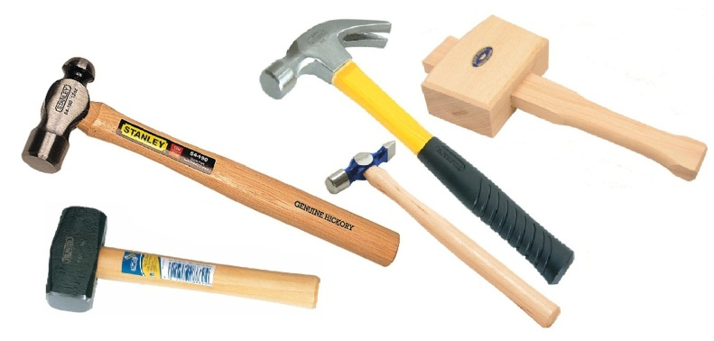
Safety glasses must be worn at all times in ITD practical workshops
Appropriate protective footwear is also required when using hammers.
This range of hand tools will usually include the following:
- Claw hammer, warrington hammer, brad hammer, ball pein hammer and cross pein hammer
- Club or lump hammer and sledge hammer
- Wooden mallet, bossing mallet and tinman’s mallet
- Rubber mallet, soft face mallet and dresser

OPERATIONAL SAFETY CHECKS
- It is important to choose the right hammer or mallet for the job. They will vary widely, and are all designed for specific purposes.
- Always inspect any hammer before use to make sure its head is firmly fixed to the handle.
- The head should have no unevenness, burring, chipped or worn edges or excessive wear.
- Always grip the handle tightly near the end of its length to provide maximum sticking force.
- Strike the hammer or mallet squarely, deliberately and accurately to avoid any mishits.
- Never deliberately strike the faces of two steel hammers together as this may cause small shards or chips to break away, potentially causing eye injury.
- Never deliberately strike a soft face hammer or mallet on metal edges or sharp objects.

HOUSEKEEPING
- Return all hammers to their appropriate storage cupboard.
- Leave the work area in a safe, clean and tidy condition.
- If the handle of a hammer or mallet is broken, loose, splintered or cracked, report it. Damaged handles will need to be replaced before being used again.
- The face of all soft faced hammers and mallets should be inspected regularly and maintained if worn or damaged.
POTENTIAL HAZARDS AND RISKS
■ Impact and striking ■ Pinch and squash ■ Lacerations ■ Eye injuries

Date of last review: ______________________________ Signature: _________________________________

