MARKING - OUT TOOLS
BELT SANDER
DO NOT use any hand tool unless a teacher has instructed you in its
safe use and operation and has given permission
 |  | Safety glasses must be worn at all times in ITD practical workshops. | 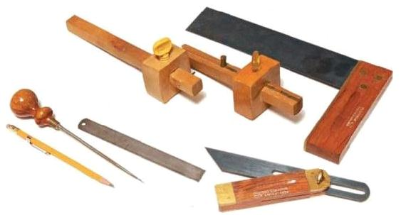
 |  | Appropriate protective footwear is also required in all ITD workshops.

This range of hand tools will usually include the following:
- Steel ruler, pencil, scriber and scratch gauge
- Try square, engineers square, combination square, roofing square and sliding bevel
- Marking gauge, mortise gauge and trammel
- Spring dividers and compass
OPERATIONAL SAFETY CHECKS
- It is important to choose the right marking-out tool for the job. They will vary widely, and are all designed for specific purposes.
- Never misuse or abuse any of the accurately machined hand tools designed for marking-out.
- To attain an accurate result when marking-out, carefully handle and align your ruler, try square, sliding bevel or marking gauge, etc. Take the time to “measure twice – cut once”.
- Always try to keep your marking-out tools clean and protected – away from the regular hand tools and power tools on your work bench.
- Some marking-out tools may require regular maintenance to ensure continued accuracy.

Date of last review: ______________________________ Signature: _________________________________
POTENTIAL HAZARDS AND RISKS
■ Lacerations from sharp cutting edges ■ Pinch and squash ■ Eye injuries

HOUSEKEEPING
- Leave the work area in a safe, clean and tidy condition.
- Return all marking-out hand tools to their appropriate storage cupboard, in a dry environment.
- Regularly clean and maintain the condition of all marking-out hand tools.
- Adjust and sharpen marking gauges and mortise gauges as required.
- Inspect and clean all squares. Remove all surface rust and glue, etc. They are normally not repairable if damaged. Discard and replace as required.

