PLIERS & GRIPS
BELT SANDER
DO NOT use any hand tool unless a teacher has instructed you in its
safe use and operation and has given permission
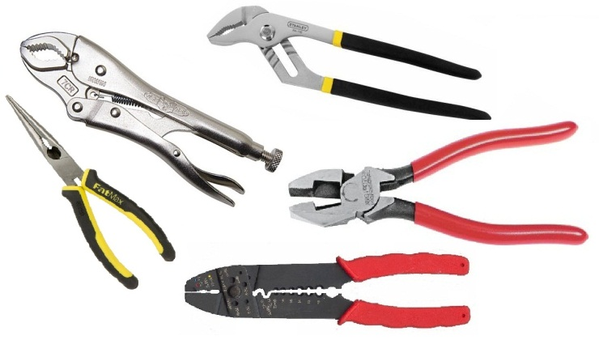
Safety glasses must be worn at all times in ITD practical workshops.
Appropriate protective footwear is also required in all ITD workshops.
This range of hand tools will usually include the following:
- Combination pliers, long nose pliers, pincers and circlip pliers
- Multi-grips, locking grips, adjustable grips and stillsons
- Riveting piers or rivet gun and wire stripping pliers

POTENTIAL HAZARDS AND RISKS
■ Pinch and squash ■ Impact and striking ■ Lacerations ■ Eye injuries

HOUSEKEEPING
- Return all pliers and grips to their appropriate storage cupboard, in a dry environment.
- Leave the work area in a safe, clean and tidy condition.
- Regularly clean the serrations on the gripping jaws of all foreign debris.
- Apply a little lubricant to all pivot points to keep the jaws operating freely.
OPERATIONAL SAFETY CHECKS
- It is important to choose the right pliers or gripping tool for the job. They will vary widely, and are all designed for specific purposes.
- It is important to grip the handles firmly. Ensure that your fingers are not near the jaws of the tool prior to applying load.
- Cushioned handles on pliers or grips are primarily for comfort – for all electrical work, always use the pliers, grips or cutters designed and appropriate for protective insulation.
- DO NOT hammer onto pliers or griping pincers to cut nails or steel wire.
- Never expose pliers or grips to excessive heat.
- Discard worn or damaged pliers and gripping tools that show any sign of damage.

Date of last review: ______________________________ Signature: _________________________________

