PUNCHES AND STAMPS
BELT SANDER
DO NOT use any hand tool unless a teacher has instructed you in its
safe use and operation and has given permission
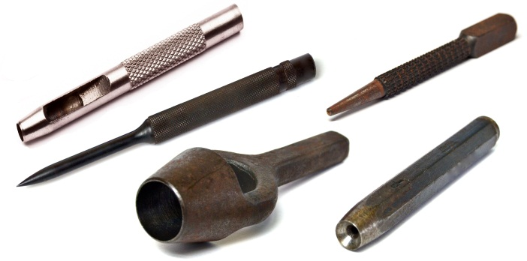
Safety glasses must be worn at all times in ITD practical workshops.
Appropriate protective footwear is also required in all ITD workshops.
This range of hand tools will usually include the following:
- Nail punch, centre punch, prick punch and pin punch
- Wad punch and hole punch
- Number and letter stamps
- Groove punch and rivet set

OPERATIONAL SAFETY CHECKS
- It is important to choose the right punch for the job. They will vary widely, and are all designed for specific purposes.
- Always wear appropriate safety glasses or goggles when using punches or stamping tools.
- All punches and stamping tools are used in conjunction with a hammer. Always select a hammer style and size that is appropriate for the punch selected.
- Excessive force with the hammer may cause a miss-strike, inaccurate indentations, or even personal injury to the operator or others nearby.

HOUSEKEEPING
- Leave the work area in a safe, clean and tidy condition.
- Return all punches and stamping tools to their appropriate storage cupboard.
- Regularly inspect and maintain all punches and stamps for damage.
- Grind off any “mushrooming” and re-shape the head correctly.
- If punches require sharpening, the grinding angle, shape or cutting profile is very specific to each style of punch.
- Discard and replace any Letter and Number stamping tools that show signs of damage.
POTENTIAL HAZARDS AND RISKS
■ Lacerations from sharp cutting edges ■ Striking and impact ■ pinch and squash ■ Eye injuries

Date of last review: ______________________________ Signature: _________________________________

