SNIPS & CUTTERS
BELT SANDER
DO NOT use any hand tool unless a teacher has instructed you in its safe use and operation and has given permission
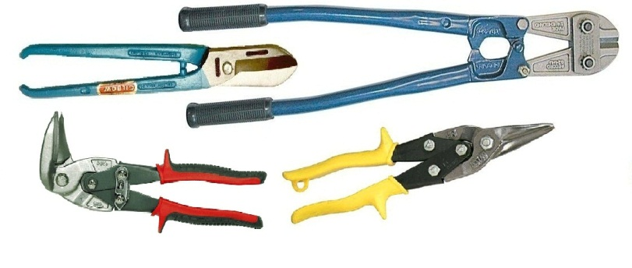
Safety glasses must be worn at all times when using snips and cutters.
Appropriate protective footwear is also required in all ITD workshops.
This range of hand tools will usually include the follow:
- Straight tin snips, Curved tin snips & Jewellers snips
- Aviation snips – straight cut, right hand, left hand, off-set & bulldog
- Bolt cutters

OPERATIONAL SAFETY CHECKS
- It is important to choose the right snips and cutting tools for the job. They will vary widely, and are all designed for specific purposes.
- It is important to grip the handles firmly. Only use snips and cutters that are in good condition.
- Squeeze the handles together with just enough force to produce a short, accurate cut line.
- Avoid pinching your hand with the end of the handles when the snips close completely.
- Never run your fingers along a recently cut edge of sheet metal. Sharp burrs are often present.
- Avoid misuse of tin snips. Their blades are designed to sheer thin metal only.
- DO NOT attempt to cut wire or nails with tin snips. This could indent and dull the blades.
- Bolt cutter blades or jaws are designed, however, to sever through round wire, rod and bolts, etc.

POTENTIAL HAZARDS AND RISKS
■ Lacerations from sharp cutting edges ■ Pinch and squash ■ Eye injuries

HOUSEKEEPING
- Return all snips and cutting tools to their appropriate storage cupboard, in a dry environment.
- Leave the work area in a safe, clean and tidy condition.
- Regularly clean, tighten and maintain all snips and bolt cutter tools.
- Apply a little light oil or lubricant to all pivot points and blades to keep the jaws operating freely.

Date of last review: ______________________________ Signature: _________________________________

