POWER BLOWER – PETROL OPERATED

DO NOT use this machine unless a teacher has instructed you in its safe use and operation and has given permission.

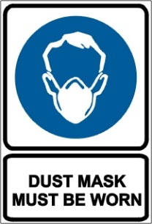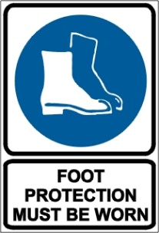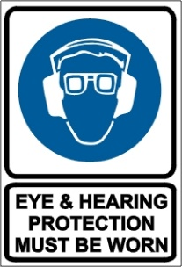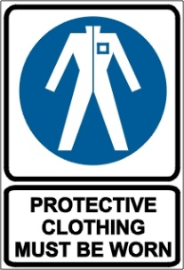

PRE-OPERATIONAL SAFETY CHECKS
- Check unit for loose/missing nuts, bolts and screws. Tighten and/or replace as needed.
- Inspect fuel lines, tank, and area around carburetor for fuel leaks. Do not operate machine if leaks are found.
- Do not use any attachment or accessory unless it is recommended in the operator's manual.
- Ensure that all guards are fitted, secure and functional.
- Faulty equipment must not be used. Report suspect machinery immediately.

OPERATIONAL SAFETY CHECKS
- Ensure that no person or animal is endangered when operating equipment.
- When starting stand the machine upright on a level surface. Check that blower pipe is not blocked by the ground or by any objects.
- Allow the machine to warm up at fast idle for a few minutes before using.
- Keep a firm grip. Hold handle with fingers together encircling handle.
- Maintain a straight wrist position. Avoid using your wrist in a bent, extended or twisted position.
- The muffler side of the engine should be away from your body to avoid burns.
- Maintain footing and balance at all times. Do not work on slippery, uneven or unstable surfaces. Do not work in odd positions or on ladders.
- Never use a higher speed setting then necessary to perform a task.
- Do not direct the blower in the direction of other people.
- Take wind conditions into account. Avoid open doors and windows.
- Minimize dust by using blower at lower speeds.
- Always keep exhaust area clear of flammable debris.
- Disconnect spark plug wire before you work on the unit or leave it unattended.
- Allow the engine and muffler to completely cool before performing any maintenance activity.
- Do not refuel a hot engine.

HOUSEKEEPING
- Remove any foreign material from engine, air intake and guards.
- Keep the work area and implement shed in a clean and tidy condition.

POTENTIAL HAZARDS
Noise Flying debris Dust Vibration Burns from exhaust

This SOP should be used in conjunction with Curriculum Activity Risk Management Modules
Acknowledgement: Much of the information for this document has been sourced from content kindly provided by Department for Education SA website.

Date of last review | ______/______/______ | Signature ______________________

