POWER TAKE OFF (PTO)

DO NOT use this machine unless a teacher has instructed you in its safe use and operation and has given permission.

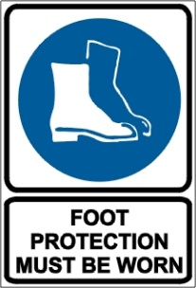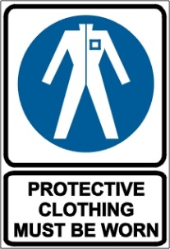

Do not wear loose or bulky clothing around the PTO or other moving parts.

PRE-OPERATIONAL SAFETY CHECKS
- Wear close fitting clothing and keep long hair covered.
- Ensure PTO and driveline guarding is correctly installed and properly maintained.
- Before installing or using PTO- driven equipment, read the manufacturer’s manual and review the safety labels attached to the equipment.
- Use only implements that meet the specifications listed in the vehicle operation manual.
- Before attaching PTO-powered equipment, confirm that the tractor drawbar is adjusted to the length specified in the driven machines manual.
- Do not use a machine with damaged or missing PTO or driveline guards. Report suspect machinery immediately.

OPERATIONAL SAFETY CHECKS
- Start the engine only from the operator’s seat. Never start engine while standing on the ground.
- Before starting the engine ensure that all levers are in their neutral positions, that the parking brake is engaged, and that both the clutch and PTO are disengaged.
- Ensure the clutch pedal is fully depressed to stop the tractor movement and any PTO-driven equipment movement before shifting the PTO gearshift lever.
- Operate the PTO from the lower speed (540 rpm) unless the equipment manufacturer specifically recommends the higher speed (1000 rpm) is safe.
- When operating stationery PTO driven equipment always apply the tractor parking brake, place chocks behind and in front of rear wheels and stay well clear of all rotating parts.
- Keep all bystanders away from PTO driven equipment.
- Always walk around operating equipment. Never step onto or across a PTO shaft or driveline.
- Wait until all moving components have completely stopped before getting off the tractor, connecting, disconnecting, adjusting, cleaning, or servicing any PTO equipment.
- When shutting down disengage the PTO, shut off the tractor engine and remove the keys before leaving the tractor seat.

HOUSEKEEPING
- Keep warning labels clean and free from obstructing material. Replace damaged or missing labels with new labels available from equipment supplier.
- Keep the work area in a clean and tidy condition.

POTENTIAL HAZARDS
Noise Flying debris Dust Vibration Burns from exhaust

This SOP should be used in conjunction with Curriculum Activity Risk Management Modules
Acknowledgement: Much of the information for this document has been sourced from content kindly provided by Department for Education SA website.

Date of last review | ______/______/______ | Signature ______________________

