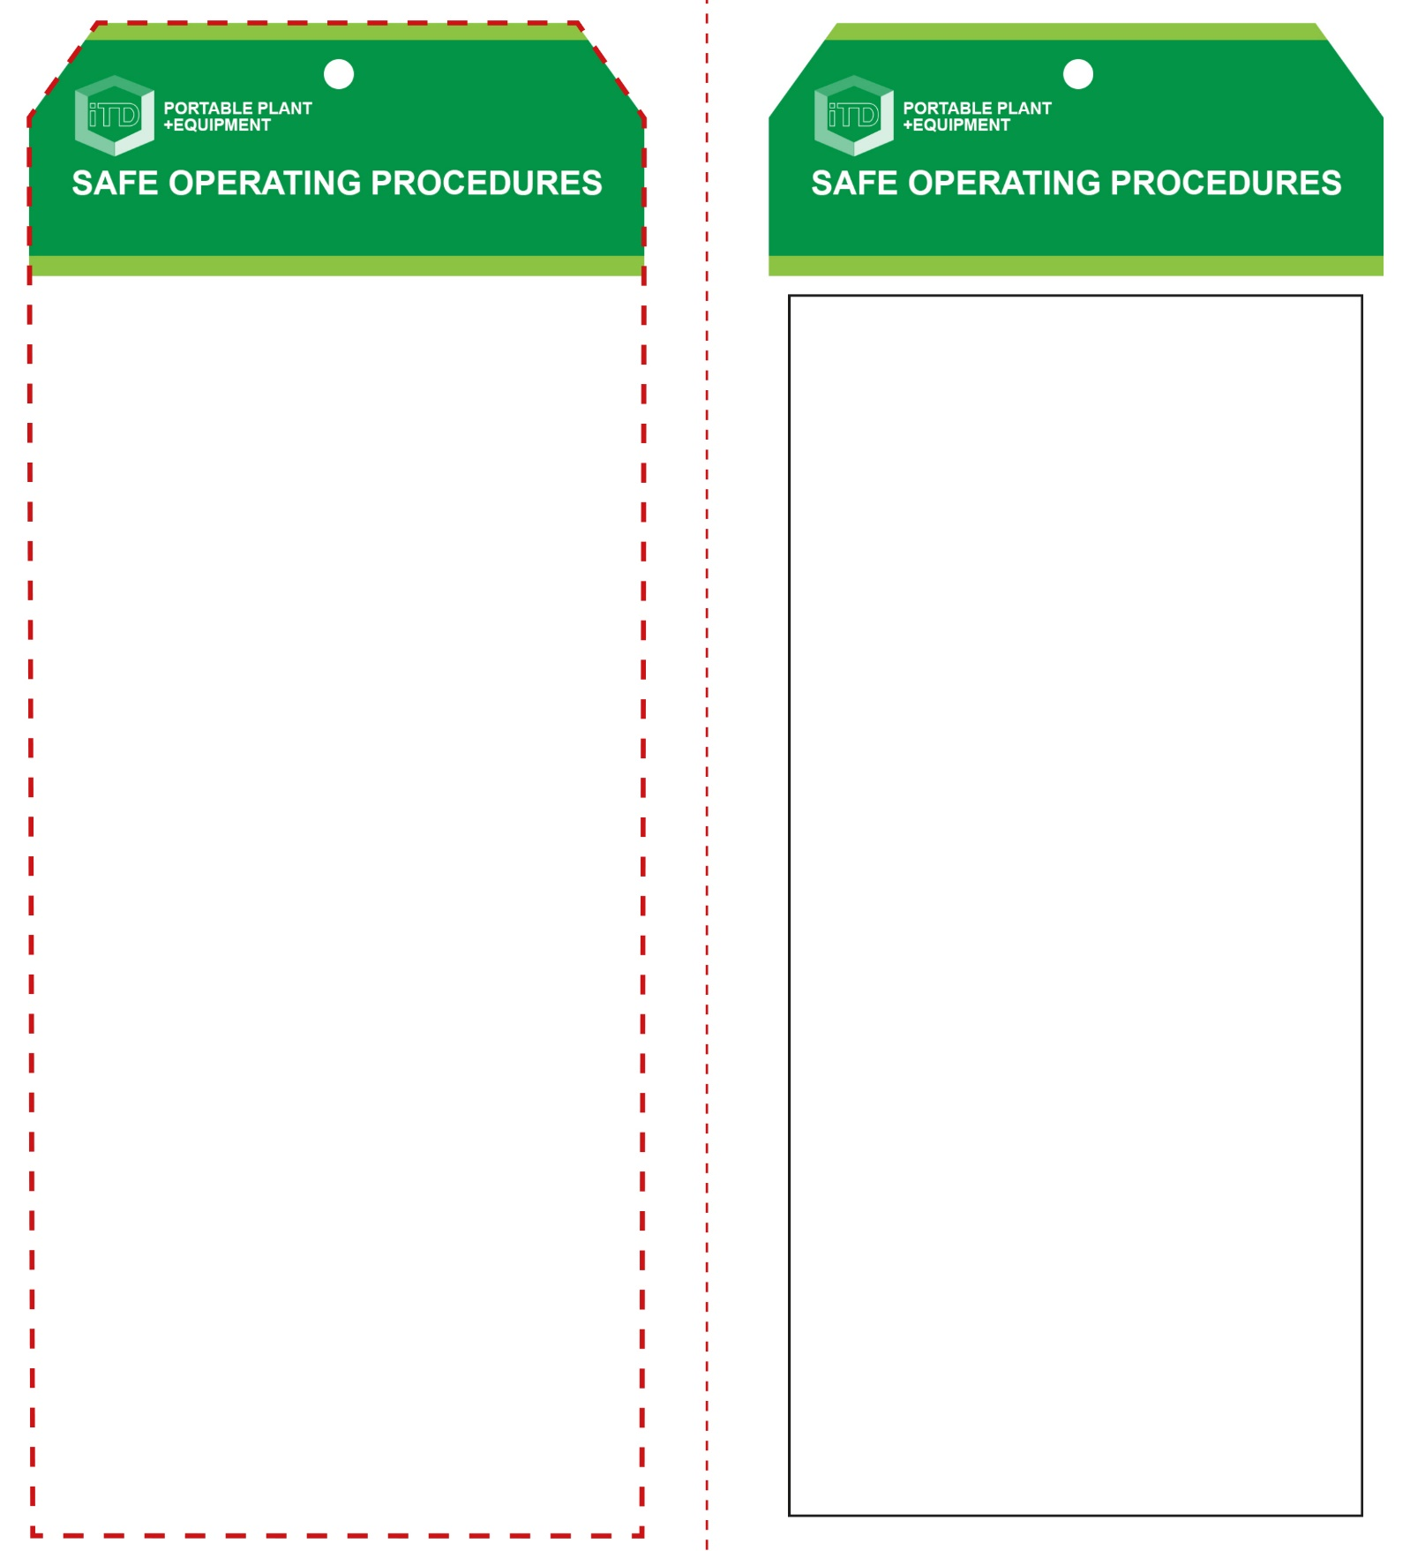

**Students must read this important information before using the equipment**

|  |  |
| --- | --- |
| Has your teacher given you instruction on the safe use and operation of this equipment? | |
|  | |
| Has your teacher given permission  for you to use this equipment? | |
|  | Approved safety glasses *must* be worn at all times in all ITD workspaces. |
|  | Appropriate protective footwear with substantial uppers *must* be worn in all ITD workspaces. |
|  | Hearing protection *must* be worn when noise levels are identified as excessive. |
|  | Contain or restrain long and loose hair and remove exposed rings or jewellery. |
| **PRE-OPERATIONAL SAFETY CHECKS**   1. Ensure the compressor has a suitable safe work area. 2. Examine the power lead for obvious damage. 3. Examine all air hoses, connections and couplings. 4. Check any air tools and accessories for serviceability. 5. Faulty compressed air equipment must be reported. 6. Locate and be familiar with the ON/OFF controls. | |

**OPERATIONAL SAFETY CHECK**

|  |
| --- |
| **Never operate a faulty electrical power tool. Report it to your teacher.** |
| 1. Start the compressor noting the pressure gauge increase and the cut-in/cut-out pressure levels. 2. Listen for any air leaks from all flexible airlines or hoses and immediately report any leaks that are observed. 3. Adjust the pressure regulator to suit the particular work requirements. 4. Always check these pressures at regular intervals during normal operation. 5. Air hose connections must be secured and checked prior to being pressurised. 6. If possible, position the compressor unit in an area that will not disturb or obstruct the workshop environment. 7. Use compressed air power tools responsibly and within the manufacturer’s recommended guidelines. 8. Compressed air cleaning of machine parts must only be undertaken after all PPE and general workshop safety precautions have been observed. 9. Never use the compressed air to clean down work benches, floors or dust from clothing. 10. Never kink an air hose to restrict or cut off the flow of air. |
| **Never direct compressed air towards the body** |
| **HOUSEKEEPING**   1. Return this tool to the appropriate storage cupboard 2. Leave the work area in a safe, clean and tidy condition.   **POTENTIAL HAZARDS AND RISKS**  ■ Moving and rotating parts ■ Electricity  ■ Pinch and squash ■ Noise ■ Dust ■ Burns  ■ Compressed air ■ Eye injuries |

**Air Compressor**

**Air Compressor**

**Front Reverse**

**Assembly instructions:**

1. Carefully fold this page in half vertically down the centre line
2. This should align ‘Front’ and ‘Reverse’ sides, then glue the halves back to back
3. Cut out the ‘Tag’ shape along the RED dotted outlines indicated on the ‘Front’ side
4. Laminate and trim to size with a clear 2mm border
5. Securely fasten an 8mm (ID) brass eyelet and washer where indicated.