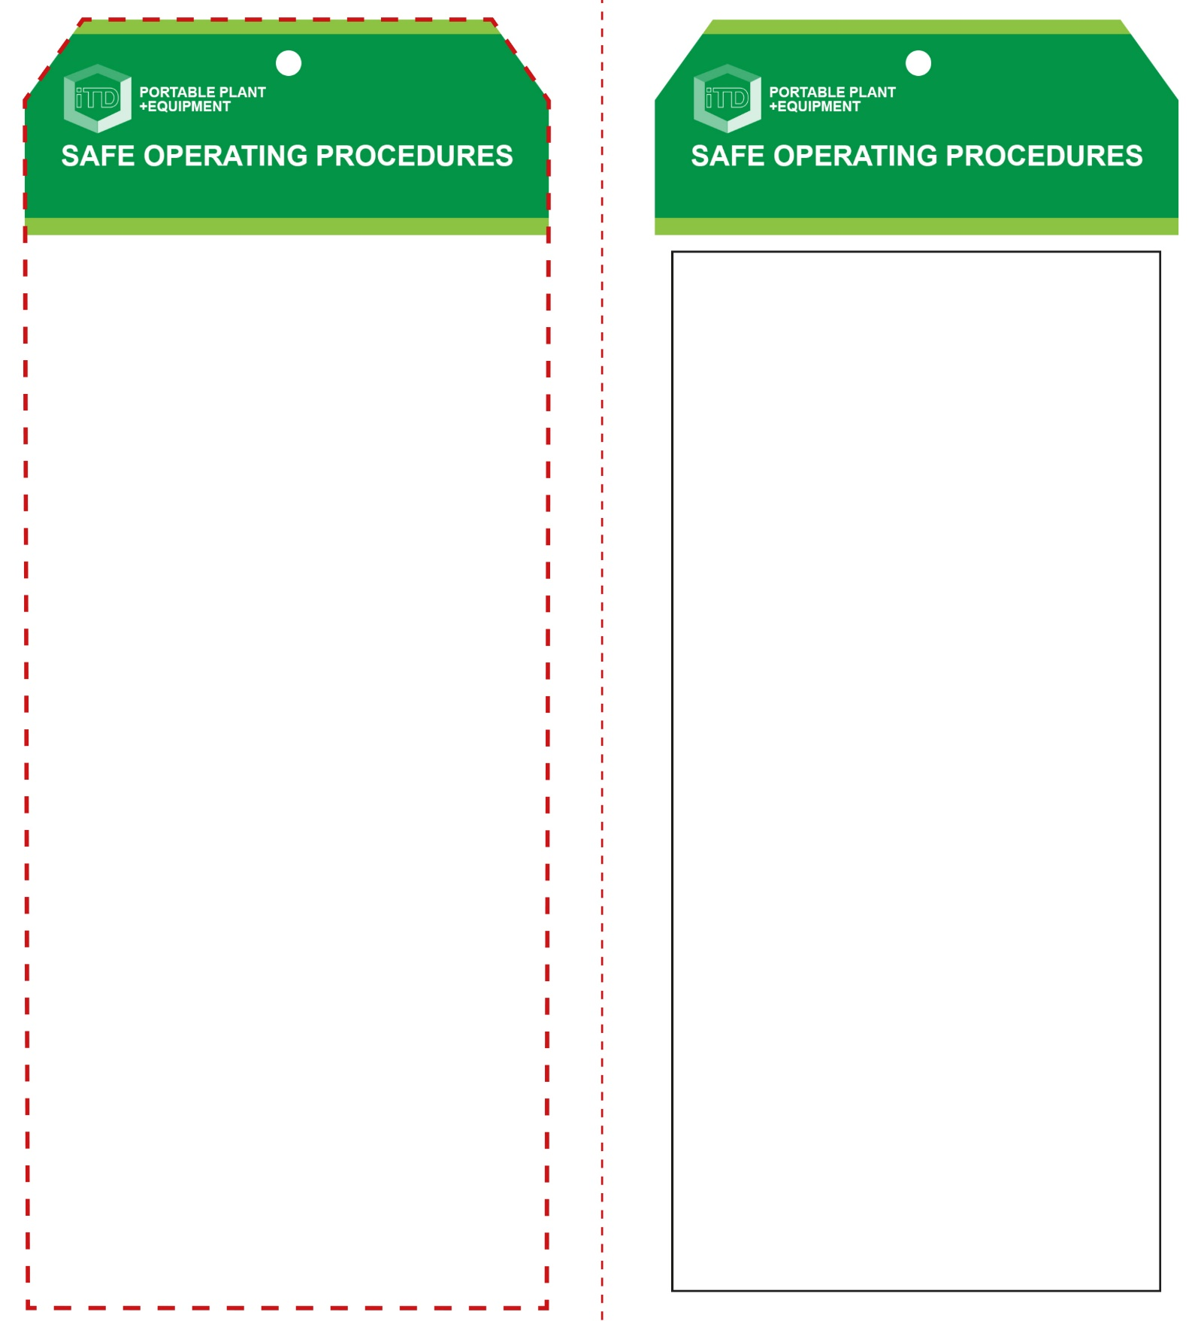

**Students must read this important information before using the equipment**

|  |  |
| --- | --- |
| Has your teacher given you instruction on the safe use and operation of this equipment? | |
|  | |
| Has your teacher given permission  for you to use this equipment? | |
|  | Approved safety glasses *must* be worn at all times in all ITD workspaces. |
|  | Appropriate protective footwear with substantial uppers *must* be worn in all ITD workspaces. |
|  | Hearing protection*(Class 5 – SLC80 >26 dB)* *must* be worn at all times when using this equipment. |
|  | A mask *should* be worn when excessive airborne dusts or fumes are created. |
| Prohibition circle | Remove all rings and jewellery. |
| **PRE-OPERATIONAL SAFETY CHECKS**   1. Ensure the mixer is in a suitable safe work area and select a firm, level and stable ground surface. 2. Confirm the mixer has a current electrical safety tag. 3. Ensure that the power lead can be kept dry, off the ground and connected through an RCD safety switch. 4. Ensure all safety guards are correctly fitted and secured. 5. Ensure that the unit is mechanically sound. 6. Check the tyres for appropriate inflation. | |

**OPERATIONAL SAFETY CHECK**

|  |
| --- |
| **Never operate a faulty electrical power tool. Report it to your teacher.** |
| 1. Never use the electrical mixer outdoors in the rain. 2. Never use the mixer without all guarding in place. 3. Ensure that the area does not contain any hazards that may impact on the safe operation of the mixer. 4. Never insert your hands into a rotating mixer bowl. 5. Be conscious of your manual handling techniques when adding cement powder, gravel or sand to the mixer bowl using a shovel or similar. 6. Regularly inspect the mixer bowl for consistency and suitability for the concrete mix. 7. Never leave the mixer running unattended. |
| **Never allow arms or hands into a moving bowl** |
| **HOUSEKEEPING**   1. Empty the mixer drum of all contents. 2. While still wet, wash out with clean water. 3. Allow the mixer to revolve to wash the interior and carefully clean off the exterior. 4. Disconnect the electrical AC power source. 5. Clean up the work area. 6. Return the mixer to a secured storage area.   **POTENTIAL HAZARDS AND RISKS**  ■ Moving, rotating parts ■ Entrapment  ■ Eye injuries ■ Electricity  ■ Manual handling  ■ Skin irritation from cement or additives  **FORBIDDEN**  ■ Never use compressed air to clean off the mixer, clothing or floor surfaces |

**Concrete Mixer**

**Concrete Mixer**

**Front Reverse**

**Assembly instructions:**

1. Carefully fold this page in half vertically down the centre line
2. This should align ‘Front’ and ‘Reverse’ sides, then glue the halves back to back
3. Cut out the ‘Tag’ shape along the RED dotted outlines indicated on the ‘Front’ side
4. Laminate and trim to size with a clear 2mm border
5. Securely fasten an 8mm (ID) brass eyelet and washer where indicated.