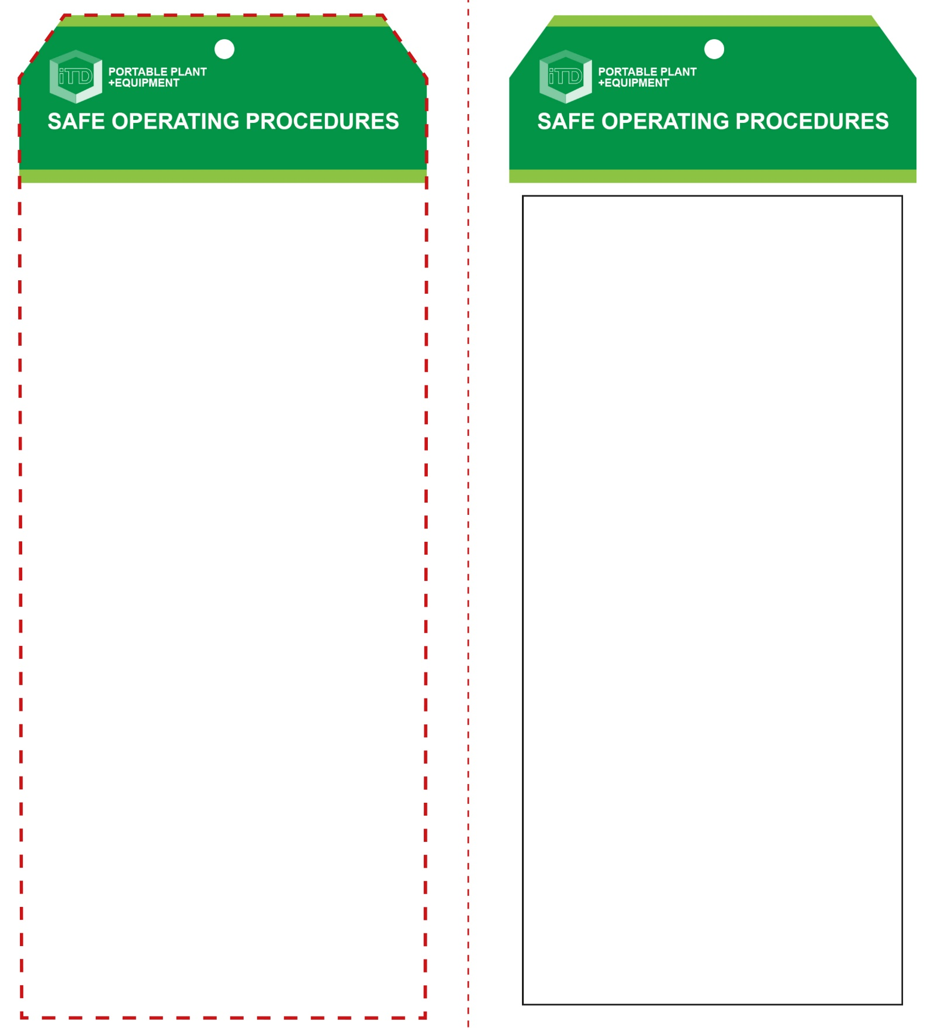

**Students must read this important information before using the equipment**

|  |  |
| --- | --- |
| Has your teacher given you instruction on the safe use and operation of this equipment? | |
|  | |
| Has your teacher given permission  for you to use this equipment? | |
|  | Approved safety glasses *must* be worn at all times in all ITD workspaces. |
|  | Appropriate protective footwear with substantial uppers *must* be worn in all ITD workspaces. |
|  | Hearing protection may be necessary when noise levels are considered excessive. |
|  | A dust mask may be necessary when excessive airborne dust levels are considered excessive. |
|  | Protective clothing or a suitable workshop apron is advisable. |
| **PRE-OPERATIONAL SAFETY CHECKS**   1. Ensure you have a suitable safe work area. 2. Examine the drill and battery for obvious damage. 3. Do not use dull or damaged drill or driver bits. 4. Check the correct drill or driver bit is correctly fitted. 5. Avoid wearing loose clothing that may cover your hands possibly causing injury or broken drill bits. | |

**OPERATIONAL SAFETY CHECK**

|  |
| --- |
| **Never operate a faulty electrical power tool. Report it to your teacher.** |
| 1. Fit the battery after all adjustments have been made. 2. Examine the material to be drilled for splits, loose knots and nails, etc. 3. Select and securely tighten the correct drill or driver bit. 4. Keep fingers, hands, clothing and hair, etc. well clear of the rotating drill chuck, drill bit or driver bit. 5. Beware of hot drill bits caused by friction or abrasion. 6. Securely clamp your project to a stable work surface to avoid having hands and fingers close to the hot drill bit. 7. Allow the drill to reach operating speed, then apply load gradually. Do not apply excessive force. 8. Cordless hand drills or screwdrivers normally will not operate when the battery charge level is too low. 9. Avoid blocking and covering the motor ventilation slots with your hands. 10. Be cautious of drilling too close to edges and corners. |
| **Look before you drill – inspect for live wires** |
| **HOUSEKEEPING**   1. After use, return the battery for recharging. 2. Leave the work area in a safe, clean and tidy condition.   **POTENTIAL HAZARDS AND RISKS**  ■ Moving, rotating parts ■ Dust  ■ Noise ■ Burns (friction)  ■ Eye injuries |

**Hand Drill – cordless**

**Hand Drill – cordless**

**Front Reverse**

**Assembly Instructions:**

1. Carefully fold this page in half vertically down the centre line
2. This should align “Front” & “Reverse” sides, then glue the halves back to back
3. Cut out the “Tag” shape along the RED dotted outlines indicated on the “Front” side
4. Laminate & trim to size with a clear 2 mm border
5. Securely fasten an 8mm (ID) brass eyelet and washer where indicated.

*Website link to this SOP document:* <http://education.qld.gov.au/health/safety/hazards/equip-resources.html>