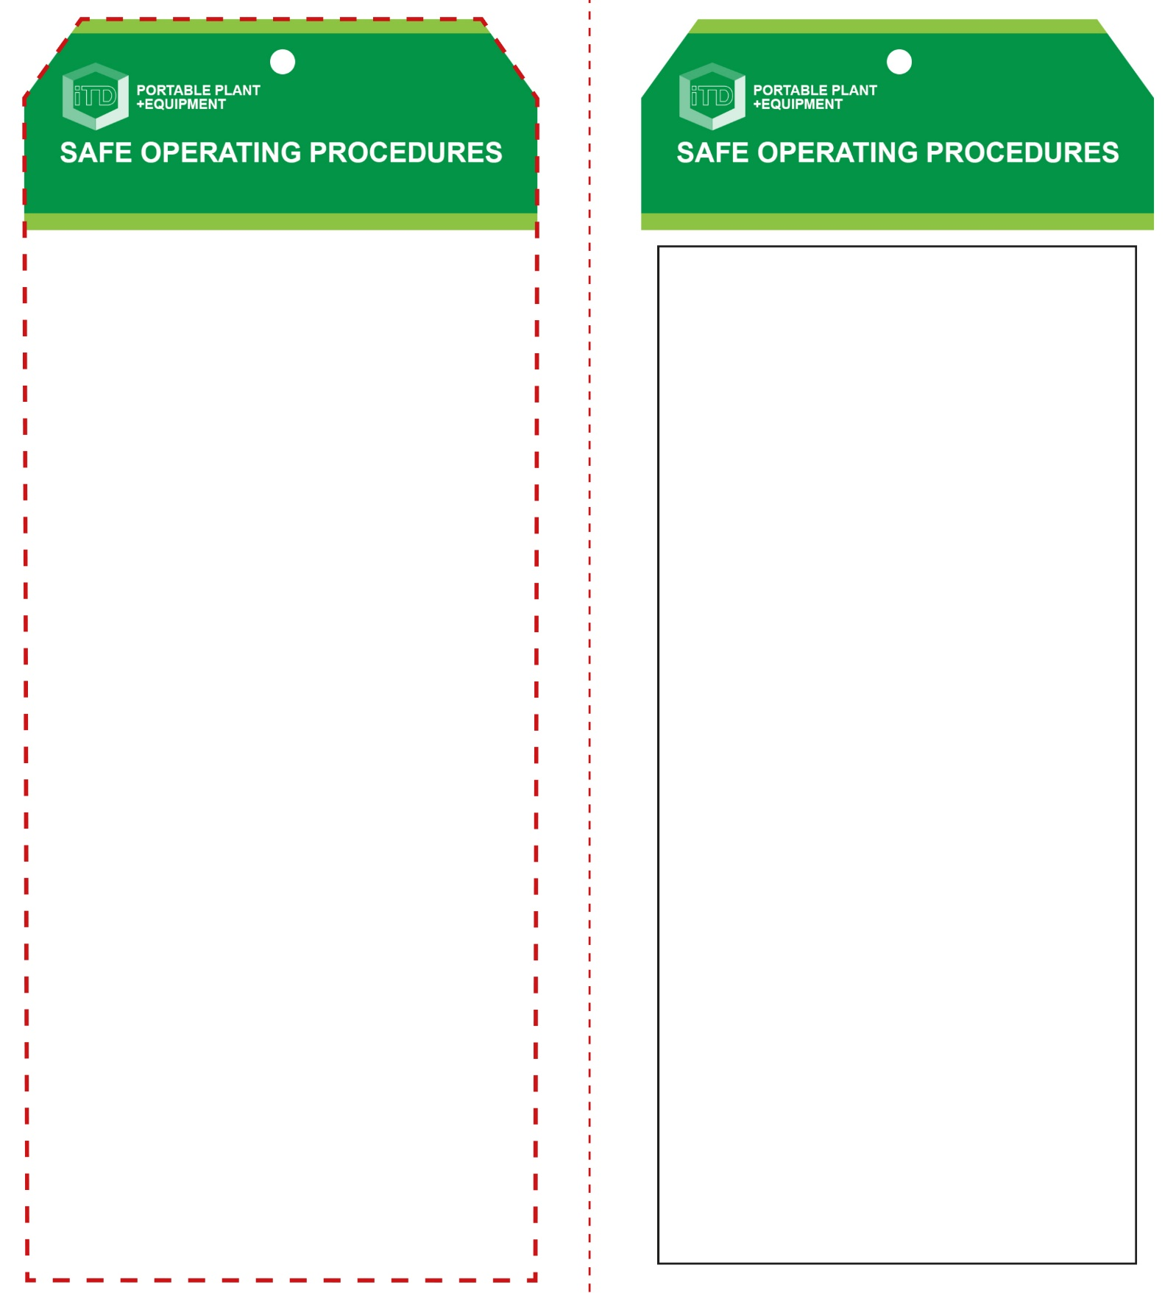

**Students must read this important information before using the equipment**

|  |  |
| --- | --- |
| Has your teacher given you instruction on the safe use and operation of this equipment? | |
|  | |
| Has your teacher given permission  for you to use this equipment? | |
|  | Approved safety glasses *must* be worn at all times in all ITD workspaces. |
|  | Appropriate protective footwear with substantial uppers *must* be worn in all ITD workspaces. |
| Hand Protection circle | Protective cotton gloves must be worn when using the hot plastics. |
| Hair Protection circle | Long or loose hair must be restrained and contained. |
| Prohibition circle | All rings and jewellery must be removed. |
| **PRE-OPERATIONAL SAFETY CHECKS**   1. Familiarise yourself with the granulator operations and controls. 2. Never attempt to shed/granulate materials other than plastics. However, thermosetting plastics can only be heated and moulded once and are not commonly recycled. 3. Identify the recyclable plastics materials suitable for thermoforming i.e. use only thermoplastics such as acrylic, polypropylene and HDPE (such as milk bottles, etc.) 4. Faulty or damaged equipment must not be used. Immediately report this to your teacher. | |

**OPERATIONAL SAFETY CHECK**

|  |
| --- |
| **Never operate a faulty electrical power tool. Report it to your teacher.** |
| 1. Make all adjustments to the granulator before turning it on. 2. Feed the material gradually and carefully. Never use force to load the paper feed hopper. 3. Beware of ejected material from the feed hopper. 4. Eye protection is absolutely mandatory as minimum PPE before operating this machine. 5. Wear appropriate hearing protection as required against excessive noise. 6. Never attempt to remove any material that may have become jammed in the top feed hopper, grinding mechanism or lower collection tray. Always turn the machine off at the wall first. |
| **Eye protection is absolutely mandatory when operating this machine** |
| **HOUSEKEEPING**   1. Turn the granulator unit off and unplug after use. 2. Always leave the machine in a safe, clean and tidy condition. Clean the lower collection tray. 3. Inspect all externally fixed guarding for condition and functionality. 4. Inspect and clean the shedding blades (by the teacher, only as required).   **POTENTIAL HAZARDS AND RISKS**  ■ Hot machine parts ■ Electricity  ■ Eye injuries ■ Dust ■ Pinch and squash ■ Compressed air |

**Granulator**

**Granulator**

**Front Reverse**

**Assembly instructions:**

1. Carefully fold this page in half vertically down the centre line
2. This should align ‘front’ and ‘reverse’ sides, then glue the halves back to back
3. Cut out the ‘tag’ shape along the RED dotted outlines indicated on the ‘front’ side
4. Laminate and trim to size with a clear 2mm border
5. Securely fasten an 8mm (ID) brass eyelet and washer where indicated.