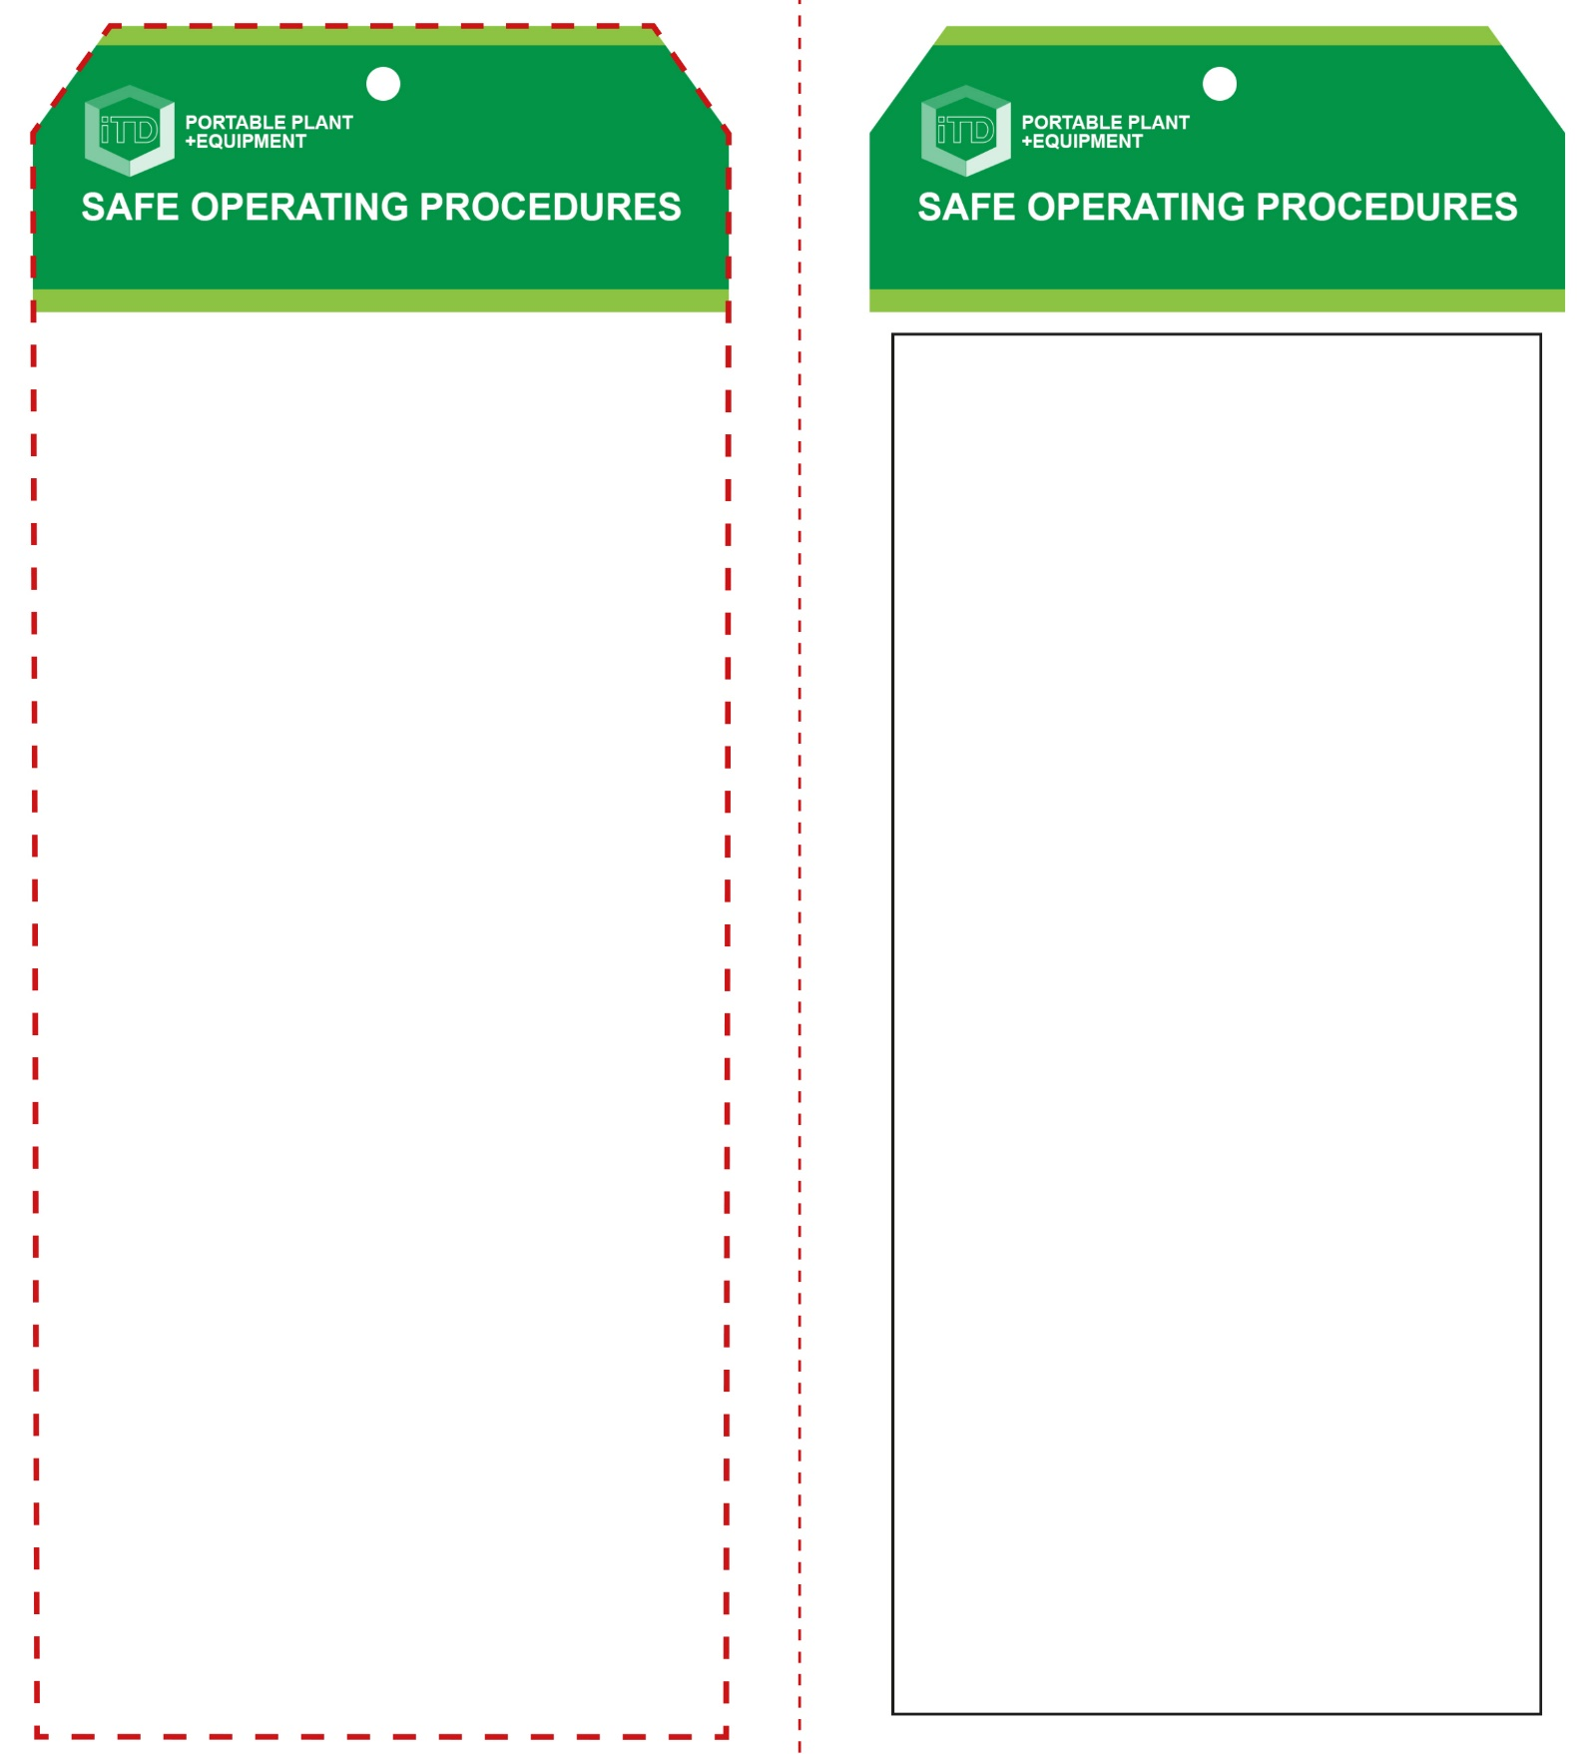

**Students must read this important information before using the equipment**

|  |  |
| --- | --- |
| Has your teacher given you instruction on the safe use and operation of this equipment? | |
|  | |
| Has your teacher given permission  for you to use this equipment? | |
|  | Approved safety glasses *must* be worn at all times in all ITD workspaces. |
|  | Appropriate protective steel-toed boots must be worn. |
|  | Appropriate hearing protection (*Class 5 – SLC80 >26 dB*) must be worn |
| Hard hat | A hard hat must be worn |
|  | A suitable P2 or P3 filter mask *must* be worn whenever potentially toxic smoke and fumes are created. |
|  | Sturdy, long work wear, a suitable protective workshop apron and leather gloves must be worn. |
| Prohibition circle | All exposed rings and jewellery must be removed. |
| **PRE-OPERATIONAL SAFETY CHECKS**   1. Ensure your work area is safe – well lit, with no flammable liquids, gases or dust. 2. Establish an exclusion zone with barricading and appropriate safety signage. 3. Establish the location of all underground utilities. 4. Be aware of common overuse injuries i.e. hearing loss and back pain. 5. Inspect the equipment for any obvious mechanical defects. | |

**OPERATIONAL SAFETY CHECK**

|  |
| --- |
| **Never operate a faulty electrical power tool. Report it to your teacher.** |
| 1. Ensure all components, attachments and guards are secure before starting. 2. Know the best way to do the job. Review any operational procedures. 3. Be aware that this power tool is designed to create severe vibration. The hands, arms and legs will quickly tire. Take regular breaks. 4. Always use two hands. Ensure you have a firm footing and are ready to handle any reaction from the tool. 5. Operators should be ready to brace themselves against the high level of torque exerted by the tool. 6. Apply slight pressure on the tool. Pressing very hard will not increase efficiency. Stop operation if the tool bounces around uncontrollably. 7. Do not touch the bit immediately after operation. It may be extremely hot. 8. Do not operate this power tool at no-load unnecessarily. 9. To stop, release the handle grip switch. Turn off and disconnect after use. 10. Never leave this power tool unattended. |
| **NB. This power tool can produce excessive noise levels greater than 105dB** |
| **HOUSEKEEPING**   1. Leave the power tool in a safe, clean and tidy state. 2. Stow away correctly. Remove any barricading and safety warning signage.   **POTENTIAL HAZARDS AND RISKS**  ■ Moving, rotating and sharp parts ■ Excessive noise  ■ Pinch and squash ■ Eye injuries  ■ Slips, trips and falls ■ Ejected material  ■ High pressure air hose ■ Loss of control  ■ Dust and fumes – incl. crystalline silica  ■ Manual handling – incl. vibration, duration and force  **FORBIDDEN**  ■ Never operate on a continuous or repetitive basis. Always take multiple breaks. |

**Jackhammer**

**Jackhammer**

**Front Reverse**

**Assembly instructions:**

1. Carefully fold this page in half vertically down the centre line.
2. This should align ‘front’ and ‘reverse’ sides, then glue the halves back to back.
3. Cut out the ‘tag’ shape along the RED dotted outlines indicated on the ‘front’ side.
4. Laminate and trim to size with a clear 2mm border.
5. Securely fasten an 8mm (ID) brass eyelet and washer where indicated.