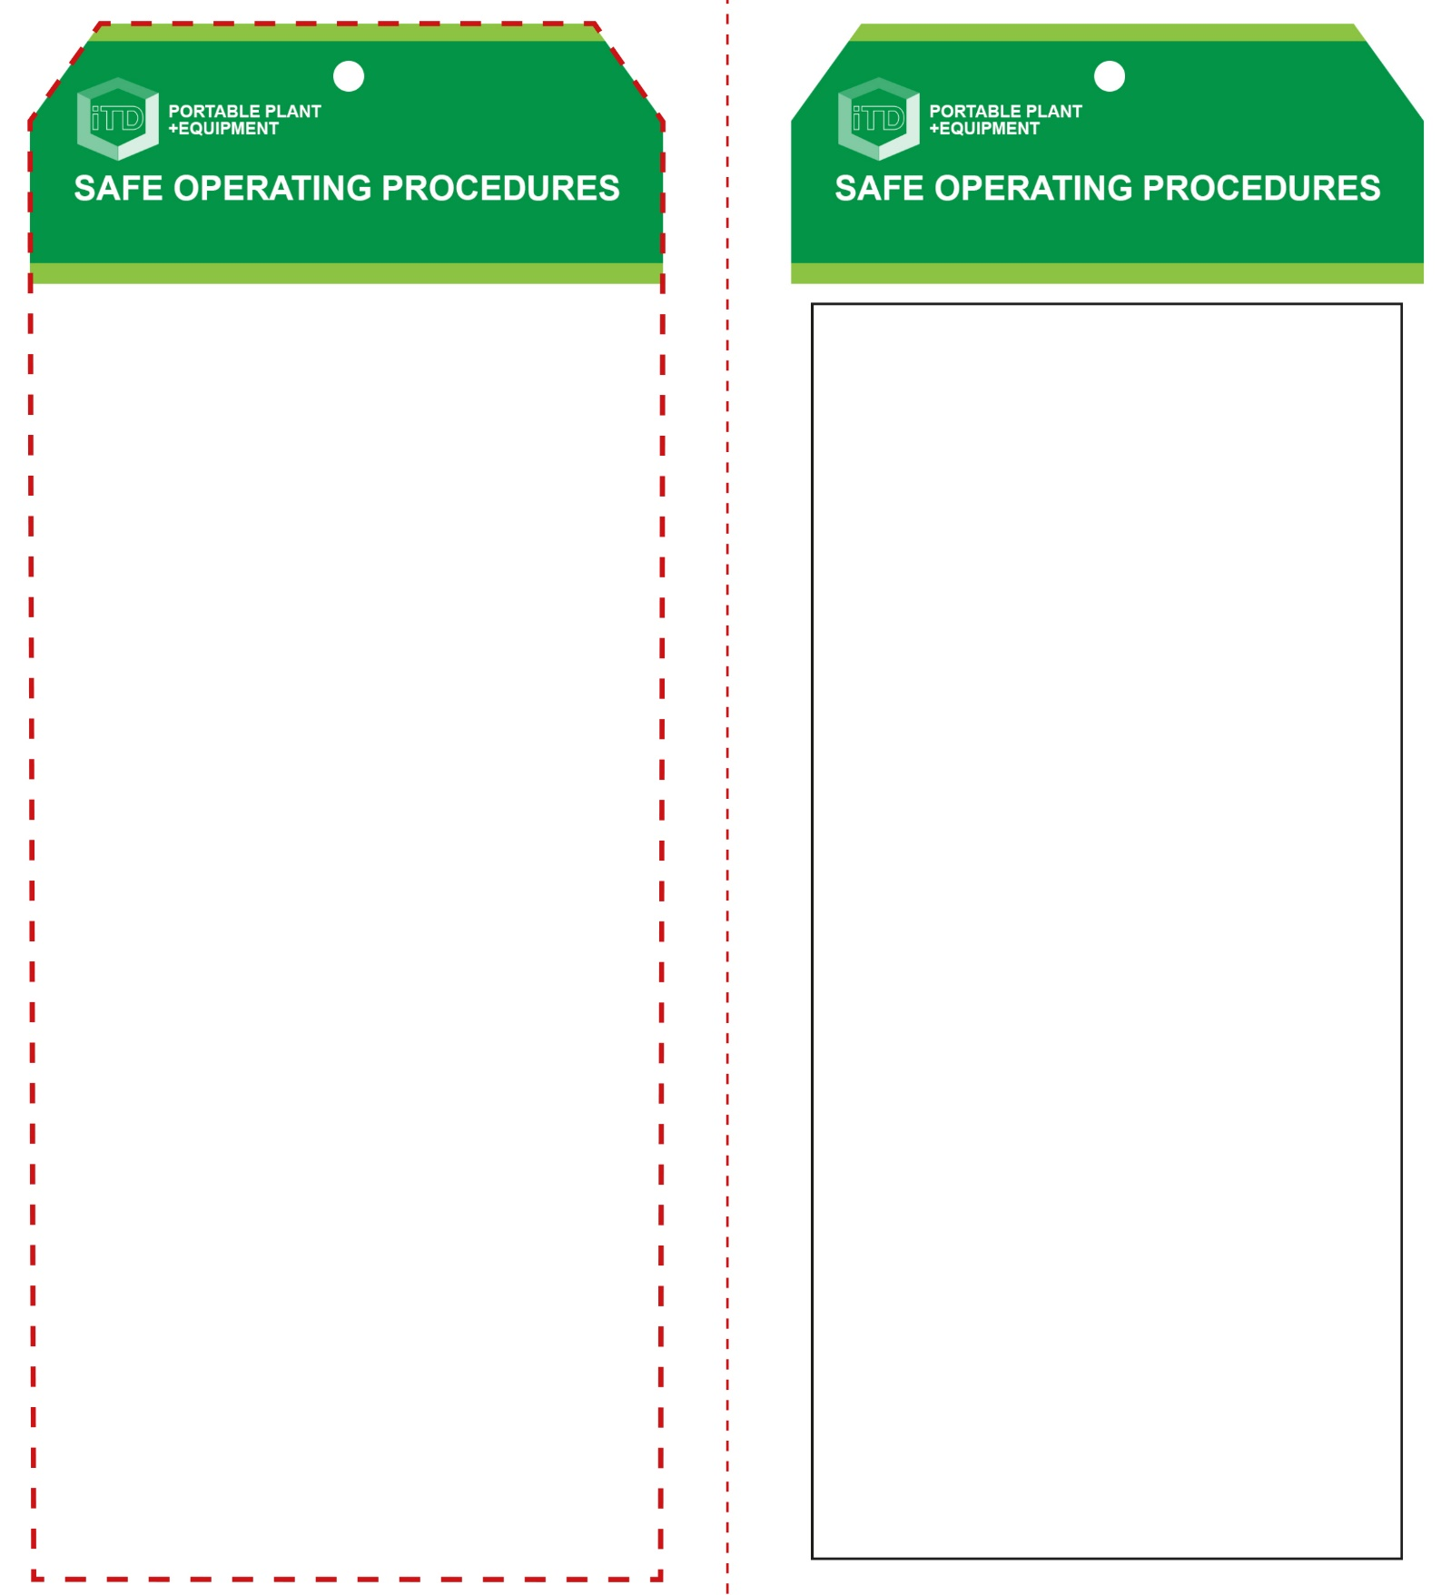

**Students must read this important information before using the equipment**

|  |  |
| --- | --- |
| Has your teacher given you instruction on the safe use and operation of this equipment? | |
|  | |
| Has your teacher given permission  for you to use this equipment? | |
|  | Approved safety glasses *must* be worn at all times in all ITD workspaces. |
|  | Appropriate protective footwear with substantial uppers *must* be worn in all ITD workspaces. |
|  | Contain or restrain long and loose hair and remove exposed rings or jewellery. |
|  | A suitable workshop apron or close fitting protective clothing must be worn. |
|  | Gloves *must not* be worn when using this portable power tool. |
| **PRE-OPERATIONAL SAFETY CHECKS**   1. Ensure this power tool has a suitable safe work area. 2. Make sure blade is intact and suits the material to be cut. 3. Examine the jigsaw and battery for obvious damage. 4. Plan a sawing procedure to minimise backing out. | |

**OPERATIONAL SAFETY CHECK**

|  |
| --- |
| **Never operate a faulty electrical power tool. Report it to your teacher.** |
| 1. Examine the material to be cut for splits, loose knots. 2. Ensure the material is secure and well-supported. 3. Fit the battery after all adjustments have been made. 4. Check the underside of the cut to ensure that the blade will not cause any damage or be obstructed. 5. Allow the machine to reach full speed before starting a cut – always saw at a moderate rate. 6. The jigsaw will not operate if the battery is too low. 7. Keep hands away from front of cutting operation. 8. Do not apply excessive force to the material being cut. 9. Take care when cutting curves to ensure that the blade does not twist or bind – if necessary, drill small holes. 10. If the blade binds, release the switch immediately – free the blade and inspect for damage. 11. Do not allow waste to accumulate on or around the saw blade or the workpiece. Ensure that off-cuts will not cause binding, or fall on your feet. 12. On completion, wait for the blade to stop moving before lifting the jigsaw from the workpiece, and then rest the saw on its side, protecting the blade. 13. If the blade breaks, stop sawing immediately. Switch the machine off and report it to your teacher. |
| **Ensure the blade is clear of obstructions.** |
| **HOUSEKEEPING**   1. After use, return the battery for recharging. 2. Leave the work bench and machine clean and tidy.   **POTENTIAL HAZARDS AND RISKS**  ■ Moving, rotating and sharp parts ■ Electricity  ■ Dust ■ Ejected waste ■ Eye injuries ■ Burns |

**Jigsaw (cordless)**

**Jigsaw (cordless)**

**Front Reverse**

**Assembly instructions:**

1. Carefully fold this page in half vertically down the centre line
2. This should align ‘front’ and ‘reverse’ sides, then glue the halves back to back
3. Cut out the ‘tag’ shape along the RED dotted outlines indicated on the ‘front’ side
4. Laminate and trim to size with a clear 2mm border
5. Securely fasten an 8mm (ID) brass eyelet and washer where indicated.