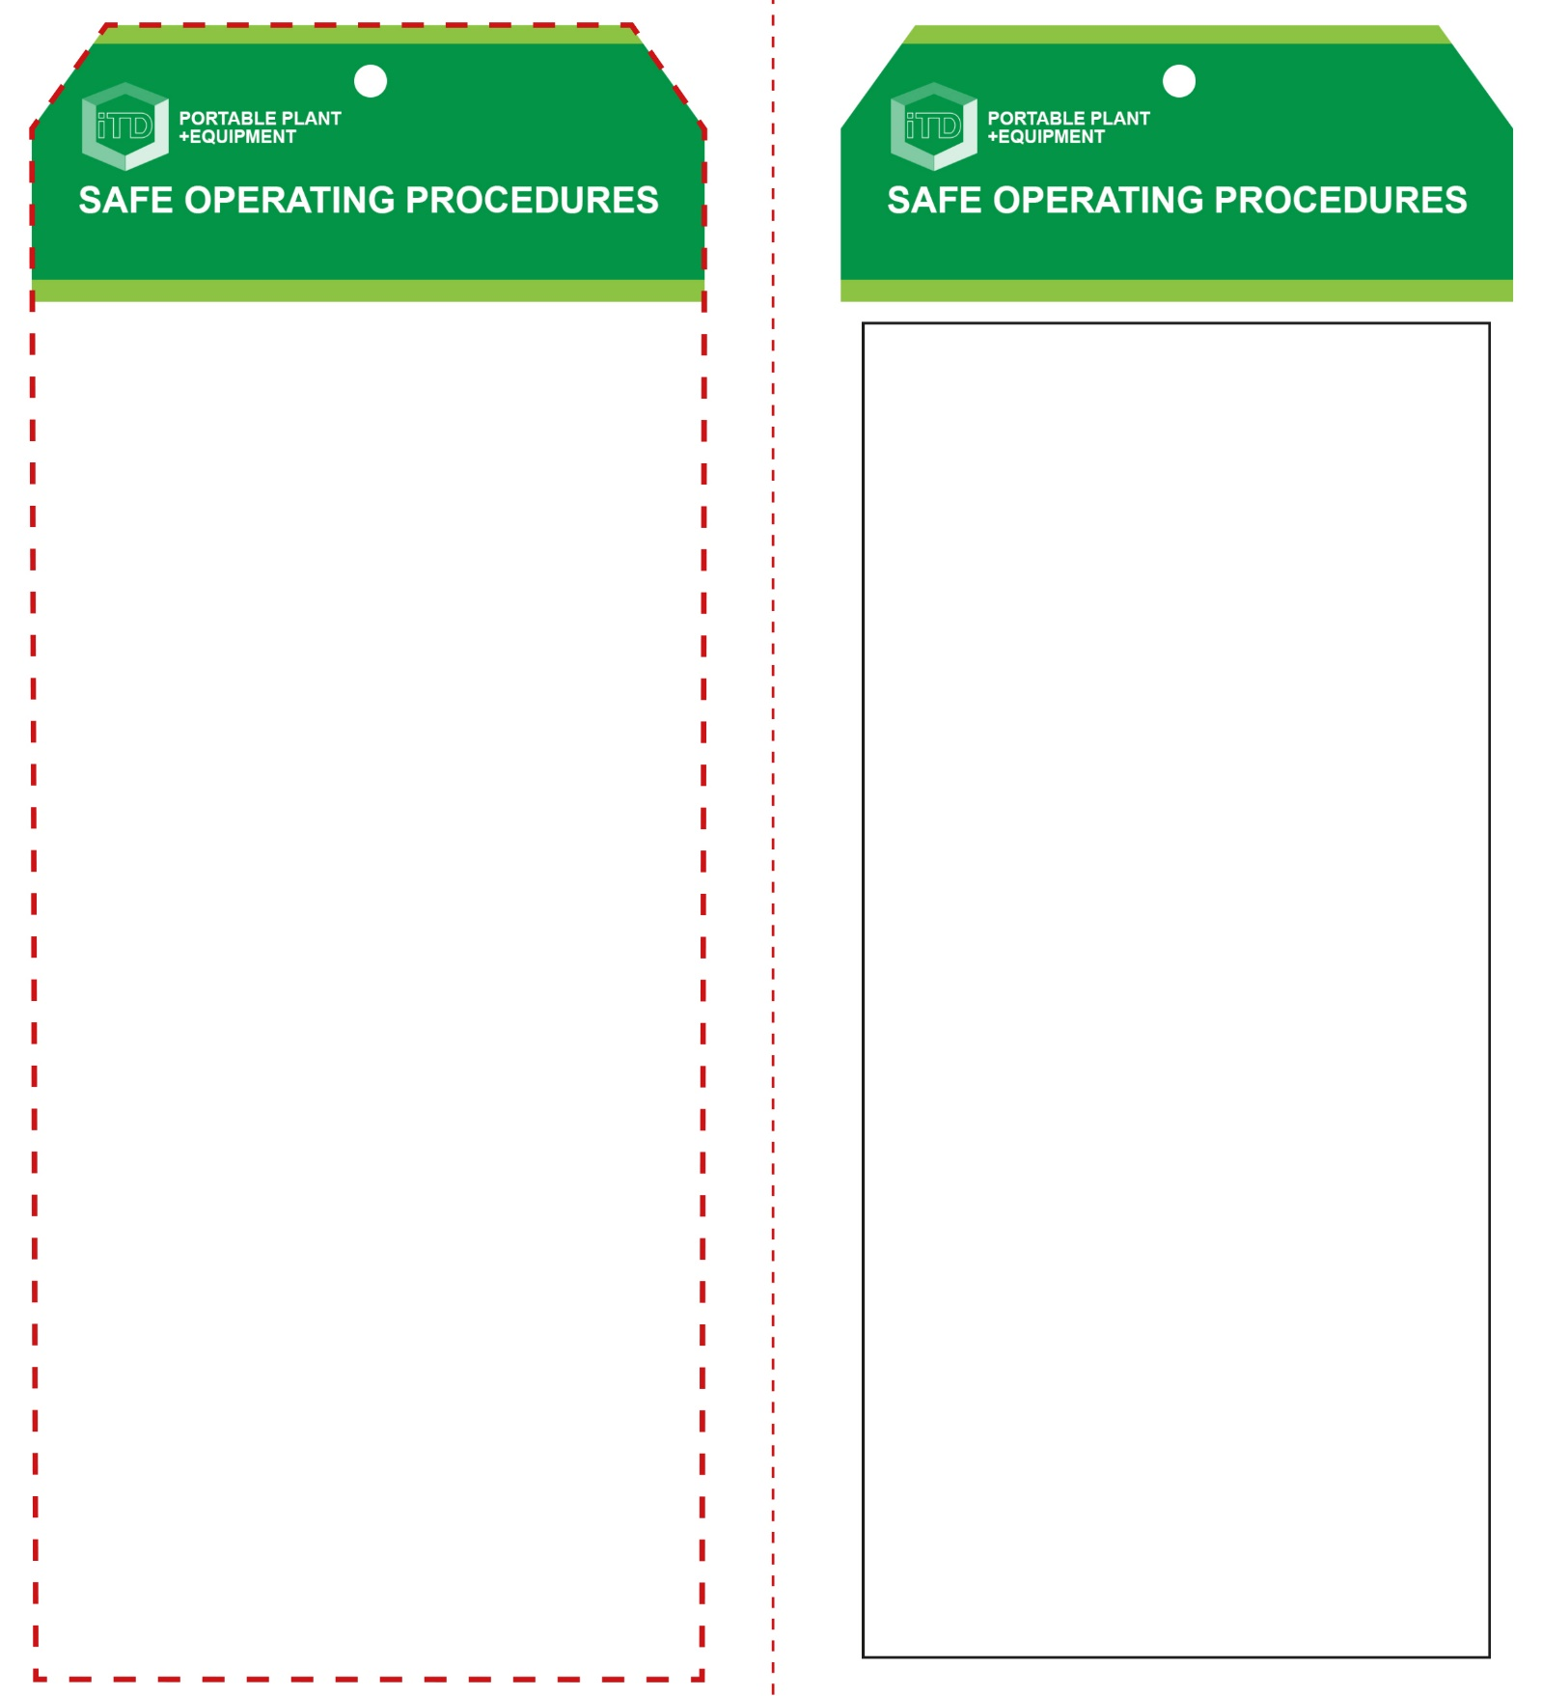

**Students must read this important information before using the equipment**

|  |  |
| --- | --- |
| Has your teacher given you instruction on the safe use and operation of this equipment? | |
|  | |
| Has your teacher given permission  for you to use this equipment? | |
|  | Approved safety glasses *must* be worn at all times in all ITD workspaces. |
|  | Appropriate protective footwear with substantial uppers *must* be worn in all ITD workspaces. |
|  | Long and loose hair *must* be contained or restrained for some operations. |
|  | Protective clothing or a suitable workshop apron is advisable. |
|  | Rings and jewellery *must not* be worn when using this portable power tool. |
|  | Gloves *must not* be worn when using this portable power tool. |
| **PRE-OPERATIONAL SAFETY CHECKS**   1. Ensure this power tool has a suitable safe work area. 2. Check the condition of the auger and chisel tool bit. 3. Check the operation of all fences, clamps and guards. 4. Examine the power lead and plug for obvious damage. | |

**OPERATIONAL SAFETY CHECK**

|  |
| --- |
| **Never operate a faulty electrical power tool. Report it to your teacher.** |
| 1. Always select the correct hollow chisel and auger set for the mortise to drill. 2. Tighten the chuck uniformly when the auger bit is inserted – using the correct key. 3. Always remove the chuck key before starting the mortising machine. 4. Keep clear of moving machine parts. 5. Never attempt to drill material that does not lie flat on the table. Irregular shaped work should be securely held in a jig, vice or clamp. 6. Set the slot in the side of the chisel bit to align with the lateral direction of your intended mortise. 7. The work piece should be moved so that the chisel is releasing chips into the already cut part of the work piece. 8. Allow the auger bit to cut at its own speed without applying excessive pressure. 9. Keep hands clear of the auger and chisel when the machine is running. 10. Do not remove waste material from the table while the machine is running. 11. Never leave the machine running unattended. |
| **Apply even pressure – avoid overlapping cuts** |
| **HOUSEKEEPING**   1. Ensure all switches, guards and clamping are cleaned. 2. Leave the work area in a safe, clean and tidy condition.   **POTENTIAL HAZARDS AND RISKS**  ■ Moving, rotating and sharp parts  ■ Eye injuries ■ Electricity ■ Dust ■ Ejected waste  ■ Burns (friction) ■ Pinch and squash |

**Mortising Machine**

**Mortising Machine**

**Front Reverse**

**Assembly instructions:**

1. Carefully fold this page in half vertically down the centre line
2. This should align ‘front’ and ‘reverse’ sides, then glue the halves back to back
3. Cut out the ‘tag’ shape along the RED dotted outlines indicated on the ‘front’ side
4. Laminate and trim to size with a clear 2mm border
5. Securely fasten an 8mm (ID) brass eyelet and washer where indicated.