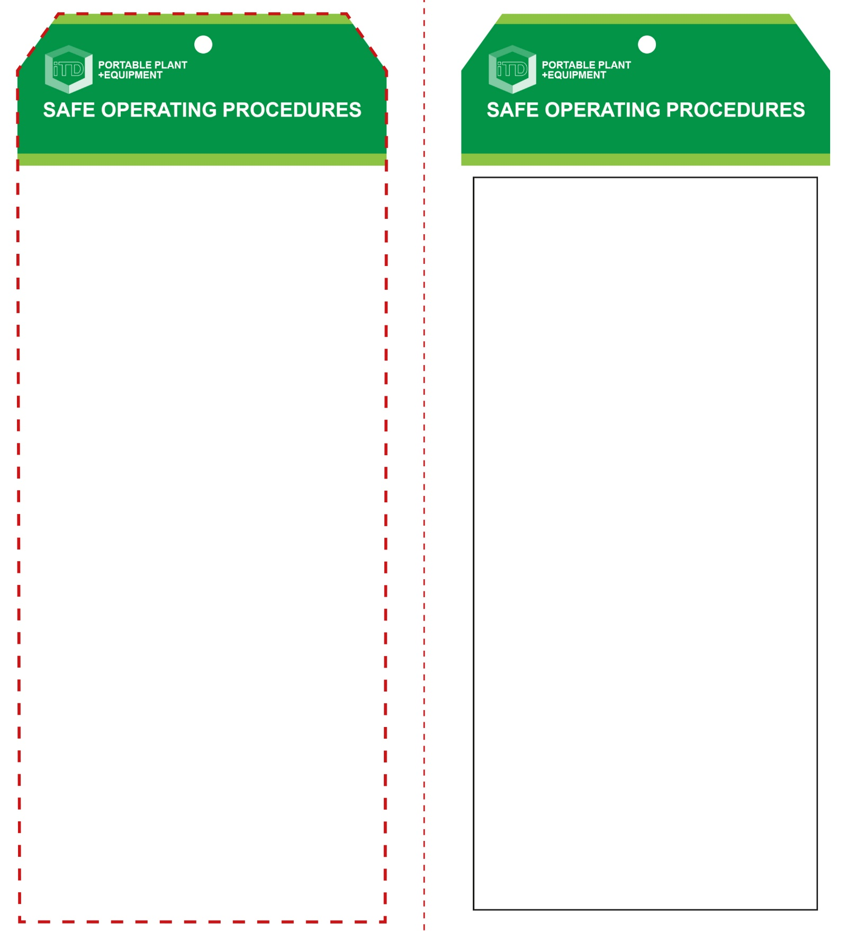

**Students must read this important information before using the equipment**

|  |  |
| --- | --- |
| Has your teacher given you instruction on the safe use and operation of this equipment? | |
|  | |
| Has your teacher given permission  for you to use this equipment? | |
|  | Approved safety glasses *must* be worn at all times in all ITD workspaces. |
|  | Appropriate protective steel-toed work boots *must* be worn in all ITD workspaces. |
|  | An approved dust mask must be worn (P2 dust and fumes). |
|  | Appropriate hearing protection must be worn (*Class 5 – SLC80 >26 dB)* |
| Description: mand154_safety_overalls_must_ | Sturdy ‘work wear’ clothing or overalls must be worn. |
| **PRE-OPERATIONAL SAFETY CHECKS**   1. Ensure the power tool has a suitable safe work area. 2. Material should be free of loose knots or foreign objects. 3. Make sure the planer blades are not chipped or cracked. 4. Examine the power lead and plug for obvious damage 5. Material should be well supported and at a good working height. 6. Ensure you are familiar with the ON/OFF switch. 7. Ensure your work area is clear of trip hazards and flammable materials. | |

**OPERATIONAL SAFETY CHECK**

|  |
| --- |
| **Never operate a faulty electrical power tool. Report it to your teacher.** |
| 1. Do not support your material by hand. Set it up on a bench or supports. Use two hands to operate the planer. 2. Do not start the planer with the blade touching the material. Allow the equipment to reach full speed before starting to cut. 3. Keep fingers and any objects clear of the chip ejector while the planer is running. 4. Keep hands and clothing away from underneath the work. Do not attempt to remove cut material while the blades are turning. 5. Never pull the planer backward over the work piece, always cut in the forward direction. 6. Never place the planer down on a surface until the blade is completely stopped. 7. Before making any adjustments of the planer, bring the machine to a complete standstill and then remove battery or isolate the tool. 8. After changing blades, rotate the blade cylinder carefully by hand to make sure blade is secure and not hitting any part of the planer casing. Remove the battery. |
| **NB. This power tool can produce excessive noise levels greater than 105dB.** |
| **HOUSEKEEPING**   1. Stow power tool away correctly and remove the battery for recharging. 2. Leave the work area in safe, clean and tidy   **POTENTIAL HAZARDS AND RISKS**  ■ Moving, rotating and sharp parts  ■ Electricity ■ Noise  ■ Ejected waste ■ Eye injuries  ■ Dust and fumes ■ Pinch and squash |

**FORBIDDEN**

■ DO NOT operate this equipment in wet conditions.

**Electric Planer (cordless)**

**Electric Planer (cordless)**

**Front Reverse**

**Assembly instructions:**

1. Carefully fold this page in half vertically down the centre line
2. This should align ‘front’ and ‘reverse’ sides, then glue the halves back to back
3. Cut out the ‘tag’ shape along the RED dotted outlines indicated on the ‘front’ side
4. Laminate and trim to size with a clear 2mm border
5. Securely fasten an 8mm (ID) brass eyelet and washer where indicated.