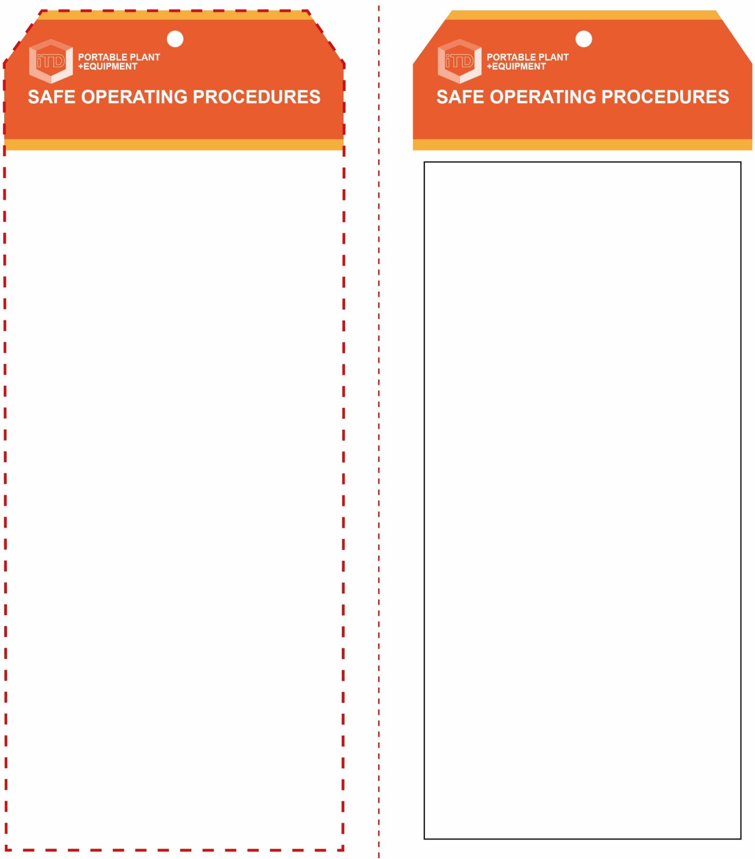

**Students must read this important information before using the equipment**

|  |  |
| --- | --- |
| Has your teacher given you instruction on the safe use and operation of this equipment? | |
|  | |
| Has your teacher given permission  for you to use this equipment? | |
|  | Approved safety glasses *must* be worn at all times in addition to a welding helmet. |
|  | Appropriate protective footwear with substantial uppers *must* be worn in all ITD workspaces. |
|  | Protective welding helmet with the correct grade UV and IR lens *must* be worn. |
|  | Protective leather gloves *must* be worn when using this equipment. |
|  | Protective overalls or leather apron *must* be worn when using this equipment. |
|  | Respiratory protection may be required for some plasma cutting operation. |
|  | Rings and jewellery *must not* be worn when using any welding equipment. |
| **PRE-OPERATIONAL SAFETY CHECKS**   1. Ensure the plasma cutter has a suitable safe work area. 2. Ensure the material to be cut poses no hazards. 3. Do not weld or attempt to cut empty containers that have previously held combustible substances. 4. Keep the area clean and free of grease, oils and flammables. 5. Ensure the others are protected from any UV welding flash. 6. Ensure the area is well-ventilated (with fume extraction). | |

**OPERATIONAL SAFETY CHECK**

|  |
| --- |
| **Never operate a faulty electrical power tool. Report it to your teacher.** |
| 1. Ensure the machine is correctly set up for current, voltage and gas flow rate. 2. Ensure that other workers in this locality are protected from any UV and IR radiation flash. Always close the UV curtain to the welding bay or erect a UV screen. 3. Ensure the return cables (earth connections) make firm contact to provide a good electrical contact. 4. Ensure the work piece has been prepared to be free of any paint, oxides or other surface finishes ensuring a good electrical contact. 5. Take particular care to avoid accidental UV welding flash to the skin or eyes. 6. Hearing protection may be required when cutting thick materials. 7. Never leave the plasma cutter running unattended. |
| **Use hearing protection when cutting thick metal** |
| **HOUSEKEEPING**   1. Ensure the welder and fume extraction are switched off. 2. Ensure the air regulator is off and the unit secured. 3. Hang up the handpiece, hoses and cables appropriately. 4. Leave the work area and welding bench in a safe, clean and tidy condition.   **POTENTIAL HAZARDS AND RISKS**  ■ Electricity and electric shock  ■ Burns due to hot, molten materials  ■ UV radiation to skin and eyes |

**Plasma Cutter**

**Plasma Cutter**

**Front Reverse**

**Assembly Instructions:**

1. Carefully fold this page in half vertically down the centre line
2. This should align “Front” & “Reverse” sides, then glue the halves back to back
3. Cut out the “Tag” shape along the RED dotted outlines indicated on the “Front” side
4. Laminate & trim to size with a clear 2 mm border
5. Securely fasten an 8mm (ID) brass eyelet and washer where indicated.

*Website link to this SOP document:* <http://education.qld.gov.au/health/safety/hazards/equip-resources.html>