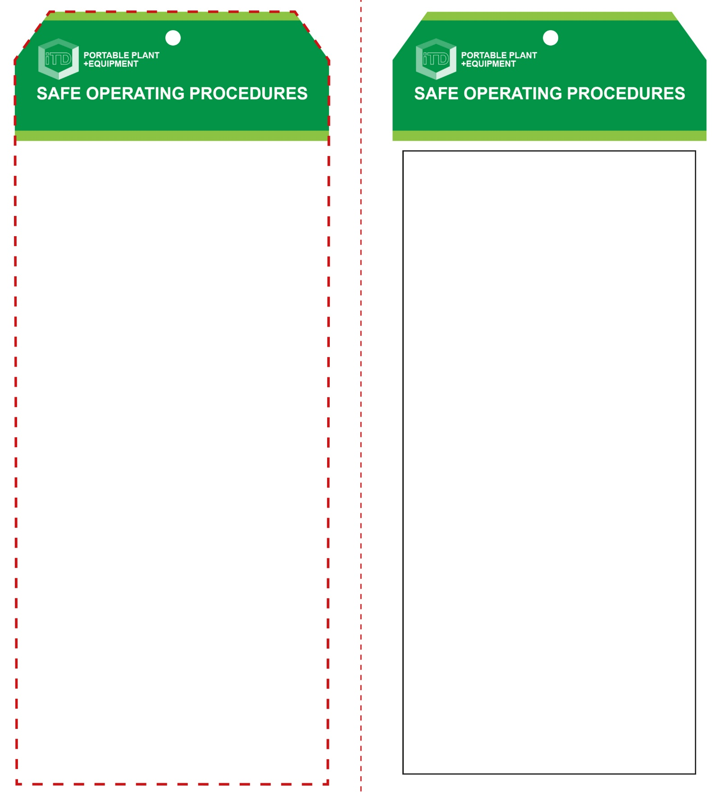

**OPERATIONAL SAFETY CHECK**

|  |
| --- |
| **Never operate a faulty electrical power tool. Report it to your teacher.** |
| 1. Fit and tighten the correct cutter bit. Ensure that it conforms to specifications. 2. Secure the router to the underside of the table and adjust the cutter depth. 3. All guards and necessary fences must be in place to operate this equipment. 4. Jigs and template are to be used wherever possible. NEVER freeform. 5. Check the functions of all fences, jigs, fixtures and templates. Ensure all adjustments are secure. 6. Note: the isolating switch on the table must be connected and operational. 7. Allow the machine to reach full speed before contacting the work piece. 8. Feed direction must be AGAINST the direction of rotation of the cutter bit. 9. Feed work piece slowly into the cutter bit and hold firmly against a fence. 10. Keep hands away from the cutting area. DO NOT attempt to remove any waste material which the cutter bit is moving. 11. If any unforeseen problems arise while routing, stop immediately, switch off and report it to your teacher. Never leave the router running unattended. |
| **NB a very high risk of injury exists if guards and fences are removed** |
| **HOUSEKEEPING**   1. Switch off and isolate the router after use. Ensure all guards are closed. 2. Leave the work area in a safe, clean and tidy condition.   **POTENTIAL HAZARDS AND RISKS**  ■ Moving, rotating and sharp parts  ■ Pinch and squash ■ Electricity ■ Eye injuries ■ Noise  ■ Dust and fumes ■ Ejected material  **FORBIDDEN**  ■ Freeform machining where no guards or fence is fitted is strictly prohibited. |

**Students must read this important information before using the equipment**

|  |  |
| --- | --- |
| Has your teacher given you instruction on the safe use and operation of this equipment? | |
|  | |
| Has your teacher given permission  for you to use this equipment? | |
|  | Approved safety glasses *must* be worn at all times in all ITD workspaces. |
|  | Appropriate protective steel-toed boots *must* be worn in all ITD workspaces. |
|  | Hearing protection *(Class 5 – SLC80 >26 dB)* *must* be worn at all times when using the router table. |
|  | A dust mask *must* be worn when excessive airborne dust is created. |
|  | Long and loose hair *must* be contained or restrained for some operations. |
|  | Protective clothing, overalls or a workshop apron is encouraged. |
| **PRE-OPERATIONAL SAFETY CHECKS**   1. Ensure your work area is suitable, safe and free of slip and trip hazards. 2. Inspect the condition of the cutter bit to ensure it’s free of damage i.e. chips and burning. 3. If changing the cutter bit, unplug and isolate router. 4. Ensure all guards and fences are in place and in good working order. 5. Familiarise yourself with the ON/OFF switch. 6. Check that the isolating switch on the table is connected and functional. | |

**Router Table**

**Router Table**

**Front Reverse**

**Assembly instructions:**

1. Carefully fold this page in half vertically down the centre line
2. This should align ‘front’ and ‘reverse’ sides, then glue the halves back to back
3. Cut out the ‘tag’ shape along the RED dotted outlines indicated on the ‘front’ side
4. Laminate and trim to size with a clear 2mm border
5. Securely fasten an 8mm (ID) brass eyelet and washer where indicated.