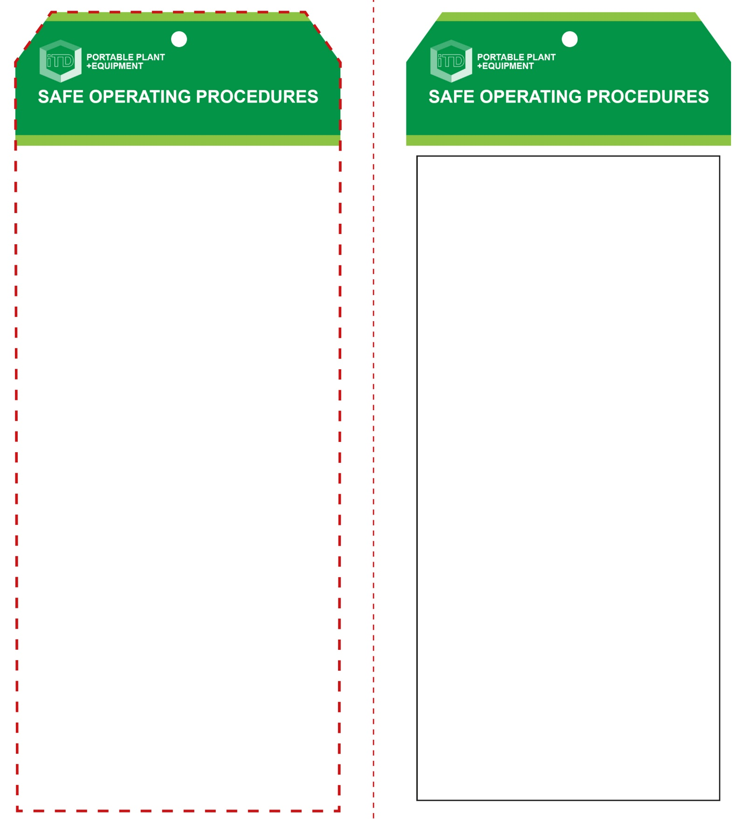

**OPERATIONAL SAFETY CHECK**

|  |
| --- |
| **Never operate a faulty electrical power tool. Report it to your teacher.** |
| 1. Do not plug in until all adjustments have been made. 2. Examine the material to be sanded for splits, loose knots and nails, etc. 3. Always select the correct abrasive and grade of disc. 4. Sanding discs with holes must align with those on the rubber pad to allow for efficient dust collection. 5. Always make sure a dust bag is fitted and emptied regularly for efficient operation of the sander. Some machines may be fitted to ducted dust extraction. 6. Ensure the work piece is secure and well supported. 7. Ensure the power cord is well clear of the work piece. 8. The sander is best used when held with both hands. 9. Keep finger and hands well clear of moving parts. 10. Allow the sander to reach operating speed, then apply load gradually. Do not apply excessive force. 11. Avoid blocking and covering the motor ventilation slots with your hands. 12. Avoid prolonged use. This could overheat the motor. 13. Maintain a constant pace to avoid uneven standing. 14. Be cautious of sanding too close to edges and corners. 15. Replace sanding disc once edges are torn or frayed. |
| **Always wear safety goggles and a dust mask** |
| **HOUSEKEEPING**   1. Return this tool to the appropriate storage cupboard. 2. Leave the work area in a safe, clean and tidy condition.   **POTENTIAL HAZARDS AND RISKS**  ■ Moving, rotating and abrasive parts  ■ Electricity ■ Noise ■ Excessive dust  ■ Eye injuries ■ Burns (friction) |

**Students must read this important information before using the equipment**

|  |  |
| --- | --- |
| Has your teacher given you instruction on the safe use and operation of this equipment? | |
|  | |
| Has your teacher given permission  for you to use this equipment? | |
|  | Approved safety glasses *must* be worn at all times in all ITD workspaces. |
|  | Appropriate protective footwear with substantial uppers *must* be worn in all ITD workspaces. |
|  | A mask *must* be worn when excessive airborne dust is created. |
|  | Hearing protection must be worn when noise levels are identified as excessive. |
|  | A suitable workshop apron or close fitting protective clothing must be worn. |
|  | Gloves must *not* be worn when using this portable power tool. |
| **PRE-OPERATIONAL SAFETY CHECKS**   1. Ensure this sanding tool has a suitable safe work area 2. Examine the power lead and plug for obvious damage 3. Do not use dull or damaged abrasive sanding discs. 4. Check the sanding disc is correctly fitted. | |

**Orbital Sander**

**Orbital Sander**

**Front Reverse**

**Assembly instructions:**

1. Carefully fold this page in half vertically down the centre line
2. This should align ‘front’ and ‘reverse’ sides, then glue the halves back to back
3. Cut out the ‘tag’ shape along the RED dotted outlines indicated on the ‘front’ side
4. Laminate and trim to size with a clear 2mm border
5. Securely fasten an 8mm (ID) brass eyelet and washer where indicated.