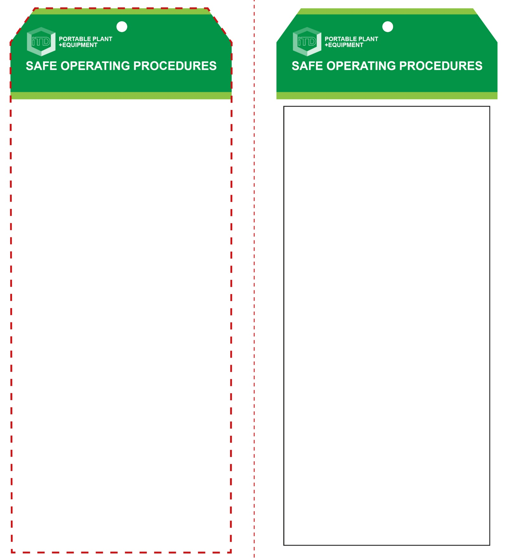

**Students must read this important information before using the equipment**

|  |  |
| --- | --- |
| Has your teacher given you instruction on the safe use and operation of this equipment? | |
|  | |
| Has your teacher given permission  for you to use this equipment? | |
|  | Approved safety glasses *must* be worn at all times in all ITD workspaces. |
|  | Appropriate protective steel-toed work boots *must* be worn in all ITD workspaces. |
|  | Long and loose hair *must* be contained or restrained for some operations and all jewellery must be removed. |
|  | Appropriate hearing protection may be needed *(Class 3 – SLC80 18-21dB).* |
|  | A suitable workshop apron or close fitting protective clothing must be worn. |
| **PRE-OPERATIONAL SAFETY CHECKS**   1. Ensure this sanding tool has a suitable safe work area and free of trip hazards and waste materials. 2. Ensure material is free of loose knots and foreign objects. 3. Check that saw is securely supported and at a good working height. 4. Check that the blade nut/stud is tight and blade is free of chips and cracks. 5. Check that the saw guard/s are in place and in good working condition, and that all adjustment levers have been tightened. 6. Adjust the blade correctly for the task. 7. Familiarise yourself with the ON/OFF switch. | |

**Circular Saw**

**OPERATIONAL SAFETY CHECK**

|  |
| --- |
| **Never operate a faulty electrical power tool. Report it to your teacher.** |
| 1. Ensure base plate/foot of the saw is correctly positioned and secured. 2. Do not support your material by hand. Secure to a bench or supports. Use two hands to operate the saw. 3. Do not start the saw with blade touching the material. Allow the saw to reach full speed before starting to cut. 4. Do not have any part of your body in line with the path of the saw blade. 5. Keep hands and power leads away from underneath the work. Do not attempt to remove cut material while the blade is turning. 6. Keep blade path straight during cut to prevent ‘kickback’ and avoid twisting. 7. Use a fence or guide where possible when making long rips or cross cuts. 8. When cutting larger sheets, ensure material is well supported to prevent binding on the blade and ‘kickback’ of the saw. 9. If task requires the cut to be stopped within the material, release the switch, hold the saw securely and wait for the blade to stop before removing. 10. Before making any adjustments to the saw, bring the machine to a complete standstill and then disconnect the AC plug from the power source. |
| **Ensure the power cord is clear of the blade** |
| **HOUSEKEEPING**   1. Switch off and isolate the circular saw after use. Ensure all guards are closed. 2. Leave the work area in a safe, clean and tidy condition.   **POTENTIAL HAZARDS AND RISKS**  ■ Moving, rotating and sharp parts  ■ Electricity ■ Noise ■ Dust and fumes  ■ Eye injuries ■ Pinch and squash  **FORBIDDEN**  ■ DO NOT operate this saw in moist or wet conditions. |

**Circular Saw**

**Front Reverse**

**Assembly instructions:**

1. Carefully fold this page in half vertically down the centre line
2. This should align ‘front’ and ‘reverse’ sides, then glue the halves back to back
3. Cut out the ‘tag’ shape along the RED dotted outlines indicated on the ‘front’ side
4. Laminate and trim to size with a clear 2mm border
5. Securely fasten an 8mm (ID) brass eyelet and washer where indicated.