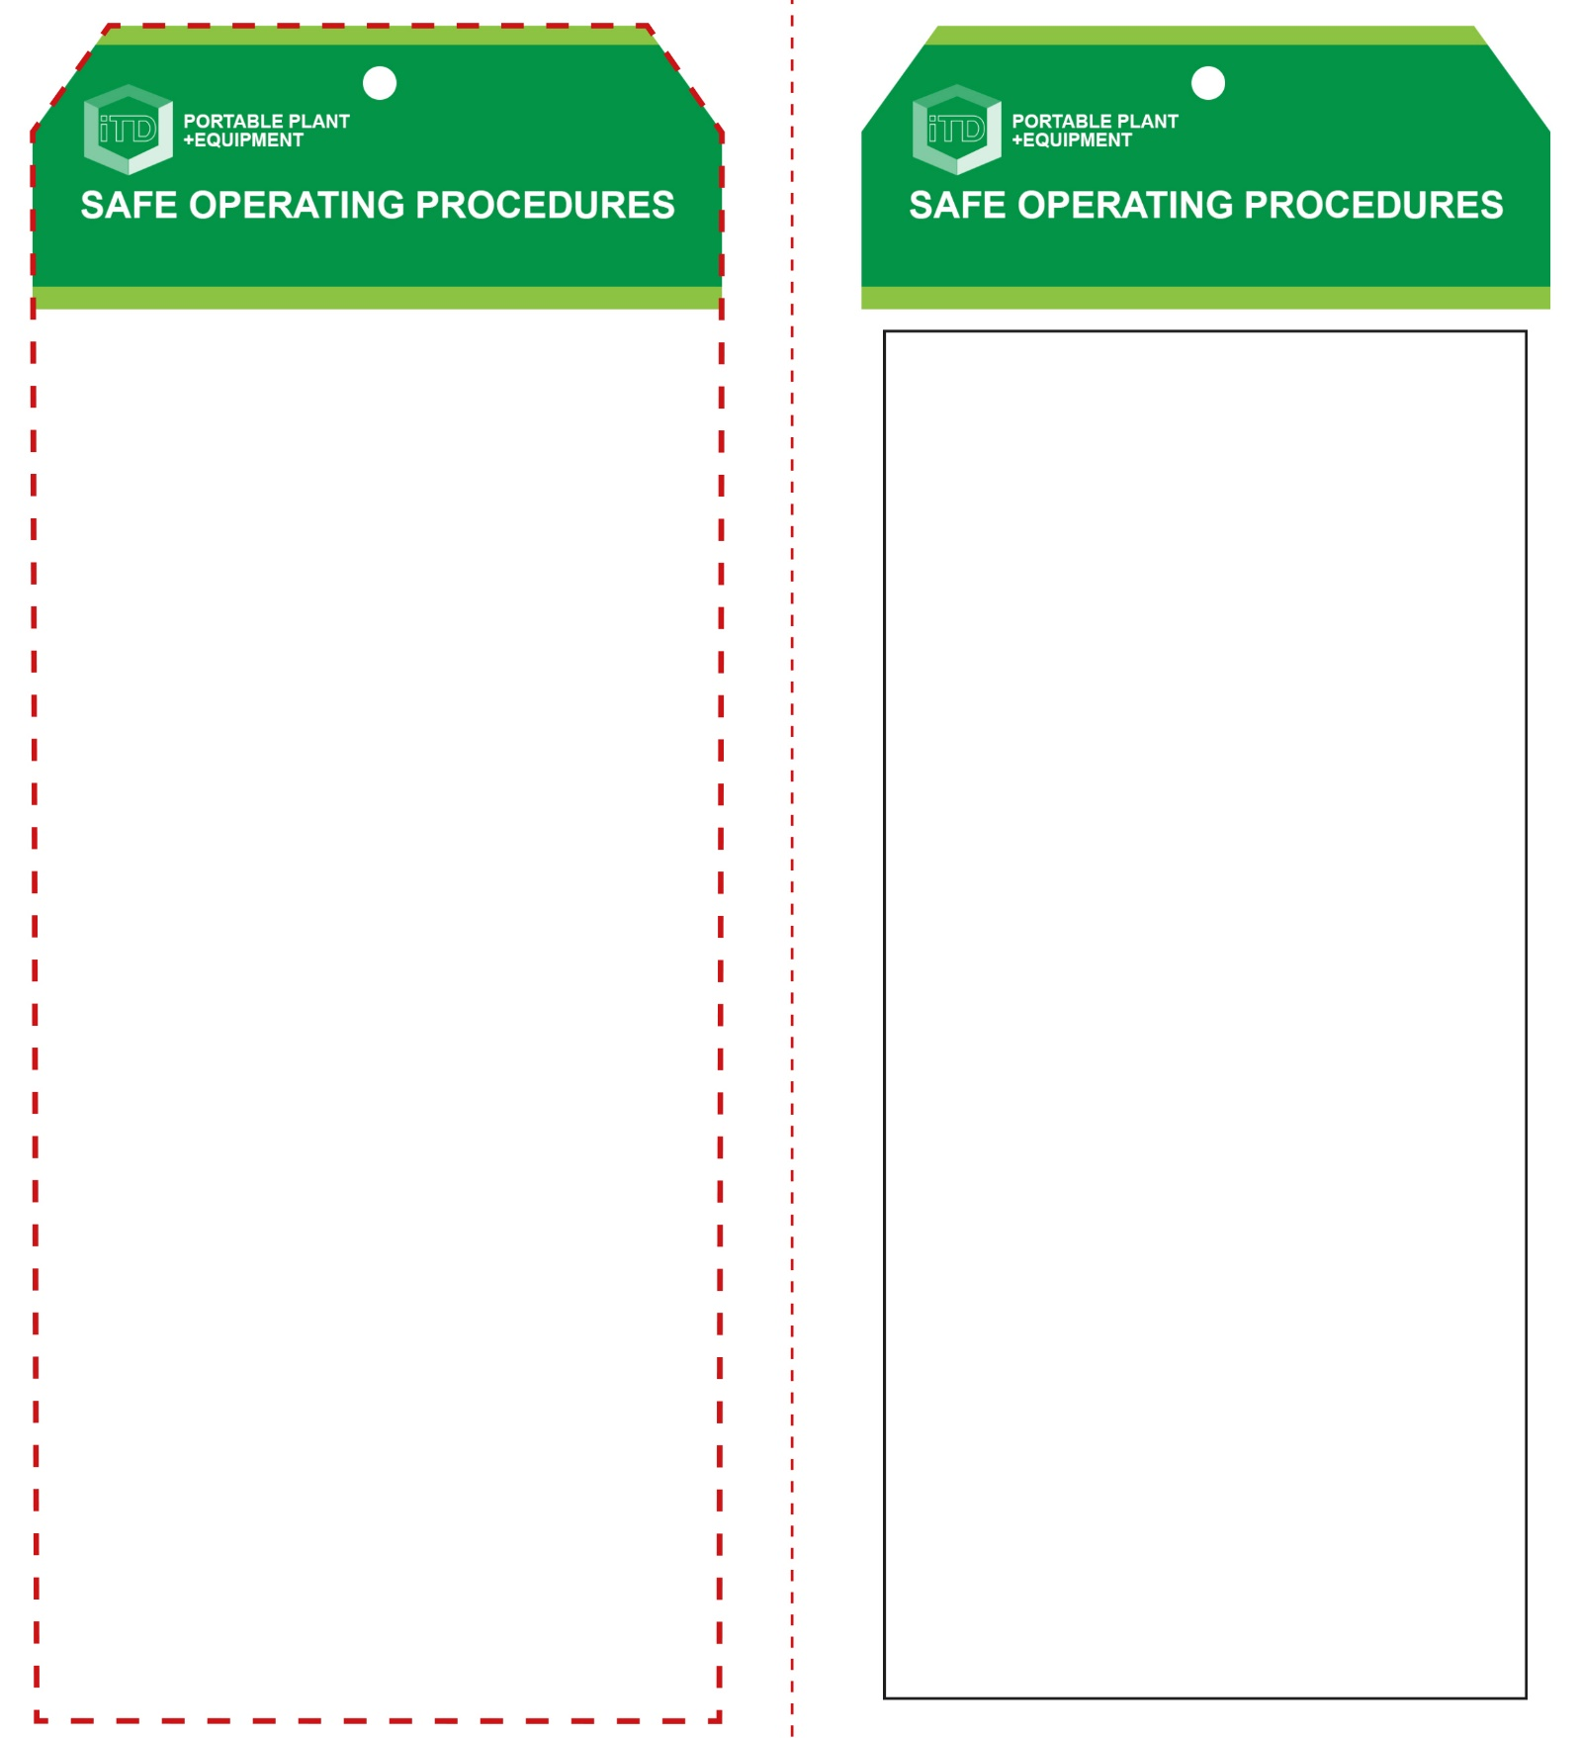

**Students must read this important information before using the equipment**

|  |  |
| --- | --- |
| Has your teacher given you instruction on the safe use and operation of this equipment? | |
|  | |
| Has your teacher given permission  for you to use this equipment? | |
|  | Approved safety glasses *must* be worn at all times in all ITD workspaces. |
|  | Appropriate protective footwear with substantial uppers *must* be worn in all ITD workspaces. |
|  | Long and loose hair *must* be contained or restrained for some operations. |
|  | A suitable workshop apron or close fitting protective clothing must be worn. |
| Hearing Protection circle | Appropriate hearing protection *(Class 5 – SLC80 >26 dB)* must be worn. |
|  | Rings and jewellery *must not* be worn. |
| **PRE-OPERATIONAL SAFETY CHECKS**   1. Ensure the machine has a suitable safe work area 2. If changing the cutting blade, check for appropriateness and arbor size. 3. Ensure all safety guards are serviceable and in place. 4. Inspect the cutting blade for chipped teeth or cracks. 5. If fitted with a depth stop, ensure it is adjusted and in proper alignment, 6. Familiarise yourself with the ON/OFF switch. 7. Check the coolant delivery system is sufficient and operational. | |

**OPERATIONAL SAFETY CHECK**

|  |
| --- |
| **Never operate a faulty electrical power tool. Report it to your teacher.** |
| 1. Do not attempt to hold the work piece by hand. 2. Always use the vice to clamp the work. Properly support any over-hanging portion so the work piece is level with the base of the machine. 3. Do not leave the length stop in place on the free off-cut end of a clamped work piece after clamping. 4. Do not have any part of your body in line with the path of the cutting blade. 5. Allow the blade to reach full speed before cutting. 6. Ease the cutting blade against the work piece. Do not use excessive force when cutting. 7. Keep hands away from cutting area. Do not attempt to remove cut material or swarf while blade is moving. 8. After finishing the cut, raise the saw arm up, release the switch and wait for the blade to stop completely before removing your work piece or off-cut piece. 9. Immediately clean up any coolant spills. 10. Before making any adjustments, bring the saw to a complete standstill, and disconnect from the AC power source. |
| **This saw is used to cut metal materials only** |
| **HOUSEKEEPING**   1. Ensure all switches, guards and clamping are cleaned. 2. Leave the work area in a safe, clean and tidy condition.   **POTENTIAL HAZARDS AND RISKS**  ■ Moving, rotating and sharp parts  ■ Electricity ■ Noise ■ Sharp edges, burrs  ■ Eye injuries ■ Coolant contagion  ■ Hot ejected waste material |

**Cold Saw**

**Cold Saw**

**Front Reverse**

**Assembly instructions:**

1. Carefully fold this page in half vertically down the centre line
2. This should align ‘front’ and ‘reverse’ sides, then glue the halves back to back
3. Cut out the ‘tag’ shape along the RED dotted outlines indicated on the ‘front’ side
4. Laminate and trim to size with a clear 2mm border
5. Securely fasten an 8mm (ID) brass eyelet and washer where indicated.