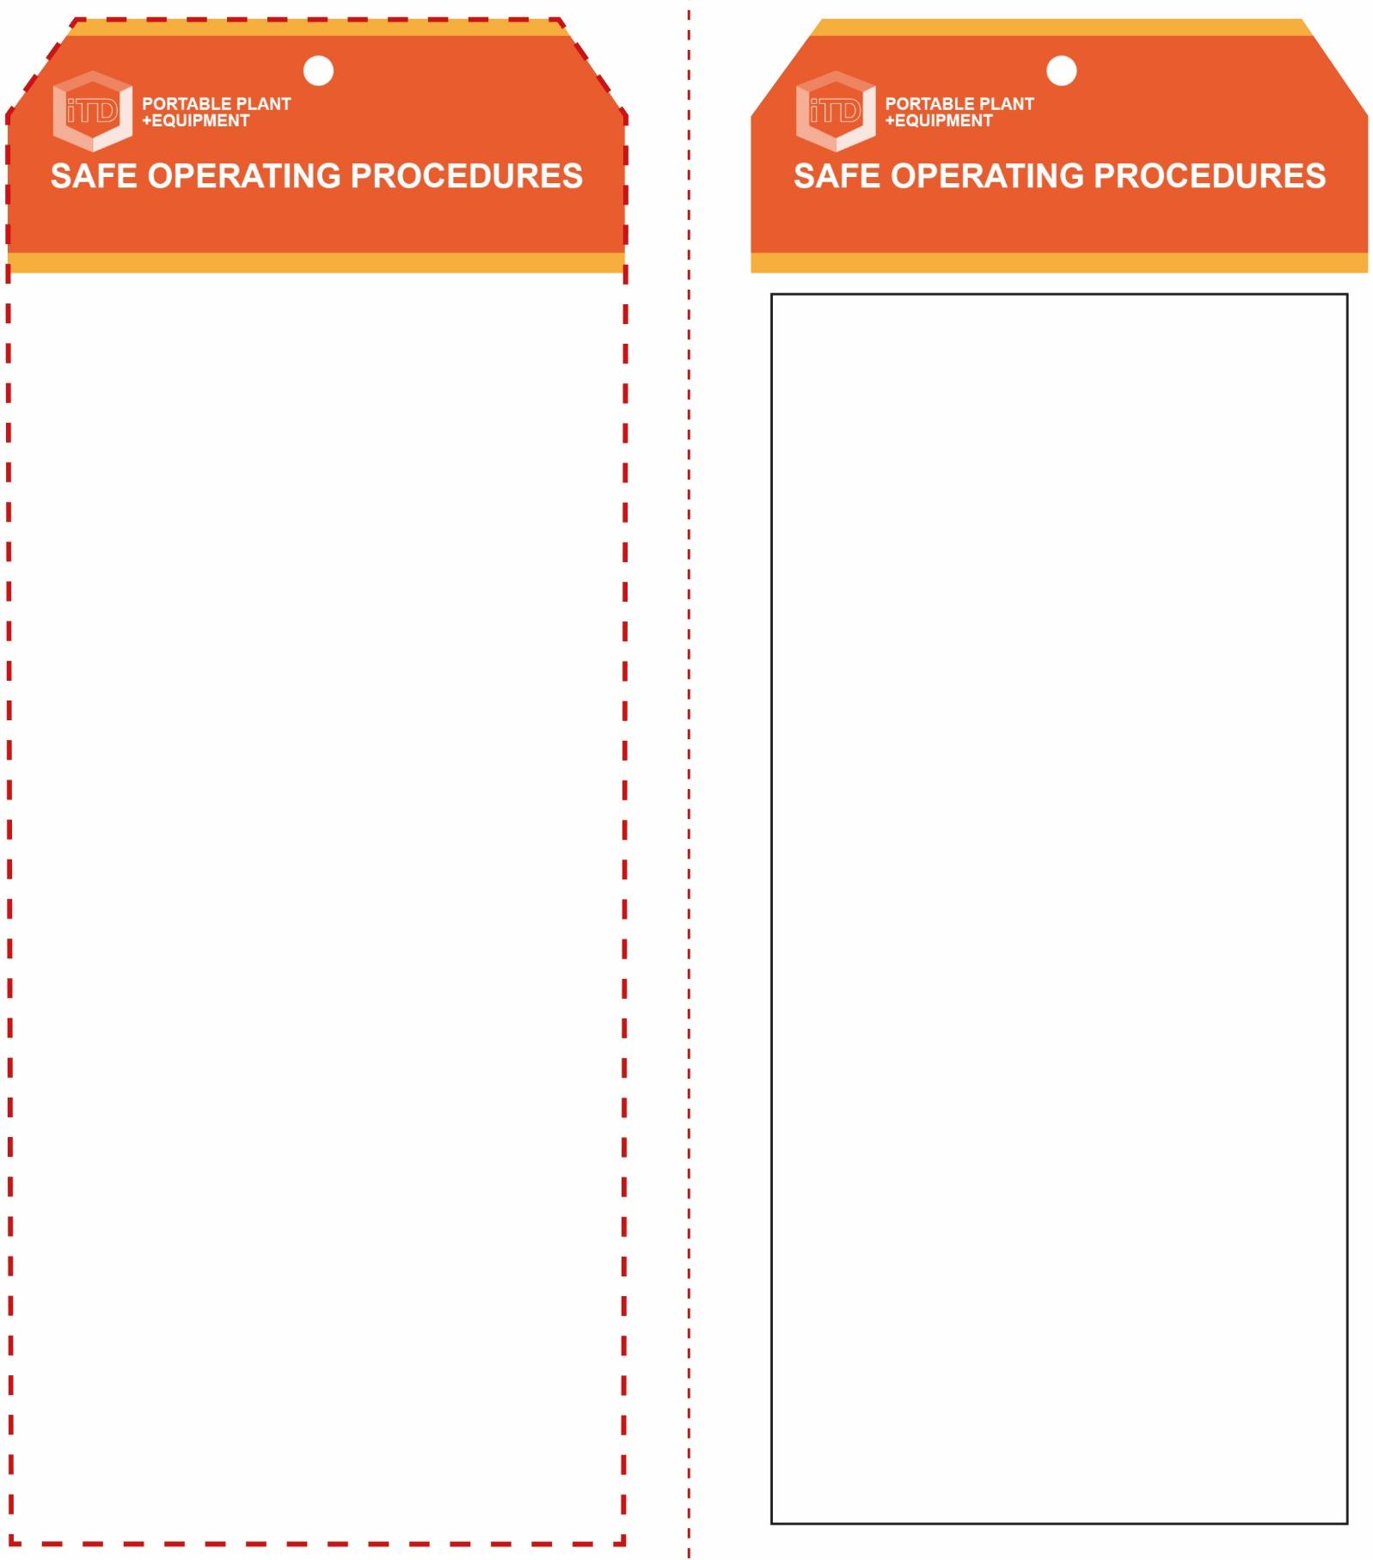

**OPERATIONAL SAFETY CHECK**

|  |
| --- |
| **Never operate a faulty electrical power tool. Report it to your teacher.** |
| 1. Do not plug in until adjustments have been made. 2. Ensure the spot welder has cooled before making any adjustments. 3. Avoid prolonged use as this can lead to heat build-up of electrodes and extension arms. 4. Take care when holding work due to heat created during welding process. 5. Ensure that the spot welder is always well supported on a flat bench surface when in use. 6. Do not leave the spot welder until it has cooled down or is placed in an appropriate area to prevent accidental burns to others. 7. Select the appropriate tips and arms for the article to be spot welded (discuss with your teacher). 8. Examine tips regularly for pitting and build-up of contamination. Do not use if tips are in poor condition. 9. Ensure spot welding process is carried out in a well ventilated area. |
| **Work area must be dry to avoid electric shock** |
| **HOUSEKEEPING**   1. Switch off, unplug and allow to cool down before storing. 2. Leave the work area in a safe, clean and tidy condition.   **POTENTIAL HAZARDS AND RISKS**  ■ Hot parts and surfaces ■ Electricity  ■ Burns ■ Eye injuries  ■ Spitting metal or flying sparks ■ Trip and slip |

**Students must read this important information before using the equipment**

|  |  |
| --- | --- |
| **Has your teacher given you instruction on the safe use and operation of this equipment?** | |
|  | |
| **Has your teacher given permission  for you to use this equipment?** | |
|  | Approved safety glasses *must* be worn at all times in addition to a welding helmet. |
|  | Appropriate protective footwear with substantial uppers *must* be worn in all ITD workspaces. |
|  | Protective leather welding gloves *must* be worn to position and hold the workpiece. |
|  | Close fitting protective clothing or overalls, and a leather apron *must* be worn. |
| **PRE-OPERATIONAL SAFETY CHECKS**   1. Ensure this spot welder has a suitable safe work area. 2. Ensure power cord does not cause any slip/trip hazards. 3. Check that the electrode points are appropriate for the procedure, are in good condition and meet accurately. 4. The electrode points must also be securely mounted and cleaned of all contaminants. 5. Adjust the pressure on the clamps to hold work securely without damaging the work piece. 6. Pre-set weld time under teacher direction (if timer fitted). 7. Gloves should be used to position and hold work piece. | |

**Spot Welder**

**Spot Welder**