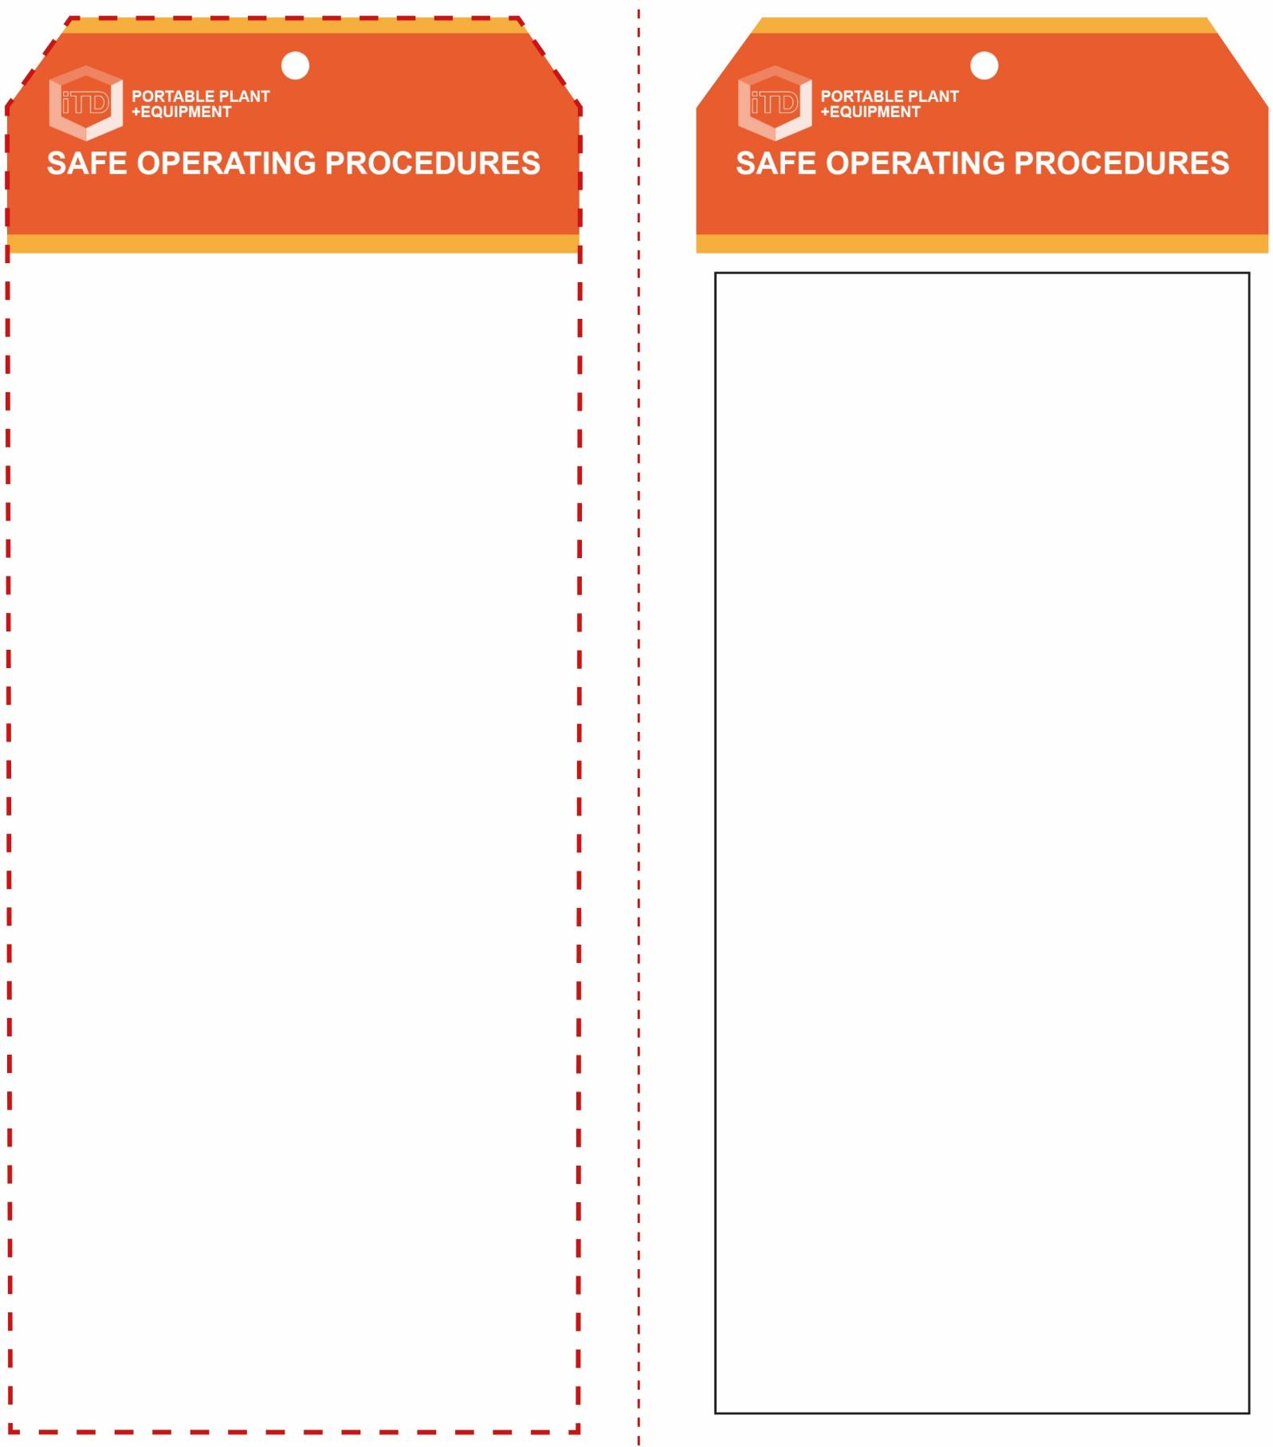

**OPERATIONAL SAFETY CHECK**

|  |
| --- |
| **Never operate a faulty electrical power tool. Report it to your teacher.** |
| 1. Ensure the machine is correctly set up for current, voltage, wire feed and shielding gas flow rate. 2. Ensure that other workers in this locality are protected from any UV and IR radiation flash. Always close the UV curtain to the welding bay or erect a UV screen. 3. Ensure the welding return cable (earth) makes firm contact to provide a good electrical contact. 4. Ensure the work piece has been prepared to be free of any paint, oxides or other surface finishes ensuring a good electrical contact. 5. Strike the arc before placing the tip of the filler wire in the weld zone. 6. Regularly inspect the tungsten electrode for damage. Turn all power off before changing the electrode. 7. Take particular care to avoid accidental UV welding flash to the skin or eyes. 8. Never leave the TIG welder running unattended. |
| **Work area must be dry to avoid electric shock** |
| **HOUSEKEEPING**   1. Close the shielding gas bottle valve and regulator. 2. Ensure the welder and fume extraction are switched off. 3. Hang up and stow the welding gun and hoses securely. 4. Leave the work area and welding bench in a safe, clean and tidy condition.   **POTENTIAL HAZARDS AND RISKS**  ■ Electricity and electric shock  ■ Burns due to hot, molten materials  ■ UV radiation to skin and eyes  ■ Cuts and lacerations  ■ Flying sparks |

**Students must read this important information before using the equipment**

|  |  |
| --- | --- |
| Has your teacher given you instruction on the safe use and operation of this equipment? | |
|  | |
| Has your teacher given permission  for you to use this equipment? | |
|  | Approved safety glasses *must* be worn at all times in addition to a welding helmet. |
|  | Appropriate protective footwear with substantial uppers *must* be worn in all ITD workspaces. |
|  | Protective welding helmet with the correct grade UV lens for TIG *must* be worn. |
|  | Protective leather gloves *must* be worn when using this equipment. |
|  | Close fitting protective clothing or overalls, a leather apron and spats *must* be worn. |
|  | Rings and jewellery *must not* be worn when using any welding equipment. |
| **PRE-OPERATIONAL SAFETY CHECKS**   1. Ensure the TIG welder has a suitable safe work area. 2. Keep the area clean and free of grease, oils and flammables. 3. Ensure others are protected from any UV welding flash. 4. Ensure the area is well ventilated with fume extraction. | |

**TIG Welder**

**TIG Welder**

**Front Reverse**

**Assembly Instructions:**

1. Carefully fold this page in half vertically down the centre line
2. This should align “Front” & “Reverse” sides, then glue the halves back to back
3. Cut out the “Tag” shape along the RED dotted outlines indicated on the “Front” side
4. Laminate & trim to size with a clear 2 mm border
5. Securely fasten an 8mm (ID) brass eyelet and washer where indicated.

*Website link to this SOP document:* <http://education.qld.gov.au/health/safety/hazards/equip-resources.html>